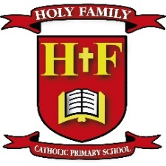
Holy Family Catholic Primary School

Headteacher: Mr S Gallagher

Deputy Headteacher

Dear Applicant

Thank you for your interest in the role of Deputy Headteacher for our school.

Holy Family is a successful and popular school within the area of New Springs, Wigan and has a very close relationship with its parish community.

We are a catholic primary school and currently have 137 pupils on roll. We are in the Diocese of Salford and in the Local Authority (LA) of Wigan. Our school prides itself on being a smaller than average primary school, enabling us to cultivate a close-knit community where every child is known and supported.

The children are a delight, they have excellent behaviour and conduct and we continue to be impressed with their confidence, love of learning and their engagement in all the school has to offer. We encourage harmonious, respectful relationships so that children can grow into responsible, well-mannered citizens, eager to make a positive difference to society.

We feel this position of Deputy Headteacher at Holy Family is an exciting opportunity for the right candidate. We would like to appoint someone who is driven, self-motivated and who has the experience and personal qualities to have a positive impact on the further development of our school. Our new Deputy Headteacher will be an outstanding teacher and excellent role model to children and staff. They will need to be ambitious, driven and an excellent communicator at all levels.

At Holy Family we have a clear mission, ‘We are a caring family. We pray, learn and grow together.’ We hope you can share in and contribute to that mission; and strive with us to provide the best possible educational experiences for our children.

We are delighted to enclose an application pack. Within your pack you should find:

• Job advert
• Job description and person specification
• CES application form

We welcome applications by email enquiries@admin.aspullholyfamily.wigan.sch.uk or post.

Further information on our school can be found on our school website:
www.aspullholyfamily.wigan.co.uk

All prospective applicants are very welcome to contact the school to arrange a visit.

We look forward to receiving your application.

Best Wishes

Mr S Gallagher Mrs J McDonald
Headteacher Chair of Governors

