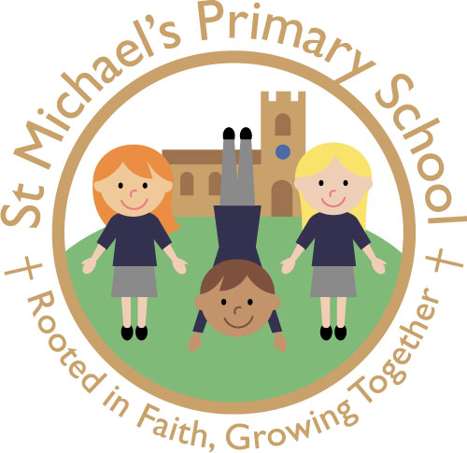
ST. MICHAEL’S C.E. (AIDED) PRIMARY SCHOOL
The Grove, Flixton, Urmston, Manchester M41 6JB

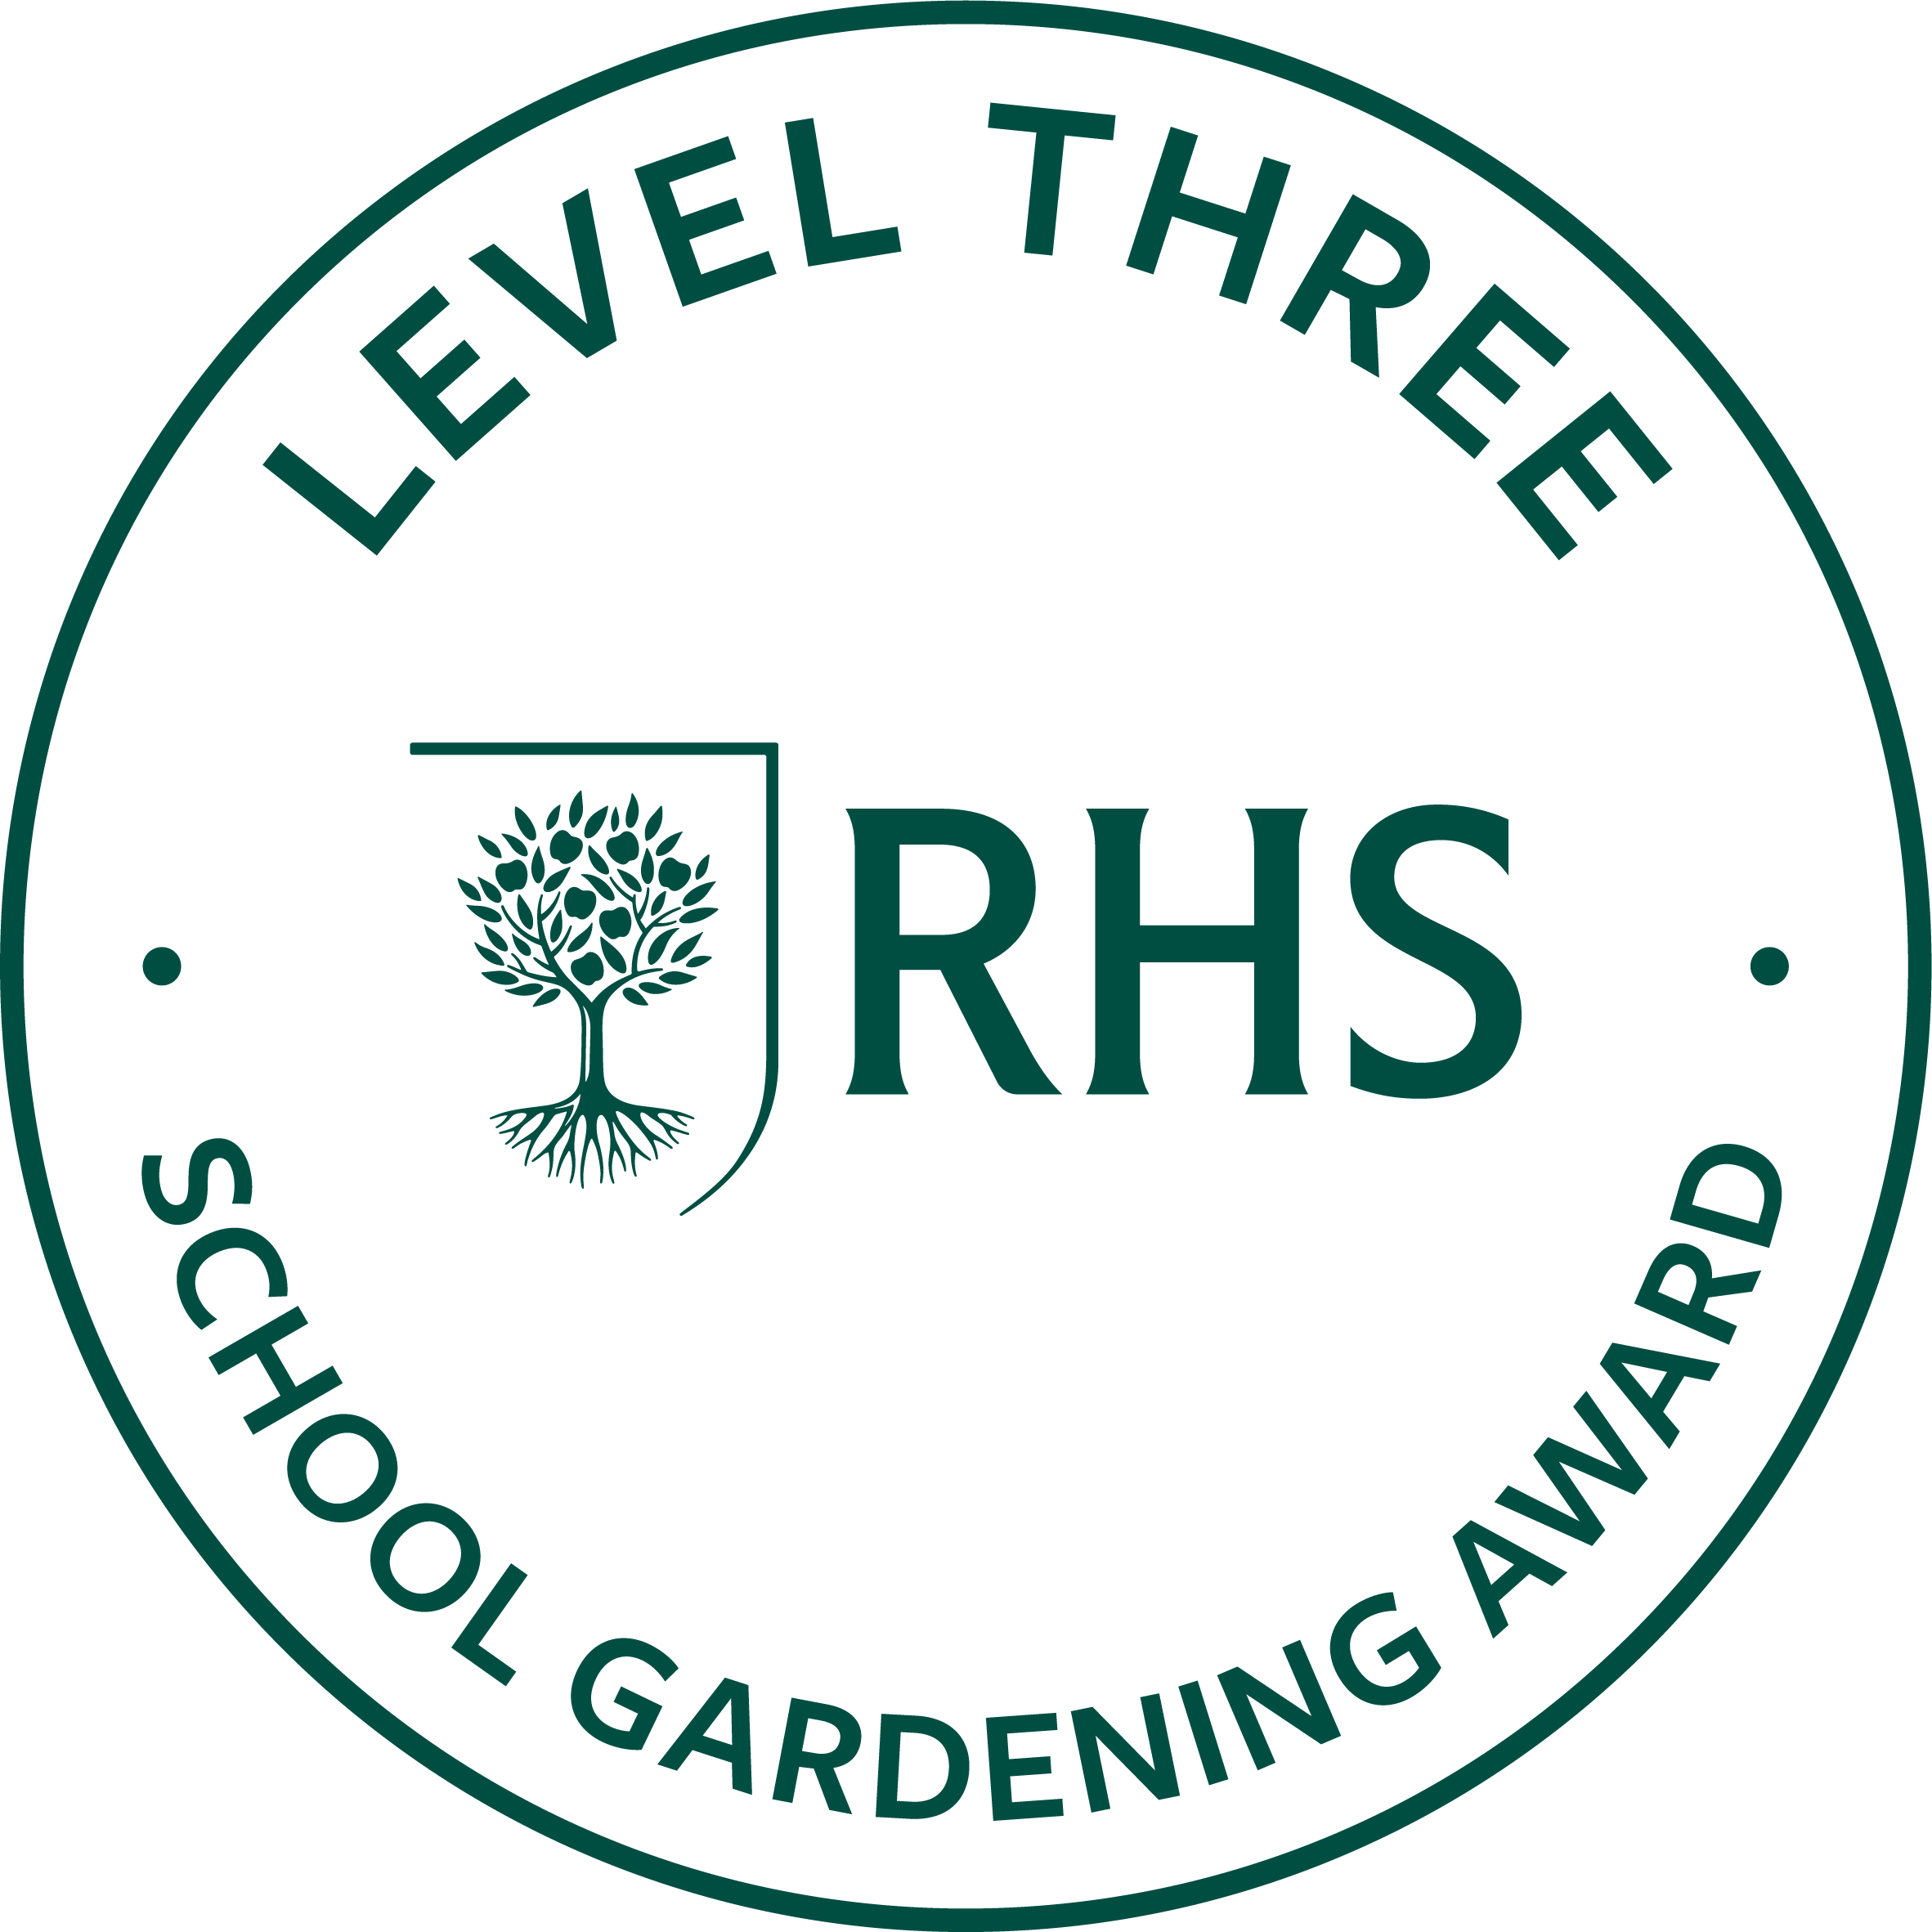
Head Teacher: Mrs L Perry

www.smpsflixton.co.uk
office@smpsflixton.co.uk
0161748 3669

Job Description – Class Teacher (Full Time – Suitable for ECT)
Job Title: Class Teacher (ECTs welcome)
Responsible to: Headteacher / Senior Leadership Team
Salary: Dependent on experience
Contract Type: Full-time

Purpose of the Role
At St Michael’s CE Primary School, our vision is to be “Rooted in Faith, Growing Together”. Guided by Luke 8:15, we are committed to nurturing pupils so they flourish academically, personally and spiritually.
The Class Teacher will deliver high-quality teaching and learning, ensuring every child is supported to become a resilient, empathetic and aspirational learner. This role is suitable for an Early Career Teacher, with a strong commitment to professional development and support.

Key Responsibilities
Teaching & Learning
- Plan and deliver high-quality, engaging lessons that inspire a love of learning
- Set high expectations for all pupils in line with the school’s values of aspiration and resilience
- Use adaptive teaching to ensure all pupils, including those with SEND, can access learning
- Create a stimulating, inclusive classroom environment where all pupils feel valued

Assessment & Progress
- Assess, monitor and track pupil progress in line with school policy
- Use assessment to inform teaching and ensure all pupils make strong progress
- Provide clear, constructive feedback to support improvement
- Identify and address gaps in learning promptly

Inclusion & Personal Development
- Promote inclusive practice so that every child can flourish
- Support pupils’ social, emotional and spiritual development
- Embed the school’s values of empathy, kindness and collaboration within classroom practice
- Work effectively with support staff to meet pupils’ needs

Behaviour & Relationships
- Establish a calm, safe and purposeful learning environment
- Promote high standards of behaviour in line with the school’s values-led approach
- Build strong, positive relationships with pupils, staff and families
- Support pupils to become respectful, responsible members of the community

Curriculum & Wider Contribution
- Contribute to the delivery of a broad, balanced and engaging curriculum
- Support whole-school priorities and initiatives
- Participate in enrichment opportunities such as trips, clubs and wider experiences

Safeguarding & Wellbeing
- Safeguard and promote the welfare of all pupils
- Follow all safeguarding policies and procedures rigorously
- Promote pupils’ wellbeing and mental health
- Act as a positive role model at all times

Professional Responsibilities
- Engage fully with the Early Career Teacher programme (if applicable)
- Reflect on practice and engage in professional development
- Work collaboratively with colleagues to ensure consistency and high standards
- Communicate effectively with parents and carers

Ethos & Church School Distinctiveness
- Actively support the Christian ethos of the school
- Contribute to collective worship and spiritual life of the school
- Promote pupils’ spiritual, moral, social and cultural development
- Uphold the school vision and values: “Rooted in Faith, Growing Together”

St Michael’s CE Primary School is committed to safeguarding and promoting the welfare of children. The successful candidate will be required to undertake an enhanced DBS check.

