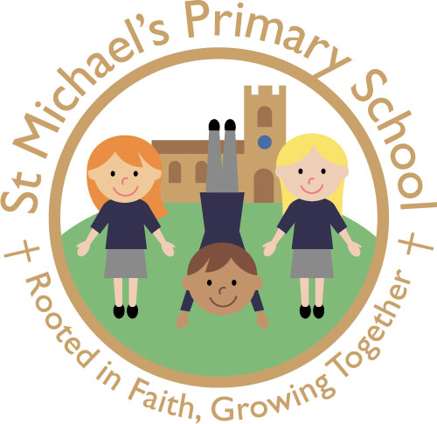
ST. MICHAEL’S C.E. (AIDED) PRIMARY SCHOOL
The Grove, Flixton, Urmston, Manchester M41 6JB

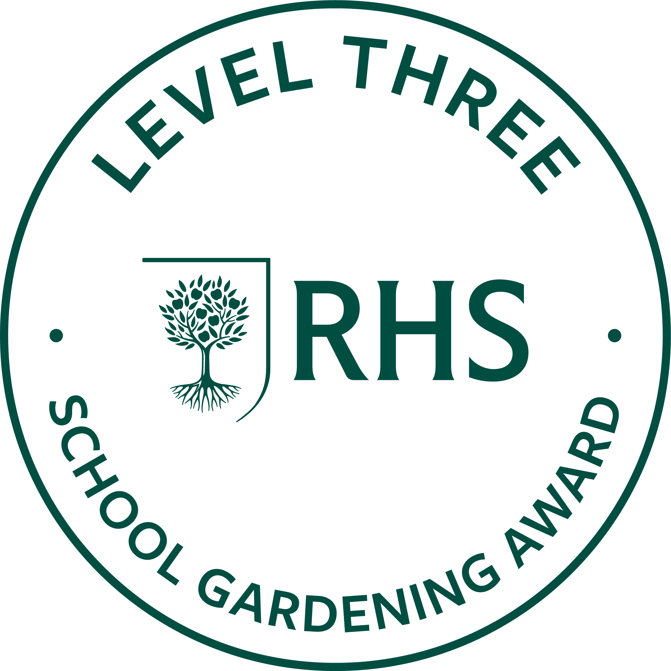
Head Teacher: Mrs L Perry

www.smpsflixton.co.uk
office@smpsflixton.co.uk
0161748 3669

Job Description – Class Teacher (Maternity Cover – 1 Year Fixed Term)
Job Title: Class Teacher
Responsible to: Headteacher / Senior Leadership Team
Salary: MPS/UPS (as appropriate)
Contract Type: Full-time / Fixed Term (1 Year Maternity Cover)

Purpose of the Role
At St Michael’s CE Primary School, we are “Rooted in Faith, Growing Together”. We strive to empower our community to become resilient, empathetic agents of change who thrive academically, personally and spiritually.
The Class Teacher will maintain high standards of teaching and learning, ensuring continuity, stability and strong outcomes for pupils during the period of maternity cover.

Key Responsibilities
Teaching & Learning
- Deliver high-quality teaching that builds on prior learning and ensures progression
- Maintain high expectations for all pupils, promoting aspiration and courage
- Use effective adaptive teaching strategies to meet the needs of all learners
- Create a positive and inclusive classroom environment

Assessment & Progress
- Accurately assess and monitor pupil progress
- Use assessment information to inform teaching and support pupil outcomes
- Ensure continuity in tracking and reporting systems
- Address underachievement effectively

Inclusion & Personal Development
- Ensure all pupils, including those with SEND, are supported to succeed
- Promote the school’s values of empathy, kindness and collaboration
- Support pupils’ wellbeing and personal development
- Work closely with support staff and external agencies where needed

Behaviour & Relationships
- Maintain consistent application of the school’s behaviour policy
- Build positive relationships with pupils and families
- Promote a respectful, safe and supportive environment
- Model high expectations and professionalism

Curriculum & Wider Contribution
- Deliver a well-sequenced and engaging curriculum
- Contribute to team planning and whole-school priorities
- Support enrichment opportunities and wider school life

Safeguarding & Wellbeing
- Uphold the highest standards of safeguarding practice
- Be vigilant and proactive in reporting concerns
- Promote pupils’ mental health and wellbeing

Professional Responsibilities
- Work collaboratively with colleagues to ensure consistency and continuity
- Communicate effectively with parents and carers
- Contribute positively to the staff team and school community
- Uphold professional standards at all times

Ethos & Church School Distinctiveness
- Support and promote the Christian vision and values of the school
- Contribute to the spiritual life of the school, including collective worship
- Foster an environment where all members of the community can flourish
- Embed the vision “Rooted in Faith, Growing Together” in daily practice

Safeguarding Statement
St Michael’s CE Primary School is committed to safeguarding and promoting the welfare of children. The successful candidate will be required to undertake an enhanced DBS check.

