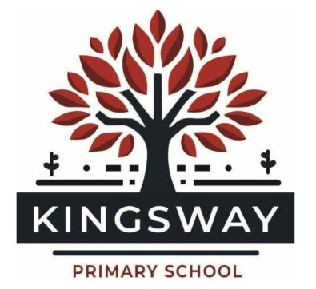
Kingsway Park, Davyhulme, Manchester, M41 0SP
Telephone: 0161 748 1867
Headteacher: Miss Kate Baskeyfield
Inspired to Make a Difference Together

Information about our school for applicants
Dear Colleague,
Thank you for expressing an interest in a vacancy at our school – we are delighted you are considering joining our school family. I hope you find all the information you need within the application pack but if not, and you have questions, please get in touch and we’ll be more than happy to help.
Our other on-line documents to support with recruitment are an application form, a job description and person specification. You can also find further information on our website, which includes our most recent Ofsted Report, from 2023:
https://www.kingswayprimary.co.uk/
Safeguarding
Safeguarding is of upmost importance at Kingsway. Our commitment to safeguarding is evident in all elements of our practice and provision and is central to our recruitment processes, which exceed the requirements outlined in Keeping Children Safe in Education including:
- At least one member of the panel trained in Safer Recruitment – usually the whole panel are;
- Sharing our Safeguarding policy with you in our application pack;
- The interview process will assess your suitability to work with children and ensure you have the right knowledge, skills, attitudes and behaviours to meet the high standards we expect for safeguarding;
- Any offers of employment are subject to satisfactory completion of all required vetting checks;
- Safeguarding and Child Protection are an integral part of our induction process for all new staff.

About Our School
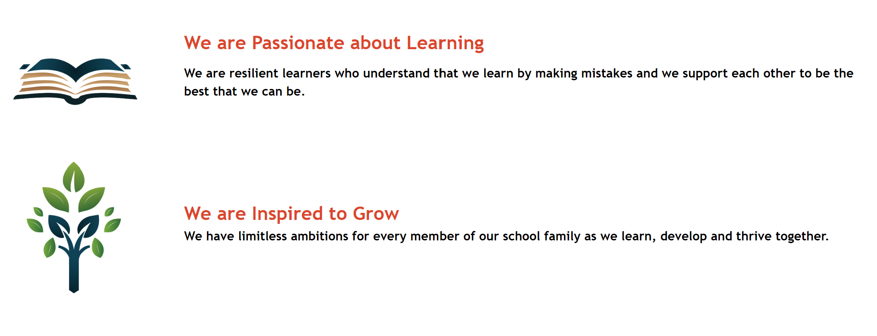
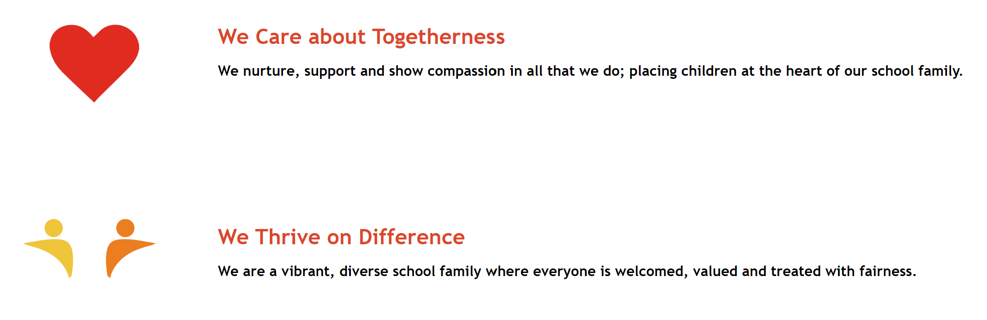
Our school values are:

These are incredibly important to us and shape our provision for all pupils, staff and the wider community. We are proud of our relational approach which underpins the ‘Kingsway Way’. Visitors to our school comment on the warm, welcoming environment and nurturing relationships. Our commitment to wellbeing, equity and inclusion is strong and can be seen through our actions at all levels across school.
Kingsway Primary School serves a diverse and vibrant community. We are a small, one-form entry, urban primary school which prides itself on knowing every single child in our school family extremely well. We form strong, effective relationships with all of our children and their families and that is what makes us special.
Ofsted inspected our school in March 2023 and we received a grading of “Good”. We are very proud of this achievement whilst recognising the ongoing school improvement journey still ahead of us. We look forward to welcoming new staff to our team, as we continue our journey of school improvement.
Currently we have 194 pupils on roll – which includes a nursery and a class for each year group from reception to year 6. In January 2026, our school welcomed an additional 20 pupils as part of two small specialist classes for children with complex learning needs. We are actively inclusive – for pupils and staff – and are committed to continually improving our offer for equality, inclusion and diversity.

We have an incredibly supportive and effective governing body and an inclusive, warm and welcoming team of staff – from our teachers and TAs through to admin, premises, cleaning and lunch time staff. Staff tell us that they feel able to ask for help when needed and value working as part of our school family. We are all very proud to work here and committed to our children and community. The job can be challenging at times but we care deeply and support each other. Our children are the highlight of our school and there is something very special about each and every one of them. Similarly, our parents, carers and wider community are respectful and positive about Kingsway Primary School.
Our site
Whilst we are an urban school, we have excellent outdoor space that we are proud of – this includes on site woodland, outdoor learning provision, a large playing field, a multi-use astro-turf games area and two playgrounds in addition to a well-resourced EYFS outdoor area. We also work hard to offer excellent facilities within the school building and are especially excited to have opened a fantastic new library recently.
How we support positive wellbeing for all staff
At Kingsway Primary School, staff well-being is a priority, with a strong focus on open communication and a collaborative team approach to ensure all staff feel valued and supported. Regular opportunities through an open-door policy for staff to share ideas, and contribute to decision-making foster a positive and inclusive working environment.
Well-being is actively considered in policy development and decision making regarding school organisation, ensuring that initiatives and expectations are realistic and supportive rather than adding unnecessary pressure. Other well-being initiatives include access to professional development that supports career growth, a commitment to reducing unnecessary administrative burdens and social events to strengthen team morale.
By embedding a culture of care, collaboration, and respect, Kingsway Primary School ensures that staff well-being is not just a consideration but a fundamental part of school life.
The future of Kingsway Primary School
At Kingsway Primary School, we are committed to providing the very best education and opportunities for our pupils and staff. In September 2025, to strengthen our vision and continue to drive excellence, we joined the Inspiring Learners Multi-Academy Trust. This partnership provides access to a wealth of expertise across multiple schools, fostering a culture of collaboration and innovation. Our staff benefit from shared best practices, high-quality joint CPD and training opportunities, and collaborative curriculum development, ensuring continued professional growth. Through cross-school initiatives, we expand opportunities for pupils to engage in enriching projects and extracurricular activities. Additionally, being part of a multi-academy trust enhances financial sustainability, allowing us to leverage bulk purchasing power, streamline centralised support services, and improve financial resilience. This means better resource allocation, ensuring continued investment in high-priority areas such as digital infrastructure and learning resources. We are excited about this new chapter and the many benefits it will bring to our school community.
If you are excited by this post and by the opportunity to work in a truly wonderful school, then I look forward to receiving your completed application.

Yours sincerely,

Miss Kate Baskeyfield
Headteacher

