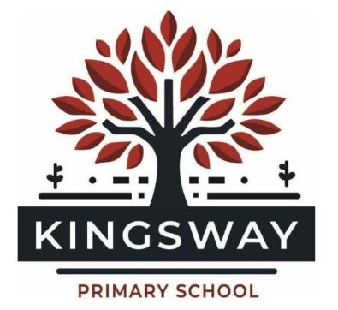
Kingsway Park, Davyhulme, Manchester, M41 0SP
Telephone: 0161 748 1867
Headteacher: Miss Kate Baskeyfield
Inspired to Make a Difference Together

JOB DESCRIPTION – CLASS TEACHER
Location: Kingsway Primary School
Salary: MPS
Contract Type: Full-time, Permanent
Start Date: September 2026
Purpose of the Post
We are seeking a passionate and dedicated class teacher to join our team on our school development journey. The successful candidate will be committed to high standards of teaching and learning, ensuring that every child reaches their full potential. As a values-driven school, we expect our teachers to foster positive relationships with pupils, staff, and the wider school community, while actively contributing to the continued development of Kingsway Primary School. This role includes the responsibility to:
- Plan, implement and deliver and appropriate and adapted curriculum to meet the needs of all children within the class whilst maintaining high expectations for all.
- Contribute to raising standards of pupil attainment.
- Promote the progress and well-being of every child assigned to them.
- Undertake the professional duties and responsibilities of a teacher as set out in the current School teachers’ Pay and Conditions document.
- Fully uphold the DfE Teacher Standards.
Core Responsibilities
Teaching and Learning
- Deliver high-quality, engaging lessons that inspire and challenge all learners, ensuring progress for every child.
- Implement quality-first teaching strategies, adapting lessons to meet the individual needs of pupils, including those with SEND and EAL.
- Maintain high expectations for learning, behaviour, and engagement, fostering a positive and inclusive classroom environment.
- Use a relational approach to support pupils’ social and emotional development, promoting positive behaviour management strategies in line with school policies.
- Plan and deliver a book-led curriculum that is broad, balanced, and promotes a love of learning.
- Ensure the effective deployment of any staff supporting the teaching and learning within the classroom.
Assessment and Pupil Progress
- Use formative and summative assessment effectively to monitor pupil progress and inform next steps in teaching.
- Provide regular, high-quality feedback to pupils to support their learning and development.
- Participate in pupil progress meetings, working collaboratively with leaders and colleagues to ensure strong outcomes for all children.
Collaboration and Professional Development
- Work as part of a team, contributing to a culture of mutual support, respect, and shared learning.
- Engage in professional development opportunities, including coaching, mentoring, and whole-school training to enhance teaching practice.
- Contribute to curriculum development and school improvement initiatives as part of the wider school team.
- responsibility for subject coordination, aligned with the experience of the successful candidate and the school’s improvement priorities.
- Communicate effectively with parents and carers to support children’s learning and well-being.
- Actively participate in the whole-school appraisal process for the evaluation of their own performance.
School Ethos and Wider Responsibilities
- Uphold and promote the school’s values, vision, and policies, modelling a positive attitude at all times.
- Take an active role in whole-school events, extra-curricular activities, and community engagement initiatives.
- Support the school’s commitment to safeguarding, ensuring the welfare of all children is a priority.
- Work in partnership with colleagues to support the ongoing development of the school, contributing ideas and taking responsibility for specific subject areas or initiatives where appropriate.

