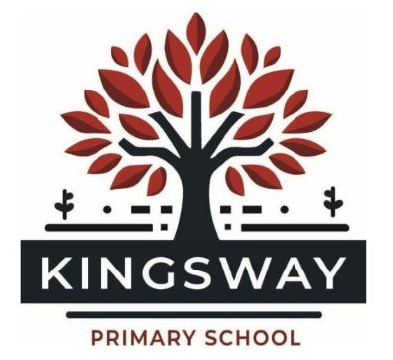
Kingsway Park, Davyhulme, Manchester, M41 0SP
Telephone: 0161 748 1867
Headteacher: Miss Kate Baskeyfield
Inspired to Make a Difference Together

PERSON SPECIFICATION – CLASS TEACHER
Criteria |  | Essential | Desirable
Training, Qualifications & Experience
Qualified Teacher Status (QTS) |  | ✅
Degree or equivalent qualification |  | ✅
Successful experience of teaching in a primary setting |  | ✅
Experience of working with children with diverse learning needs, including SEND and EAL |  | ✅
Knowledge of the National Curriculum and statutory requirements for primary education |  | ✅
Training in or experience of the Little Wandle synthetic phonics programme |  |  | ✅
Experience of working in a relational school setting |  |  | ✅
Knowledge & Understanding
Strong understanding of effective adaptive teaching to meet the needs of all learners |  | ✅
Understanding of safeguarding procedures and commitment to promoting the welfare of children |  | ✅
Knowledge of how to create an inclusive and equitable classroom environment |  | ✅
Familiarity with current research and best practices in quality first teaching |  | ✅
Understanding of how to use pupil data to inform planning and teaching |  | ✅
Awareness of strategies to support children’s social, emotional, and mental health |  | ✅
Teaching & Learning
Demonstrates high expectations for all learners and a commitment to securing strong outcomes |  | ✅
Ability to deliver engaging, well-structured, adaptive and aspirational lessons |  | ✅
Uses a relational approach to manage behaviour positively |  | ✅
Ability to use ICT effectively to support learning and reduce workload |  | ✅
Experience of or willingness to lead an extra-curricular activity |  |  | ✅
Assessment for Learning
Uses a range of assessment strategies to monitor progress and inform teaching |  | ✅
Provides high-quality verbal and written feedback to pupils to support their development |  | ✅
Works collaboratively with colleagues to analyse assessment data and plan interventions |  | ✅
Relationships with Parents & the Wider Community
Builds positive and effective relationships with parents/carers |  | ✅
Communicates effectively with families about children's progress and well-being |  | ✅
Willingness to engage in school events, trips, and community activities |  | ✅
Experience of working in partnership with external agencies to support pupil needs |  |  | ✅
Relationships with Colleagues
Works collaboratively as part of a team, valuing and respecting colleagues |  | ✅
Open to feedback and willing to engage in professional dialogue to improve practice |  | ✅
Supports whole-school development and contributes positively to staff culture |  | ✅
Developing Skills as a Subject Leader
Willingness to take on subject leadership responsibilities |  | ✅
Ability to inspire and support colleagues in developing curriculum areas |  | ✅
Awareness of strategies for leading and evaluating curriculum development |  | ✅
Personal Qualities
A committed and dedicated professional with a strong work ethic |  | ✅
Enthusiastic, reflective, and keen to develop professionally |  | ✅
Committed to inclusion and equity, ensuring all pupils have opportunities to succeed |  | ✅
A team player who is willing to contribute to the wider life of the school |  | ✅
Strong interpersonal skills with a warm and approachable manner |  | ✅
Resilient, adaptable, and able to manage challenges with a positive attitude |  | ✅
A good sense of humour and a willingness to enjoy being part of a supportive team |  | ✅

