Job Description and Person Specification Profile

Job Title | Assistant Director of Public Health
Job ID | SL22
Service | Public Health
Grade | SMT 1 (£95,162)
Accountability | Professionally accountable to Tameside MBC and managerially accountable to the council via the Director of Public Health as the line manager

The Role
The Assistant Director of Public Health is a vital role in supporting the council to deliver its core public health functions, as well as driving the wider public health agenda corporately to achieve the necessary transformation and improvement to better support the health & wellbeing needs of residents. This role will work closely with the Director of Public Health and with other senior leaders in the council and wider system, as a visible system leader to deliver excellent services as well as develop new ways of working to support residents to live healthy, happy lives in Tameside.

This role will lead and manage public health services and policy to deliver against the Tameside Corporate Plan and the Joint Health & Wellbeing Strategy for the borough, working across a range of priorities and in partnership with other stakeholders and service providers.

The Assistant Director of Public Health will play a key leadership role as part of the council’s Senior Leadership Team to deliver on the ambitions of the organisation, both within the Public Health team but also corporately across the organisation and wider partnerships. This will include having an active role in the transformation and improvement priorities of the borough, including development and delivery of a new neighbourhood model.

A key aspect of this role will be to provide day-to-day leadership of the council’s Public Health team and support the Director of Public Health in effectively managing and delivering the resources of the team. The role will also provide technical/specialist public health leadership and guidance to politicians, other officers in the council and wider stakeholders.

In delivering the key responsibilities and duties described below, the postholder is expected to demonstrate a high level of expertise in the Faculty of Public Health Competencies (Appendix 1).

There will also be opportunities and requirements for this role to deputise for the Director of Public Health as required.

PRINCIPLE RESPONSIBILITIES:
- Strategic Leadership: To take the lead for annually agreed priorities across the Public Health team, and other relevant corporate priorities aligned to the Tameside Corporate Plan; to support and deputise for the Director of Public Health as needed; to work collaboratively with partners in the NHS including at a Greater Manchester and Tameside level, as well as across primary and secondary care. The post holder will be responsible for day-to-day leadership within the Public Health team including in-house and commissioned services, alongside the Director of Public Health and the Consultants in Public Health. This post will play a leadership role in the Health and Wellbeing Board, the Tameside Strategic Partnership Committee (aka. locality board), and other relevant strategic forums and partnerships as required. The post holder will also have a key leadership role relating to the development of the emerging neighbourhoods approach in the council and implementation of the Live Well programme. Additional responsibilities will be agreed with the post holder and reviewed annually.
- Senior Leadership Team Membership: To be an active member of both the corporate Senior Leadership Team and the Public Health Management Team and work effectively with other members of the team to achieve synergy and integrated working.
- Advice and Support: To advise elected members (particularly Executive Members), the Chief Executive and the Senior Leadership Team; and also advise the Health and Wellbeing Board and Tameside Strategic Partnership Committee (aka. locality board) on matters within the scope of this role. This will also include providing advice and support to NHS partners.
- Regional Working: To contribute to the delivery of regional and sub-regional programmes and projects across the Greater Manchester (GM) City Region, including the future model of the NHS Greater Manchester Integrated Care Board, Greater Manchester Combined Authority (GMCA) and the Greater Manchester Public Health Leadership Network. There may also be requirement to liaise with other regional agencies such as OHID and UKHSA.
- Partnerships: To work effectively with internal and external partners, acting as a change agent, leading and contributing to programmes and projects across relevant strategic partnerships in Tameside. Key areas for this partnership will include topic based forums such as domestic abuse; substance misuse; intelligence, as well as wider partnership work with NHS colleagues and the voluntary, community, faith and social enterprise (VCFSE) sector.
- Stakeholders: To develop and strengthen effective communication, engagement and working relationships with key stakeholders to deliver against public health priorities, reduce health inequalities, and deliver on wider corporate ambitions including the Tameside Corporate Plan.
- Probity and Standards: To contribute to supporting the council, NHS and wider partners to meet statutory and non-statutory provisions to the highest possible standard in all relevant inspection frameworks.
- Resources: To secure and allocate resources to deliver public health outcomes, working at both a strategic level as well as ensuring the effective delivery of public health services. The role will lead on business management within the team including managing the budget, supporting the Director of Public Health.
MAIN DUTIES
- To work with the Director of Public Health and as a member of the Public Health Management Team to deliver against the Tameside Corporate Plan and the Joint Health & Wellbeing Strategy for the borough.
- Be jointly accountable (alongside other members of the Public Health Management Team) for further developing the Joint Strategic Needs Assessment (JSNA), ensuring an evidence-based approach to service re-design and commissioning as well as policy development.
- Provide public health leadership and support to the wider Senior Leadership Team within the council, and local NHS partners. This will include delivery of the Tameside Corporate Plan and associated transformation and improvement work, including a focus on the neighbourhood and Live Well model for residents.
- Have a lead role at the Tameside Health and Wellbeing Board and other partnerships as needed, alongside the Director of Public Health.
- Day-to-day leadership of the Public Health team including ensuring delivery against agreed priorities to improve health & wellbeing outcomes and tackle inequalities. This will include the effective management of in-house service provision (health improvement) and commissioned Public Health services across Tameside.
- Provide expert public health advice and leadership to ensure evidence-based approaches are used when developing high quality equitable service provision, across health, social care and voluntary sectors and, where appropriate, the private sector.
- Lead the collation, interpretation and reporting of relevant public health data, including embedding the principles of evaluation in all commissioned and delivered services.
- Advocate for approaches to tackle health inequalities and improve the health & wellbeing outcomes of residents in Tameside.
- Ensure that relevant local experience and expertise supports or drives national developments and vice versa.
- Support the Director of Public Health and Consultant in Public Health on work to protect local communities from infectious disease and environmental hazard threats, including work with UKHSA and other partners as required.
- Management of public health staff and responsibility for recruitment, supervision, appraisals, disciplinary and grievance procedures as appropriate. This will include actively contributing to the specialty public health training programme and supervising registrars in training.
- Day-to-day management of the Public Health budget, including financial resources allocated to commissioned services, staffing, and other programmes across the council.
- Take part in local on call arrangements as Strategic Commander (‘GOLD’) on call, as part of the corporate rota with other Assistant Directors and Directors across the organisation.
- Pursue a programme of CPD, in accordance with Faculty of Public Health requirements, or other recognised body, and undertake annual appraisal, revalidation or other measures required to remain on the GMC/GDC Specialist Register with a license to practice or the UK Public Health (Specialist) Register or other specialist register as appropriate.

- Undertake any additional duties commensurate with the grade of the post including deputising for the Director of Public Health as required.

The duties may vary from time to time without changing the nature of the post or the level of responsibility, and the post holder may also be required to carry out any other duties appropriate to the grading of the post.

About You
Your essential qualifications

- Inclusion in the GMC Full and Specialist Register with a license to practice/GDC Specialist List or inclusion in the UK Public Health Register (UKPHR) for Public Health Specialists at the point of application.
- If included in the GMC Specialist Register/GDC Specialist List in a specialty other than public health medicine/dental public health, candidates must have equivalent training and/or appropriate experience of public health practice.
- Any public health speciality registrar applicants who are currently on the UK public health training programme and not yet on either the GMC, GDC or UKPHR specialist register must provide verifiable signed documentary evidence that they are within 6 months of gaining entry to a register at the date of interview.
- Applicants going through the portfolio registration routes (GMC or UKPHR) are not eligible to be shortlisted for interview until they are included on the register. The six-month rule does not apply to these portfolio route applicants.
- If an applicant is UK trained in Public Health, they must ALSO be a holder of a Certificate of Completion of Training (CCT) or be within six months of award of CCT by date of interview. If an applicant is non-UK trained, they will be required to show evidence of equivalence to the UK CCT.
- Applicants must meet minimum CPD requirements (i.e. be up to date) in accordance with Faculty of Public Health requirements or other recognised body.
- MFPH by examination, by exemption or by assessment, or equivalent.

Your essential skills, knowledge and experience

- Experience of developing service practices and ensuring appropriate application.
- Experience in driving and assisting in the management of change in a variety of settings, proactively seeking opportunities to create and implement improved service effectiveness.
- Experience of people management including effective performance management of staff and understanding of policies related to pay, capability, disciplinary matters and grievances.
- Experience of successful resource and financial management, including evidence of the resolution of conflicting priorities and setting budgets.
- Experience of managing and successfully delivering projects and programmes within political, corporate, policy and financial constraints.
- Excellent communication and interpersonal skills and the ability to apply these to a variety of audiences and develop effective relationships.
- Ability to use persuading, negotiating and influencing skills to bring about behavioural change and achieve desired results/outcomes as necessary.
- Ability to prioritise and use initiative to reach sound judgements after careful and systematic evaluation of relevant facts, information and data.
- Ability to be creative and think strategically to solve issues and problems.
- A clear understanding and knowledge of the workings of the NHS and local government including their legal, financial, social and political context, political processes and the current issues faced in a multi-cultural area.
- Detailed knowledge of methods of developing clinical quality assurance, quality improvement and evidence based clinical and/or public health practice.
- Knowledge and understanding of epidemiology and statistics, public health practice, health promotion, health economics and health care evaluation.
- Knowledge of project management tools and techniques.
- Full understanding of and commitment to delivery of improved health through mainstream NHS activities
- Full understanding and commitment to addressing relationships and cultures of organisations that impact on the wider determinants of health.
If you have the following experience or qualifications – then that’s great!

- Masters in Public Health or equivalent
- Media experience demonstrating delivery of effective health behaviour or health promotion messages

Our employees’ skills, experience and knowledge are essential to our success along with their happiness, commitment, enthusiasm and motivation to be the best they can be.

What can you expect from us?
- A fair salary and benefits
- Opportunities for good health and wellbeing
- Help you to grow, develop and to do your best
- Enable you to be creative and innovative
- Fully involve you in changes that affect you and your work
- Listen, and act on your ideas and feedback
Working together, we are proud to work for Tameside

Our STRIVE values underpin our practice and behaviours and are at the heart of everything that we do:
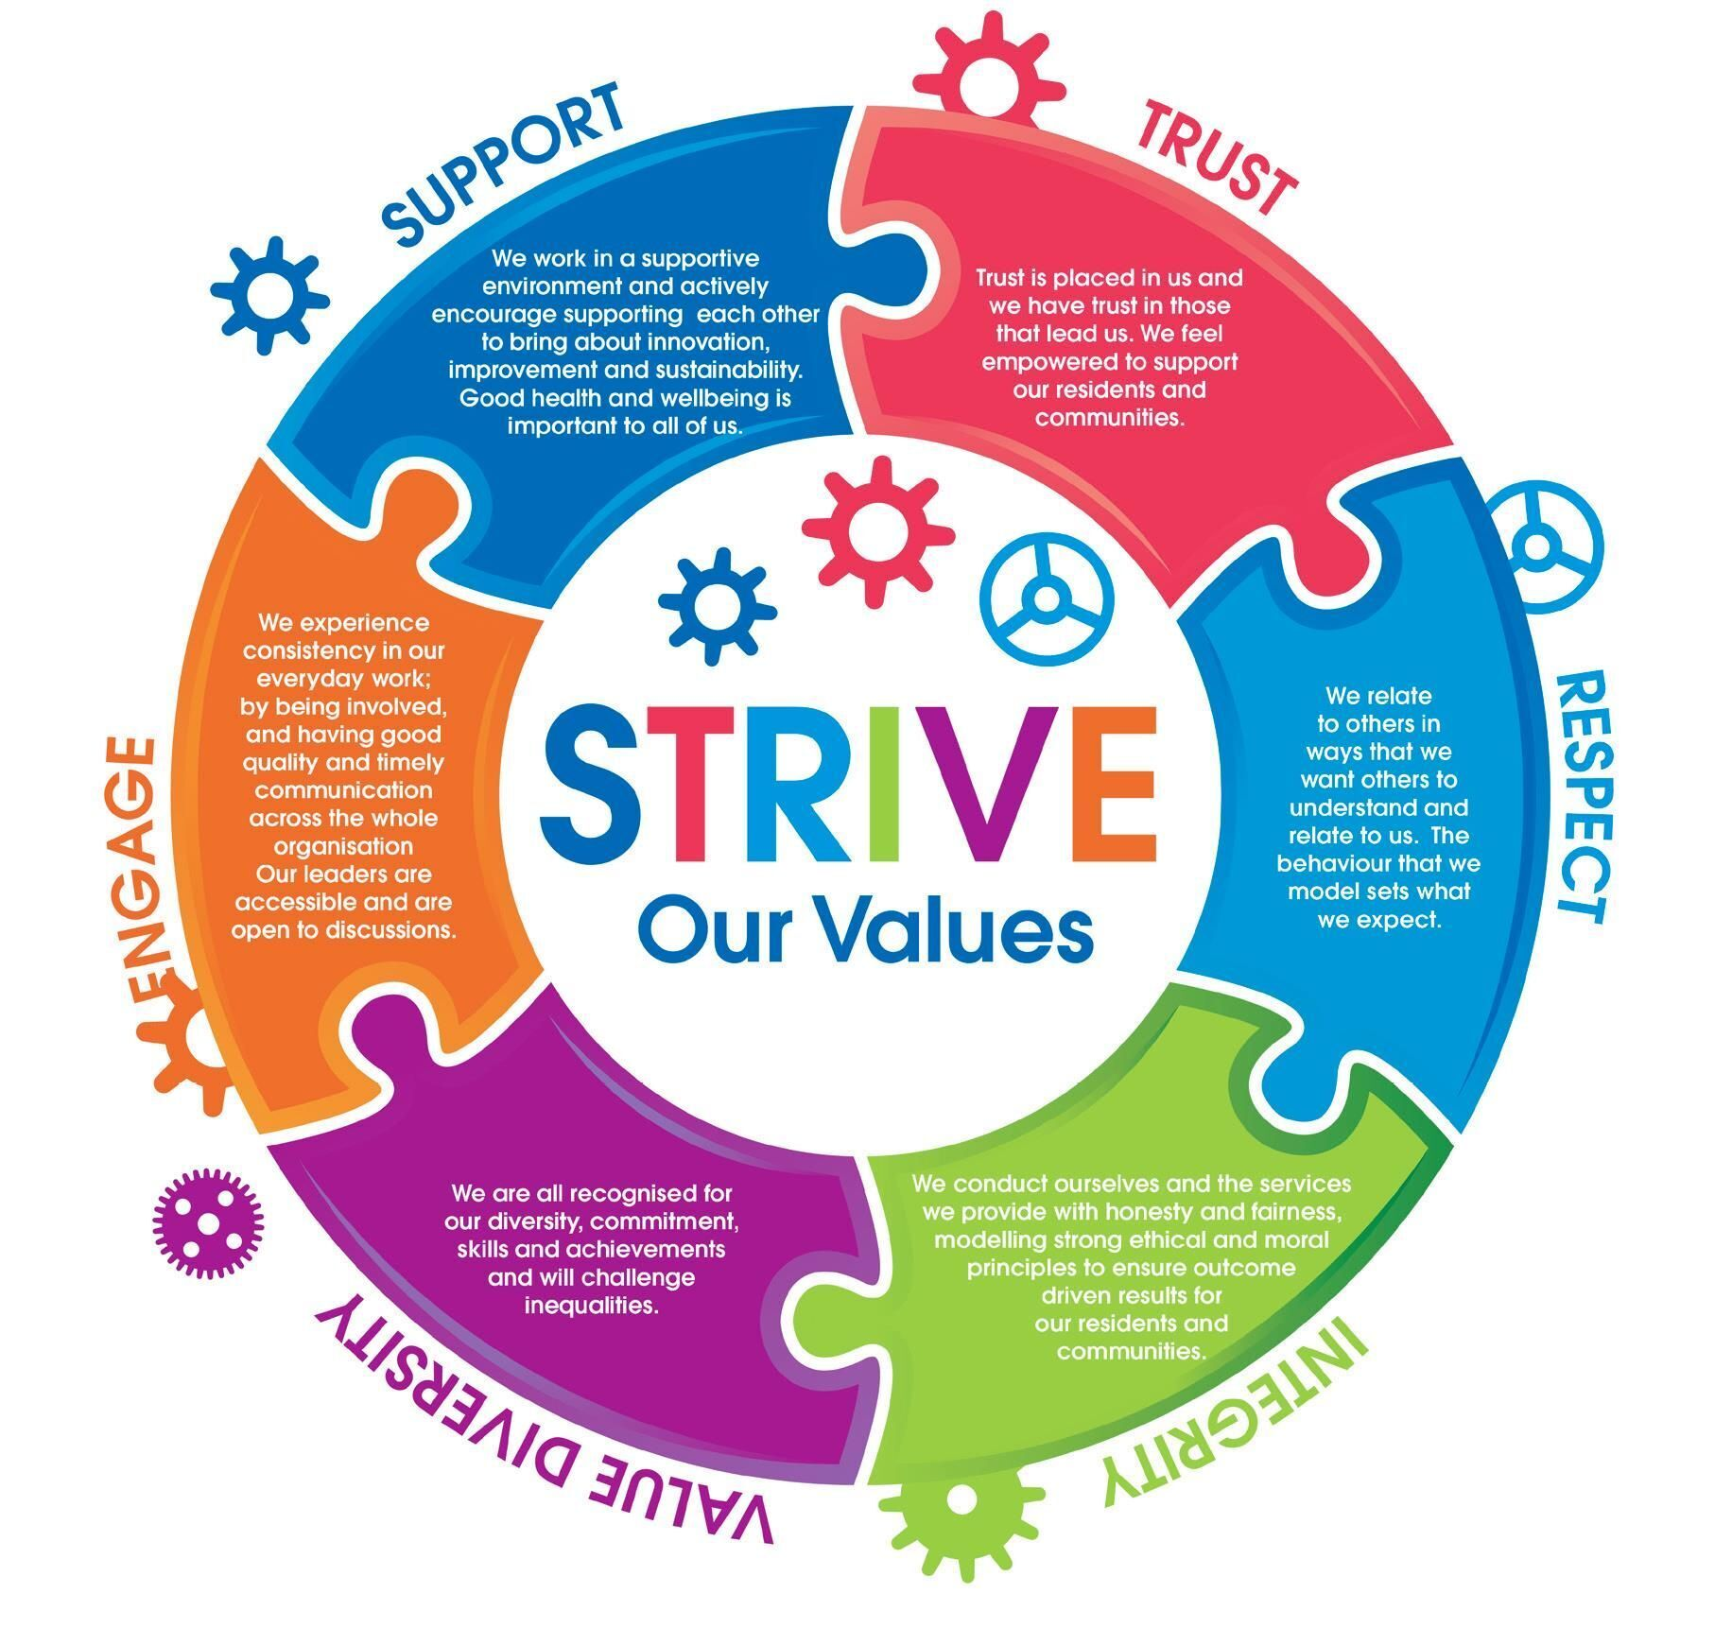
Appendix 1
CORE COMPETENCY AREAS
- Use of public health intelligence to survey and assess a population’s health and wellbeing
To be able to synthesise data from multiple sources on the surveillance or assessment of a population’s health and wellbeing and on the wider environment, so that the evidence can be communicated clearly and inform action planning to improve population health outcomes.
- Assessing the evidence of effectiveness of interventions, programmes and services intended to improve the health or wellbeing of individuals or populations
To be able to use a range of resources to generate and communicate appropriately evidenced and informed recommendations for improving population health across operational and strategic health and care settings.
- Policy and strategy development and implementation
To be able to influence and contribute to the development of policy and lead the development and implementation of a strategy.
- Strategic leadership and collaborative working for health
To use a range of effective strategic leadership, organisational and management skills, in a variety of complex public health situations and contexts, dealing effectively with uncertainty and the unexpected to achieve public health goals.
- Health Improvement, Determinants of Health, and Health Communication
To influence and act on the broad determinants, behaviours and environmental factors influencing health at a system, community and individual level to improve and promote the health of current and future generations. To be proactive in addressing health inequalities and prioritising the most vulnerable or disadvantaged groups in the population.
- Health Protection
To identify, assess and communicate risks associated with hazards relevant to health protection, and to lead and co-ordinate the appropriate public health response. To understand how those risks associated with hazards relevant to health protection may be influenced by climate change and environmental degradation currently and in the future.
- Health and Care Public Health
To be able to improve the efficiency, effectiveness, safety, reliability, responsiveness, sustainability and equity of health and care services through applying insights from multiple sources including formal research, health surveillance, needs analysis, service monitoring and evaluation.
- Academic Public Health
To add an academic perspective to all public health work undertaken. Specifically to be able to critically appraise evidence to inform policy and practice, identify evidence gaps with strategies to address these gaps, undertake research activities of a standard that is publishable in peer reviewed journals, and demonstrate competence in teaching and learning across all areas of public health practice.

- Professional, personal and ethical development
To be able to shape, pursue actively and evaluate your own personal and professional development, using insight into your own behaviours and attitudes and their impact to modify behaviour and to practise within the framework of the GMC's Good Medical Practice (as used for appraisal and revalidation for consultants in public health) and the UKPHR’s Code of Conduct.
- Integration and application for consultant practice
To be able to demonstrate the consistent use of sound judgment to select from a range of advanced public health expertise and skills, and to use them effectively, working at senior organisational levels, to deliver improved population health in complex and unpredictable environments.
The Assistant Director of Public Health, as a public health leader is expected to have both the technical expertise as well as the ability to use those techniques to both, lead and support the development of complex solutions to improve the health and wellbeing of local communities. In addition, they are expected to have skills and the attitudes to be able to present the results of applying their technical expertise so that they are understandable and stimulate actions by a range of individuals and organisations.

