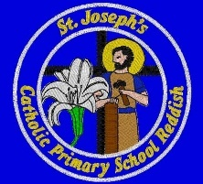
St. Joseph’s Catholic Primary School Reddish

Teaching Assistant (TA1)

Job Description
Post Title: Teaching Assistant (Level A) Grade: Scale 1

Directorate: Children & Young People Service: Schools

Responsible to: Headteacher /Phase Leader/Class Teacher/School Business Manager

Responsible for: No responsibility for staff
Main purpose of the job:
To provide support to teaching staff throughout the school, in an appropriate learning environment

Key Responsibilities
- To provide support to teaching staff throughout the school, in an appropriate learning environment
- Assisting with the integration of pupils with special educational needs
- Supporting children within a small group or on an individual basis within the classroom or on a withdrawal basis
- To be an integral part of the school, working in close partnership with all staff

General duties

1. To assist in the planning, recording and implementation of individual education plans.

2. To assist in the delivery of intervention, support or integration programmes as required.

3. To prepare, care for and store resources

4. Assisting with supervision during break, lunchtime and educational visits

5. Attending to sick children including changing soiled clothing and maintaining hygiene standards

6. To provide support for children with physical needs e.g. assisting with moving around the classroom and school, assistance with feeding, assistance with changing for PE, assisting with safe use of classroom equipment
Signed by:

Post holder:

Line manager: Date:

Job Assessor (If required)

