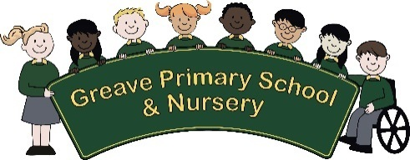
Job Description

Job Title: Midday Assistant
Salary Grade: Scale 1 Point 3

Post Reports to: Midday Supervisor

Main Purpose of the Job:

To be responsible to the Headteacher, or the Mid-Day Supervisor under the overall authority of the Headteacher, for the supervision of pupils during the lunch break.

SUMMARY OF RESPONSIBILITIES AND PERSONAL DUTIES:

Major Duties and Responsibilities:

- Supervision of children during the school lunch break

- Ensuring that hygiene standards are maintained

- Ensuring that safety standards are maintained

4. To be an integral part of the school working in close partnership with all staff

Job Activities:

- Supervision of Children in the school setting – Classroom/lunch hall and playground/school field
- Escorting children to dining area

- Encouragement of the very young children to consume their food

- To assist in the development of good table manners

- Supervision of children in playground, cloakroom, toilets etc.

- Supervise hand washing

- Cleaning up spillages, ensuring tables are clean

- Ensure that the flow of children in the immediate vicinity of the dining area is made in an orderly fashion

- To deal with minor first aid and sickness etc

This Council is committed to safeguarding and promoting the welfare of children and young people and expects all staff within this area to share this commitment and to have understanding of the common core skills and knowledge.

To work positively and inclusively with colleagues and customers so that the Council provides a workplace and delivers services that do not discriminate against people on the ground of their age, sexuality, religion or belief, race, gender or disabilities.

To fulfil personal requirements, where appropriate, with regard to Council policies and procedures, health, safety and welfare, customer care, emergency, evacuation, security and promotion of the Council’s priorities.
To work flexibly in the interests of the service. This may include undertaking other duties provided that these are appropriate to the employee’s background, skills and abilities. Where this occurs there will be consultation with the employee and any necessary personal development will be taken into account.

