At St. John’s C.E Primary School we are committed to safeguarding and promoting the welfare of children and young people and expect all staff and volunteers to share this commitment. Shortlisted candidates will be expected to complete a Disqualification Declaration. The successful applicant's appointment will be subject to satisfactory pre-clearance including a Disclosure and Barring Service.

St. John’s C.E Primary School
Headteacher Recruitment Information

This document contains:

- Letter from the Chair of Governors

- Advertisement

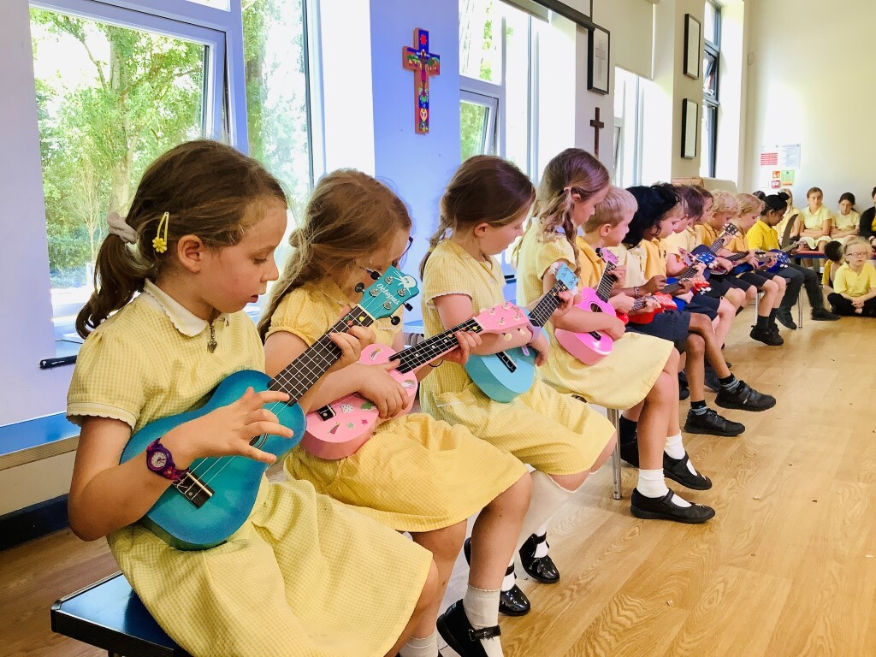

Letter from the Chair of Governors

Dear Prospective Applicant,
As Chair of Governors at St John’s Church of England Primary School in Heaton Mersey, Stockport, I am pleased to invite applications for the role of Headteacher at our thriving and welcoming school. This is a wonderful opportunity for an ambitious and compassionate leader to join a community that takes great pride in nurturing confident and curious learners.
St John’s is a one form entry Church of England school with a warm, inclusive and nurturing ethos. Our Christian values are woven through daily life, and “Love thy neighbour” is an overarching theme that guides the way our children learn, interact and grow. We are proud that our school encourages every child to flourish academically, socially and emotionally.
The school consistently achieves strong academic outcomes, with results in KS1 and KS2 regularly exceeding national and local averages in reading, writing and maths. Most recently, we successfully navigated an Ofsted inspection under the new framework, reflecting our commitment to excellence and our ability to adapt while keeping pupils’ wellbeing and character development firmly in focus.
Music is a particular strength at St John’s, with many of our children taking advantage of high quality music provision, learning instruments and participating in choirs and performances. This passion for music enriches school life and supports confidence, creativity and joy.
St John’s also benefits from a dedicated and active PTA who raise valuable funds and contribute to the wider life of the school. Our community feel is further strengthened by parents and grandparents who volunteer their time to support learning, events and enrichment activities. This strong partnership between families, staff, governors and church is central to who we are.
We are seeking a Headteacher who shares our values, places children at the centre of their decision making, and will lead our dedicated staff with authenticity, ambition and compassion. If you believe you can help build on our strong foundations and shape the next chapter of our school’s story, we would be delighted to hear from you.

Shahid Hussain
Chair of Governors

Advertisement

Position: Headteacher
Required for: September 2026
Salary Range: £70,293 to £80,634

At St. John’s C.E Primary School we are committed to safeguarding and promoting the welfare of children and young people and expect all staff and volunteers to share this commitment. Shortlisted candidates will be expected to complete a Disqualification Declaration. The successful applicant's appointment will be subject to satisfactory pre-clearance including a Disclosure and Barring Service.

As a Church of England primary school, we hold Christian values at the heart of everything we do. Every child is precious and each one has a unique role to play in our inclusive, family school. The warm, nurturing atmosphere in school has been commented on by many visitors and it is why so many families have chosen our school for their children. We strive to develop a sense of community which helps all pupils to develop confidence in themselves and their ability to serve and succeed.

We are looking for a leader who will:

- Inspire and motivate through innovative leadership
- Develop children’s learning with passion and commitment
- Have high expectations of all children and staff
- Embrace opportunities to develop our distinctive provision
- Provide high quality strategic thinking and planning
- Understand our local community and work to develop positive relationships within it

We can offer:

- Children with a passion for learning and upholding Christian values
- Hardworking and dedicated staff working as a mutually-supportive team
- A stimulating learning environment
- A rich and creative curriculum
- A strong and active PTA with a supportive family community
- Governors committed to continuous improvement
- Strong local partnerships with other schools and a supportive Local Authority

Don’t just take our word for it, come and see for yourself. Please email the School Business Manager Mrs Michelle Garner at michelle.garner@st-johns.stockport.sch.uk to book your tour of the school. Applications must be completed on the application form provided using Microsoft Word only please, and submitted electronically to hrschools@stockport.gov.uk

Closing Date: Friday 6th February 2026 at 9am
Shortlisting: Tuesday 10th February 2026
Interviews: Tuesday 24th and Wednesday 25th February 2026

