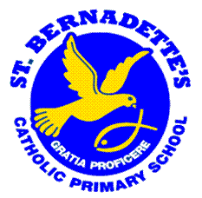
A S P I R E
St. Bernadette’s Catholic Primary School
Person Specification

 | Essential | Desirable
Qualifications | Qualified Teacher status | Evidence of continuous INSET and commitment to further professional development as a qualified teacher or student.  CCRS or the willingness to complete is desirable.
Experience | The Class Teacher should have recent experience of teaching primary aged children.  Proven record of successful teaching and learning in their current and previous teaching positions.
Knowledge and understanding | The Class Teacher should have knowledge and understanding of:  the theory and practice of providing effectively for the individual needs of all children (e.g. classroom organisation and learning strategies);  statutory National Curriculum requirements at the appropriate key stage  the monitoring, assessment, recording and reporting of pupils’ progress;  the statutory requirements of legislation concerning Safeguarding, Equal Opportunities,  Health & Safety, SEND and Child Protection; | In addition, the class teacher might also have knowledge and understanding of: the preparation and administration of statutory National Curriculum assessments;  the EYFS framework
Skills | The Class Teacher will be able to:  promote the school’s aims positively  develop good personal relationships within a team;  establish and develop good relationships with parents, governors and the community;  communicate effectively (both orally and in writing) to a variety of audiences;  create a happy, challenging and effective learning environment. | In addition, the Class Teacher might also be able to:  develop strategies for creating community or Parish links.
Personal characteristics | Willing to uphold the Catholic values and mission of the school:  Dynamic  Committed  Enthusiastic  Well-organised  Able to motivate self and others  Creative

