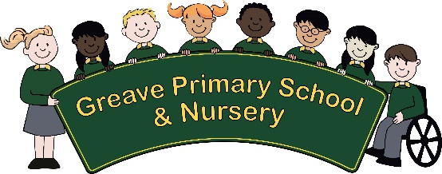
Job Description

Job Title: Cleaner
Department: Support Staff
Directorate: Schools

Salary Grade: Scale 2

Post Reports to: Cleaning Supervisor

Main Purpose of the Job: To undertake the cleaning of an Educational Establishment,
maintaining a high standard of cleanliness and work within health and safety regulations.

SUMMARY OF RESPONSIBILITIES AND PERSONAL DUTIES:

KEY AREAS

- Cleaning of designated areas as dictated by the school to ensure that they are kept in a hygienic condition.

- Emptying of waste bins or similar receptacles daily, and transport of waste material to designated collection points.

- Replenishment of consumable items including soap, toilet rolls and paper towels, where required.

- Be able to manage time in relation to workload in designated areas.

- To pass on information to the site manager relating to stocks and supplies to enable timely replenishment

- Maintain a clean and safe environment and to be aware of infection control procedures.

- Operation of powered equipment including cleaning and domestic type laundry equipment. Ensure equipment & machinery is used in line with health and safety guidelines and report any defects.

- Provide cleaning needs during the school holidays, assisting the site manager with deep cleans.

- Provide support to staff as requested and in accordance with their own training and skill parameters.

- Undertake any additional duties as reasonably requested by senior leaders.

All duties must be carried out to comply with:

- School’s relevant policies and procedures, including but not limited to: School Safeguarding Policy, Health and Safety Policy, Data Protection Policy, COSHH Assessments, School Risk Assessments

- The Health & Safety at Work Act.

- Acts of Parliament, Statutory Instruments and Regulation and other legal requirements.

- Nationally agreed Codes of Practice which are relevant.

All duties will be carried out in the working conditions normally inherent in the job.
All necessary paperwork must be completed.

Duties will be carried out for jobs up to and including those in the same grade, provided such duties are within the competence of the employee. To be responsible for your own health and safety and that of other employees.

Confidentiality
To adhere to the Service’s Policies and Procedures on confidentiality and the management and sharing of information.

Customer Care
To continually review and develop and improve systems, processes and services in supporting of the council’s pursuit of excellence in service delivery. To recognise the value of its people as a resource.

Training and Development
To identify training and development needs with your management team, taking an active part in your Personal Development and Review Plan. To access development opportunities as they arise and to share learning with others and where appropriate, actively encourage a learning environment and development within others.

This Council is committed to safeguarding and promoting the welfare of children and young people and expects all staff within this area to share this commitment and to have understanding of the common core skills and knowledge.

To work positively and inclusively with colleagues and customers so that the Council provides a workplace and delivers services that do not discriminate against people on the ground of their age, sexuality, religion or belief, race, gender or disabilities.

To work within the Council’s Equalities and Diversity Policy, embracing through personal example, open commitment and clear action that diversity is positively valued, resulting in access for all ensuring fair treatment in employment, service delivery and external communication.

To fulfill personal requirements, where appropriate, with regard to Council policies and procedures, health, safety and welfare, customer care, emergency, evacuation, security and promotion of the Council’s priorities.

To work flexibly in the interests of the service. This may include undertaking other duties provided that these are appropriate to the employee’s background, skills and abilities. Where this occurs there will be consultation with the employee and any necessary personal development will be taken into account.

