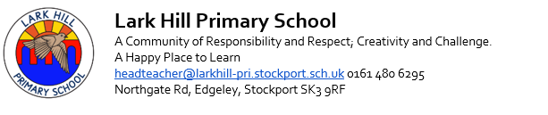
Position: Headteacher
Required for: September 2026
Salary Range: £71,330 - £83,860

Lark Hill Primary School is committed to safeguarding and promoting the welfare of children and young people and expects all staff and volunteers to share this commitment. Shortlisted candidates will be expected to complete a Disqualification Declaration. The successful applicant's appointment will be subject to satisfactory pre-clearance including a Disclosure and Barring Service.

Lark Hill Primary School is a small school where relationships are central to the work of school and we work hard to ensure that children and parents feel supported, safe and happy. We are looking for a leader who will:

- Inspire and motivate through innovative leadership
- Develop children’s learning with passion and commitment
- Demonstrate the ability to foster a nurturing and inclusive school culture where children flourish and mental health and wellbeing have a high priority
- Have high expectations of all children and staff and have a proven track record of improving outcomes
- Embrace opportunities to develop our distinctive provision which serves children with a wide range of abilities
- Provide high quality strategic thinking and planning
- Understand and work closely with our parents and wider local community to benefit the learning of all of our children
- Display strong interpersonal and communication skills
- Build positive relationships with all stakeholders
- Have the ability to confidently challenge, inspire and lead staff

We can offer:

- Happy, confident, articulate, polite, enthusiastic children who love to come to school and are eager to learn
- The opportunity to work in a warm, happy and caring school with an experienced and talented staff team
- A stimulating learning environment
- A well-established creative curriculum
- Highly supportive parents and carers
- Governors committed to continuous improvement, professional development, inclusivity and equal opportunities
- Excellent links with the local community
- Strong local partnerships with other schools and a supportive Local Authority

Visits to the school are encouraged and appointments can be arranged by emailing the School Business Manager Catherine Hutchinson via catherine.hutchinson@larkhill-pri.stockport.sch.uk. Applications must be completed on the application form provided using Microsoft Word only please. Application forms must be submitted electronically to hrclientrelations@stockport.gov.uk.

Closing Date: Friday 15th May 2026 at 9am
Shortlisting: Friday 15th May 2026
Interviews: Tuesday 19th and Wednesday 20th May 2026

