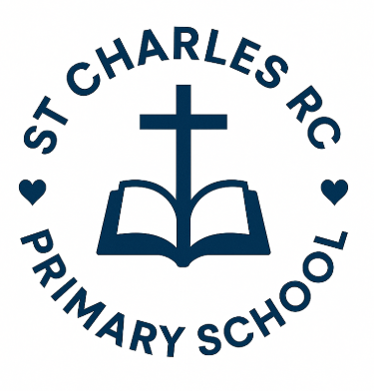
Person Specification
Description | Essential | Desirable | Evidence
Qualifications | Grade A-C in both GCSE Maths & English (or equivalent qualification)  Safeguarding training  The post holder will require an enhanced DBS (carried out by the school) | - Relevant finance/accounting qualifications  - Qualifications in ICT | Application form  Certificates of qualifications and training
Experience | - Relevant experience of working in an accounts-based environment using a computerised finance package  - Proven numerical skills with good experience of spreadsheets  - Liaising with people at all levels  - Experience of undertaking a range of administrative duties, including data input and retrieval. | - Experience of school Finance systems  - Working in an education setting | Application Form  References  Interview process
Knowledge | - Knowledge and experience of computer systems, including the suite of Microsoft packages including, Word, Excel, Email  - School MIS (Management Information Systems)  - Internet and Intranet systems  - Understanding of relevant finance regulations and statutory requirements | - Knowledge of audit requirements  - Working knowledge of good procurement procedures  - Knowledge of VAT and IR35 rules  - Knowledge of double-entry bookkeeping | Application Form  References  Interview Process
Professional  Qualities | - To maintain a high level of honesty, integrity, discretion and confidentiality  - A confident, mature and welcoming manner when dealing with staff and agencies  - Ability to communicate effectively, in writing and orally, with a wide variety of people in a sensitive manner  - Ability to build and maintain effective working relationships with colleagues internally and with external organisations  - Excellent organisational skills and ability to prioritise tasks and demands  - Ability to work calmly under pressure and have the ability to adapt quickly and effectively to changing circumstances/ situations  - Ability to cope with conflicting demands, deadlines and interruptions  - Attention to detail and high degree of accuracy  - Able to work well in a team and disciplined to work alone  - The ability to show patience in difficult and pressured situations |  | Application Form  References  Interview Process
Skills | - Training will be provided as necessary- must keep up with changing legislative and local requirements and be keen to learn, train and develop to enhance personal and team skills  - The post will require an Enhanced Disclosure and Barring Check, exemplary references, medical clearance and educational qualification checks.  - Loyal and hard-working |  | Application Form  References  Interview Process

St Charles RC Primary School is committed to safeguarding and promoting the welfare of children and young people and expects all staff, visitors and volunteers to share this commitment.

