
Head of Service – Building Control
Service | Reporting to | Location | Grade
Infrastructure - Place | Director of Infrastructure -Technical Services | Civic Centre / Hybrid | Band D: £74,502 - £81,644

About the role
- Head of Service responsible for Building Control and Technical Support teams.
- Play an active part in the development and promotion of Building Control work at a national and GM level, including supporting existing networks and partners (e.g. Building Safety Regulator) where appropriate.
- Instill an entrepreneurial spirit to deliver on the City Mayor’s priorities for our city.
- Lead, inspire and provide senior management support to employees within the division, motivating and supporting them to attain the highest professional standards, skills, knowledge, attributes and competencies required to fulfil their duties.
- Work with the Head of Planning, Heads of Development and Investment and encourage close liaison between the infrastructure and other Regeneration teams to maximise the opportunities to deliver growth within our city.
- Provides strong leadership and clear direction to the division to achieve transformational change, be digitally enabled and co-ordinate the effective delivery of services.
- Works closely with elected members and senior leadership to raise the importance and positioning of the service (given the continuing review of the future of building control) and to ensure the effective delivery of services in line with the City Mayor’s and City Council priorities.
- Provides visible, strategic leadership for the division as part of the Technical Services Senior Management Team within Place and embodies the City Council’s Leadership Framework.
- Contributes to the overall leadership and management of the service through proactive engagement with the Senior Leadership Team.
- Ensures effective people management across the division, encouraging a positive employee relations climate and active employee engagement and trade union consultation.
- Ensures appropriate arrangements are in place for preparing and monitoring budgets and associated income for the service and adheres to the standing orders and financial arrangements of the Council.
- Through personal example, commitment and action develop an inclusive, supportive and constructive environment where everyone is treated with dignity and respect and diversity is valued in the workplace, in service delivery and communications.
- Ensure the council meets its legal and statutory obligations for the services’ areas of responsibility

Key outcomes
- To display a high level of professional competency, maintaining a thorough and up to date knowledge of legislation and guidance and apply this to ensure sound, quality and robust recommendations and decisions to or on behalf of the Council in the capacity of Head of Service for Building Control in accordance with legislation and the Council’s constitution.
- Continually strive to add value to development and deliver an excellent quality and safe built and natural environment and help deliver the City’s corporate priorities.
- To provide accurate and balanced advice to the Council on building control issues including attendance at Council Committees, Member working groups, resident and business forums, partnerships and internal project groups.
- To advise the public, developers, other professional groups, organisations and individuals and other Council Services, Members of the Council and Members of Parliament on building control issues and procedures offering advice and guidance, including the initiation of correspondence, on such matters in accordance with Service and Council policies and objectives.
- Develops and maintains a team with the capacity and technical capability to deliver development and develops a culture that promotes inclusivity, enthusiasm, innovation and creativity in delivering the building control service.
- Provide support to our partners across the city in achieving our inclusive growth priorities, including both public sector partners and private sector business and development partners.
- Puts effective and digitally enabled performance management processes in place (including responding to internal and external KPIs and audit programmes) and routinely monitors them to secure continuous improvement in the services provided, and to address any issues that may affect service delivery.
- To ensure our Building Control service remains resourced, capable, responsive and resilient to the changing legislative landscape (e.g. Building Safety Regulator) it sits in and ensure the challenges it faces are shared with senior management and support given to find and develop solutions and maximise opportunities that may be presented.
- Strive to be leaders in our field through embracing technology and be bold and brave in our approach to service delivery

What we need from you
- To model and demonstrate our values and leadership behaviours.
- Qualified to degree level and significant post-qualification experience preferably in a local authority setting.
- Achiever – Proven technical skills and ability to lead projects and programmes to deliver working collaboratively with others.
- Assured - Professional credibility, able to engage with authority and express what is needed; demonstrate initiative, confidence and personal responsibility for action.
- Flexibility – Demonstrate the skills needed to work collaboratively across a range of partners in a contractual/partnership and collaborative setting.
- Leader – Plan, monitor, and review the budgets, programme and pipeline, ensuring appropriate governance to ensure that projects are provided within budget and show value for money, and that all applicable grant funded budgets and other Local Authority budget areas are effectively managed. Ensuring that project variance and risk is reported and managed appropriately.
- Solution Seeker – Understand the local context and able to identify outcome focussed solutions to meet needs.
- Values Based – Model and demonstrate our values and leadership behaviours.
- Diplomat – Open to views of others - able to constructively challenge and be challenged.
- Resource Weaver - Able to build collaborative partnerships, bring together multi-faceted activities to improve performance and/or resolve business critical issues.
- Healthy Approach to risk – Able to confront problems, take calculated risks, have difficult conversations and consider a range of options.
- Motivator – Experience of developing teams to achieve their maximum potential. Develop and maintain a workforce with the capacity and capability to deliver Place priorities and develop a culture that promotes innovation and creativity in service transformation and delivery.
- Tenacious – Experience of driving forward multiple large projects in challenging circumstances.
- Conscientious – Balanced and comprehensive thinker, able to combine self-discipline, an organised approach to work, and innovative practice.
- Technically proficient (experience) – Evidence of significant expertise and knowledge in contributing to strategy development and reviewing operating models and developing and implementing improvements.
- Technically proficient (skills/knowledge) – Able to prepare and deliver reports translating complex data and information, understanding of technical and regulatory environment.
- Astute – Able to work in and understand the political environment and effectively manage political and reputational risks.
- Adjusted – Able to deal with pressure and healthy stretch without affecting others.
- Storyteller – Able to focus on priorities, present succinctly and translate complex ideas and information into meaningful and ‘user friendly’ information; ‘tells the story’ to bring people along and ensure all audiences understand the key messages.

What we can offer you
Your ongoing professional development and success in your role is important to us, and that is why we provide a variety of learning and development opportunities. Within the sections below you will find development options tailored to you which will enable you to further develop your existing skills and learn new ones at a pace that suits you best. If you are joining us now, your development will form part of ongoing discussions with your manager. If you are an existing employee, you should use your Personal Development Reviews to discuss your development with your manager and create your development journey. It’s important you also take full advantage of any informal learning available to you during the course of your work.

Developing your leadership skills
We want to equip our leaders with the knowledge, skills and behaviours outlined in our #LeadingSalford programme. Our aim is to support you to lead highly engaged, motivated teams in today’s rapidly changing environment. This will be achieved through a range of bite-size Master Classes designed to help you meet the expectations that we have of our Salford leaders. In addition to the core Master Classes, we also provide accredited leadership programmes which let you build on your experience, learn about emerging approaches, and further develop your leadership practice.

Online learning
Develop your knowledge across a wide range of areas through our Me-Learning platform, with over 200 free courses to choose from. To have the best possible start and comply with current legislation, you must complete the following modules: Welcome to Salford, Health and Safety in the Office, GDPR, Equality Essentials, and Safeguarding Children and Adults. You may also benefit from a variety of courses in categories such as Business Skills, IT and Project Management which are available to learn at your own convenience and pace.

Professional Development
Gain role specific skills and time to learn through a wide range of development opportunities. Learn whilst working and get support towards your qualification through an apprenticeship standard. Access professional development ranging from entry level to master’s type qualifications, including achieving a role appropriate qualification. Details can be found on the Institute of apprenticeships website.

A digital organisation
Developing your digital skills
Our ambition is to provide our workforce with the right level of digital capabilities needed to be successful. Whatever your current digital abilities are, we can provide development ranging from essential workplace skills to specialist workplace skills. These will be delivered through our Digital Skills Academy using both self-directed and guided learning opportunities to enable you to develop. Additionally, you can access free online courses through the iDea website.

Sharing your digital skills
Our goal is to support you to share your digital knowledge with other people. Our Digital Eagles programme has been designed to cover basic digital skills and build your confidence to assist others. By the end of this programme, you will join hundreds of staff members who already are digital eagles, and be able to help colleagues, customers, residents, or people in your personal life with all things digital.

Our leadership behaviour framework
Leadership is action, not a position. It’s not just what we do but how we do it.
Whatever your role at Salford, we all strive to achieve our vision and the best outcomes for the residents and communities of Salford.
As leaders, we all have an important part to play in achieving our organisational and service priorities. These priorities give us direction and a shared purpose in our roles and should be the focus when making decisions.
We can help make these priorities a reality by living and breathing our Salford values and leadership behaviours.
This framework is broken down into three main areas:
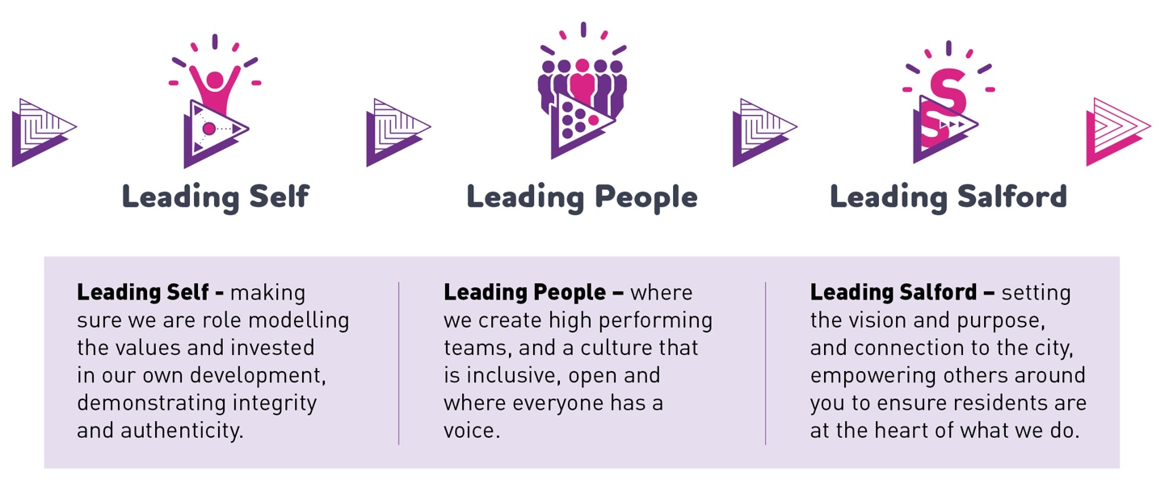
This behaviour framework will support us all to reflect and hold ourselves, and each other to account, as we strive for continuous improvement.
Full details of how this framework shapes our Leaders and is delivered in the workplace can be found on the Salford Leadership pages of our greater.jobs website.

Our organisation’s values
We have four values: Pride, Passion, People, Personal responsibility.
Our four values are central to the way we communicate about the council and the way in which we behave with colleagues, customers, and partners - so that we live and breathe our values each day.



Application guidance
We are a values-based organisation so reflecting our values or a values-based approach in your evidence will support your application.
The different sections of this role profile are there to give you an understanding of the purpose of the role. The ‘what we need from you’ section outlines the minimum criteria you will need to meet within your application.

Role details
Completed by:
Date:
Job code:
Job score:
Date of evaluation:

