Springwood Primary School

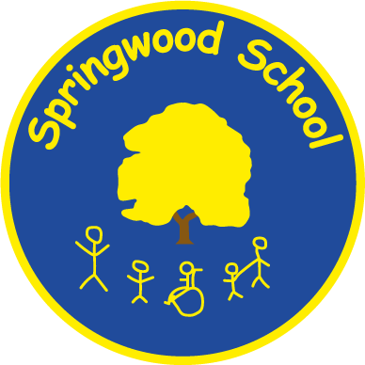



Teaching Assistant Level 3
Job Description
Person Specification

Information about Springwood Primary School

Springwood is a large primary age Special School (375 pupils aged 5 – 11) based over a number of sites, which caters for pupils with moderate, severe and complex needs. Springwood is part of The LINK Education Trust.

Pupils who are Nursery - Y2 age attend our Craig Hall Site in Irlam, those who are Y2-Y6 attend our site in Swinton. Additionally, we have small groups of pupils based at our Belvedere, Grosvenor Road and Little Hulton sites. Depending on pupil need and peer group, the decision is made annually as to which site pupils are based at.

Despite being split across various sites, the school is a cohesive learning environment with the same provision and expectations across the whole school.

Vision Statement

Springwood Primary School provides a safe, stimulating environment in which all pupils have the opportunity to succeed

At Springwood we respect each other, our pupils and their families. We have a curriculum that is meaningful, inspiring and enjoyable, promoting achievement for all. Through carefully planned holistic learning, pupils are enabled to achieve their best.

Springwood Primary School’s mission statement is Believe, Enjoy, Succeed, Together.

At Springwood BEST is embodied through everything that we do.

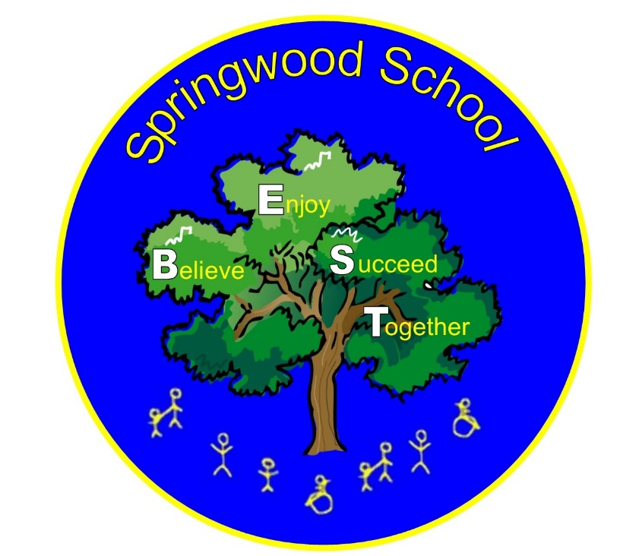
JOB DESCRIPTION
Job Title: |  | Teaching Assistant Level 3
Grade: |  | 2C (pt 14-18)
Directly responsible to:  Supervisory responsibility for: |  | Head of school / Class Teacher / other school employee  Other Teaching Assistants, as appropriate
Hours of Duty: |  | 32.5 hrs per week TTO
Summary of Role:
To work under the guidance of teaching/senior staff and within an agreed system of supervision, to implement agreed work programmes with individuals/groups, in or out of the classroom. This could include those requiring detailed and specialist knowledge in particular areas and will involve assisting the teacher in the whole planning cycle and the management/preparation of resources. Staff may also supervise whole classes occasionally during the short-term absence of teachers. The primary focus will be to maintain good order and to keep pupils on task. Cover Supervisors will need to respond to questions and generally assist pupils to undertake set activities.
To be responsible for supervising the work, development and performance of level 1 and level 2 Teaching Assistants, to provide appropriate guidance and support.
Main Duties and Responsibilities/Accountabilities:

Support for Pupils
 | Use specialist (curriculum/learning) skills/training/experience to support pupils.
 | Assist with the development and implementation of IEPs.
 | Establish productive working relationships with pupils, acting as a role model and setting high expectations.
 | Promote the inclusion and acceptance of all pupils within the classroom.
 | Support pupils consistently whilst recognising and responding to their individual needs.
 | To support pupils’ medical needs and to undertake delegated medical responsibilities, with training support from the school and/or the wider nursing team.
 | Encourage pupils to interact and work co-operatively with others and engage all pupils in activities.
 | Promote independence and employ strategies to recognise and reward achievement of self-reliance.
 | Provide feedback to pupils in relation to progress and achievement.

Support for the Teacher
 | Work with the teacher to establish an appropriate learning environment.
 | Work with the teacher in lesson planning, evaluating and adjusting lessons/work plans as appropriate.
 | Monitor and evaluate pupils’ responses to learning activities through observation and planned recording of achievement against pre-determined learning objectives.
 | Provide objective and accurate feedback and reports as required, to the teacher on pupil achievement, progress and other matters, ensuring the availability of appropriate evidence.
 | Be responsible for keeping and updating records as agreed with the teacher, contributing to reviews of systems/records as requested.
 | Undertake marking of pupils’ work and accurately record achievement/progress.
 | Promote positive values, attitudes and good pupil behaviour, dealing promptly with conflict and incidents in line with established policy and encourage pupils to take responsibility for their own behaviour.
 | Liaise sensitively and effectively with parents/carers as agreed with the teacher within your role/responsibility and participate in feedback sessions/meetings with parents, or as directed.
 | Administer and assess routine tests and invigilate exams/tests.
 | Provide general clerical/admin, support e.g. administer course work, produce worksheets for agreed activities etc.

Support for the Curriculum
 | Implement agreed learning activities/teaching programmes, adjusting activities according to pupil responses/needs.
 | Implement local and national learning strategies e.g. literacy, numeracy, KS3, early years and make effective use of opportunities provided by other learning activities to support the development of relevant skills.
 | Support the use of ICT in learning activities and develop pupils’ competence and independence in its use.
 | Help pupils to access learning activities through specialist support.
 | Determine the need for, prepare and maintain general and specialist equipment and resources.

Support for the School
 | Be aware of and comply with policies and procedures relating to child protection, health, safety and security, confidentiality and data protection, reporting all concerns to an appropriate person.
 | Be aware of and support difference and ensure all pupils have equal access to opportunities to learn and develop.
 | Contribute to the overall ethos/work/aims of the schools.
 | Establish constructive relationships and communicate with other agencies/professionals, in liaison with the teacher, to support achievement and progress of pupils.
 | Attend and participate in regular meetings.
 | Participate in training and other learning activities as required.
 | Recognise own strengths and areas of expertise and use these to advise and support others.
 | Provide appropriate guidance and supervision and assist in the training and development of staff as appropriate.
 | Undertake planned supervision of pupils’ out of school hours learning activities.
10. | Supervise pupils on visits, trips and out of school activities as required.
Safeguarding

The post-holder must be aware of child protection issues and the need for confidentiality and to identify to the named child protection colleague in school, concerns in respect of individual children.

Review Arrangements:
The details contained in this Job Description reflect the content of the job at the date it was prepared. It should be remembered, however, that it is inevitable that over time, the nature of individual jobs will change, existing duties may no longer be required and other duties may be gained without changing the general nature of the duties or the level of responsibility entailed. Consequently, the council will expect to revise this Job Description from time to time and will consult with the post-holder at the appropriate time.

PERSON SPECIFICATION

Job title | Grade | School | Location
Teaching Assistant Level 3 | 2C (pt 14-18) | Springwood Primary School | As per job advert
Note to manager
In completing this form you are setting the expected standard for the person you need for this job on this occasion. Once completed, it will help to create your shortlist of candidates and to devise the questions you ask at interview. Please describe the criterion in ways that are both accurate and capable of being tested. Above all, the requirements must be job related and non-discriminatory. The job description, person specification and advertisement must be consistent. Each of the criteria must be identified under the Essential or Desirable headings. Whilst all criterions are important, those marked Essential must be met before an interview can be offered. (See Section 6 of the Recruitment and Selection Code of Practice for more information on producing a person specification)

Note to applicants
Whilst all criterions below are important, those under the Essential heading are the key requirements. You should pay particular attention to these areas and provide evidence of meeting them. Failure to do so may mean that you will not be invited for interview.
(*See grid overleaf)
Essential criteria | Necessary requirements – skills, knowledge, experience etc. | * M.O.A.
 | Very good Numeracy skills (equivalent to Level 2). | A/I/C
 | Very good Literacy skills (equivalent to Level 2). | A/I/C
 | Supporting Teaching and Learning Level 3 Diploma (or equivalent) | A/I/C
 | Can use ICT effectively to support learning. | A/I
 | Full working knowledge of national/foundation stage curriculum and other relevant learning programmes/strategies. | A/I
 | Understanding of principles of child development and learning processes | A/I
 | Ability to self-evaluate learning needs and actively seek learning opportunities | A/I
 | Ability to relate well to children and adults | A/I
 | Work constructively as part of a team, understanding classroom roles. | A/I
 | Ability to undertake the physically demanding aspects of the role that involves a lot of moving and handling of children whom have very unpredictable and often physically challenging behaviour | A/I
 | Experience of working successfully with children in an SEND setting | A/I
Desirable criteria | Necessary requirements – skills, knowledge, experience etc. | * M.O.A.
 | Completion of Teaching Assistant Introductory Training | A/I/C
 | Training in relevant SEND strategies | A/I/C
3. | Where designated to work in a particular curriculum area to work towards Level 2 in that subject area. | A/I
4. | Appropriate First Aid Training | A/I/C

Method of assessment (* M.O.A.)

A = Application form, C = Certificate, E = Exercise, I = Interview, P = Presentation, T = Test, AC = Assessment centre

Springwood Primary School
Barton Road
Swinton
Manchester
M27 5LP
☎ 0161 778 0022 – opt 1

Website: Springwood Primary School Facebook: Springwood Primary School Facebook X: Springwood X - @SpringwoodSch

