
Job title
Service  Place | Reporting to  Lead Practitioner | Location  Civic Centre Swinton | Grade  4B SCP 36-39 £47,181 to £50,269

About the role
To contribute to the delivery of the service’s functions to protect and promote the health, safety and wellbeing of residents and visitors to Salford, and to support the maintenance and growth of Salford’s economy by working with businesses, consumers, service providers and other stakeholders to ensure that they can engage in trade, access services and accommodation in safety and with confidence.

This Role will be carried out in accordance with the Directorate Annual Business Plan and the overall policy of the Council. The post holder will model and promote the city councils’ values in all aspects of their duties.

Key outcomes
- To assist Lead Practitioners and Service Managers in developing operational solutions to area based and thematic challenges across Regulatory Services to meet the aims and objectives set out in the City Councils Values, Strategies and Directorate Business Plan.

- Assist in the monitoring and delivery of assigned tasks both individually and as part of formal and informal teams.

- To undertake all duties in full accordance with the relevant procedures and standing orders, ensuring that all relevant financial and statutory matters are dealt with promptly.

- The post holder will be assigned to, and on occasion lead on specific elements within, a focused area of work within Regulatory Services but will also be expected to work across other areas as required. The post holder will provide coaching, guidance and constructive challenge to colleagues as needed.

- To appropriately apply technical knowledge and experience to real world situations with a view to ensuring compliance with relevant minimum standards and the promotion of established best practice; by supporting stakeholders in problem solving and encouraging excellence.

- To provide in-depth advice to Lead Practitioner, colleagues and customers on technical and regulatory issues relating to the area of work on which the post holder is focused.

- To be alert for and highlight to the Lead Practitioner any emerging trends or patterns which may impact on the operational work of the Service and/or need to be addressed at a policy or strategic level.

- To take appropriate formal and informal action to ensure compliance with relevant minimum standards and promote improvement and the adoption of best practice by stakeholders through advice, persuasion, negotiation, and enforcement, in line with the Council’s Enforcement Policy and Scheme of delegation.

- To collate and seize all types of relevant evidence, conduct interviews, issue warnings and notices to facilitate the fair and proportionate use of enforcement powers and, where necessary, to secure positive outcomes from any subsequent legal proceedings.

- Prepare and collate detailed case and prosecution files for submission to the legal team and where appropriate attend Court, Civil hearings, Tribunals and Public Inquiries and present necessary evidence, where appropriate give support to witnesses/victims.

- To give detailed technical support and advice and assistance to internal and external colleagues to secure the completion of agreed work programmes.

- To manage own allocated workload effectively including, where appropriate, working outside normal hours.

- To attend relevant meetings with other Directorates, or outside bodies as required, to promote the objectives of the Service and the City Council.

- To communicate effectively and appropriately with all stakeholders to ensure their understanding, engagement and involvement with relevant work programmes and projects including providing technical information relating to the officer’s area of work that is accessible and understandable.

- To undertake such additional duties that may arise appropriate to the delivery of the service and as are reasonably commensurate with the level of the post.

- To identify and develop proposals for new opportunities for income generation and maximising take up on existing income generation schemes.

- To take a full and active role in the implementation of own training and personal development, keeping abreast of developments across Regulatory Services. Where necessary to actively support the training & development of colleagues and teams at all levels.

- To contribute to and demonstrate a commitment to relevant policies of the City Council

What we need from you
Essential

Knowledge

Degree or diploma in Environmental Health or equivalent.
Registered with EHORB or be a Registered or Chartered Environmental Health Practitioner as defined by the CIEH registration pathways.
It is also desirable to have NEBOSH Diploma or NVQ4/5 in Health and Safety Regulation

Possessing an extensive and in-depth level of knowledge of relevant legislation and technical matters including practical application. The level will be commensurate with the skill area the post is within.

Skills

Self-motivated and enthusiastic and able to work unsupervised and under own initiative

Flexible and receptive to new ideas and a willingness to take ownership of problems to ensure successful service outcomes.

Persuasive, diplomatic and able to use effective negotiation skills.

Demonstrate the required competency requirements necessary to effectively carry out this role within the specific post holder’s service area.

The ability to research, gather and analyse information and evidence from a wide range of sources. Draw reasoned conclusion, identify options for action and where asked, to make appropriate recommendations. Updating and maximising computer systems and keeping accurate records.

The ability to be assertive in a way that is appropriate, fair and proportionate.

Having excellent literacy, numeracy and digital skills to a standard acceptable for the institution of legal proceedings where necessary.

Having the ability to deliver projects, utilising one’s own knowledge and experience. Solving problems in innovative ways and operating on own initiative with minimal direct supervision within established policy frameworks.

The ability to use critical thinking and coaching, guiding and providing constructive challenge to support the thinking and development of colleagues.

Experience

At least 2 years’ experience in an enforcement role covering food safety, health and safety and infectious disease work areas.

Up to date technical knowledge and experience of legislation, codes of practice and guidance relevant to the role, particularly in respect of food safety, health and safety and infectious disease.

Combined with the ability to exercise sound professional judgement in its interpretation and implementation.

Experience of inspecting a wide range of premises and processes.

Experience of the investigation of a wide range and complexity of service requests, including complaints, accidents, infectious diseases.

An understanding of wider environmental health work.

Experience of drafting reports, letters and notices.

An in depth knowledge of a wide range of enforcement actions.

Experience in the use of IT systems/software e.g. MS office suite, property database.

Attributes and Behaviours

There is an expectation that all employees demonstrate our values of Pride, Passion, People, and Personal responsibility in all aspects of their duties.

What we can offer you
Your ongoing professional development and success in your role is important to us, and that is why we provide a variety of learning and development opportunities. Within the sections below you will find development options tailored to you which will enable you to further develop your existing skills and learn new ones at a pace that suits you best. If you are joining us now, your development will form part of ongoing discussions with your manager. If you are an existing employee, you should use your Personal Development Reviews to discuss your development with your manager and create your development journey. It’s important you also take full advantage of any informal learning available to you during the course of your work.

Online learning
Develop your knowledge across a wide range of areas through our Me-Learning platform, with over 200 free courses to choose from. To have the best possible start and comply with current legislation, you must complete the following modules: Welcome to Salford, Health and Safety in the Office, GDPR, Equality Essentials, and Safeguarding Children and Adults. You may also benefit from a variety of courses in categories such as Business Skills, IT and Project Management which are available to learn at your own convenience and pace.

Professional Development
Gain role specific skills and time to learn through a wide range of development opportunities. Learn whilst working and get support towards your qualification through an apprenticeship standard. Access professional development ranging from entry level to master’s type qualifications, including achieving a role appropriate qualification. Details can be found on the Institute of apprenticeships website.

Tailored Development
Ongoing training will be provided in food safety and health and safety.

A digital organisation
Developing your digital skills
Our ambition is to provide our workforce with the right level of digital capabilities needed to be successful. Whatever your current digital abilities are, we can provide development ranging from essential workplace skills to specialist workplace skills. These will be delivered through our Digital Skills Academy using both self-directed and guided learning opportunities to enable you to develop. Additionally, you can access free online courses through the iDea website.

Sharing your digital skills
Our goal is to support you to share your digital knowledge with other people. Our Digital Eagles programme has been designed to cover basic digital skills and build your confidence to assist others. By the end of this programme you will join hundreds of staff members who already are digital eagles, and be able to help colleagues, customers, residents, or people in your personal life with all things digital.

Our vision and priorities

Our vision
The council has a vision is to create 'A fairer, greener and healthier Salford'. To help us achieve this vision we have identified some key priorities to tackle the problems people in Salford are currently facing, the Great Eight.
Salford is beginning a journey of economic transformation, with the mapping out of the city’s economic future through key pieces of city council work. We’re calling this The Salford Way.
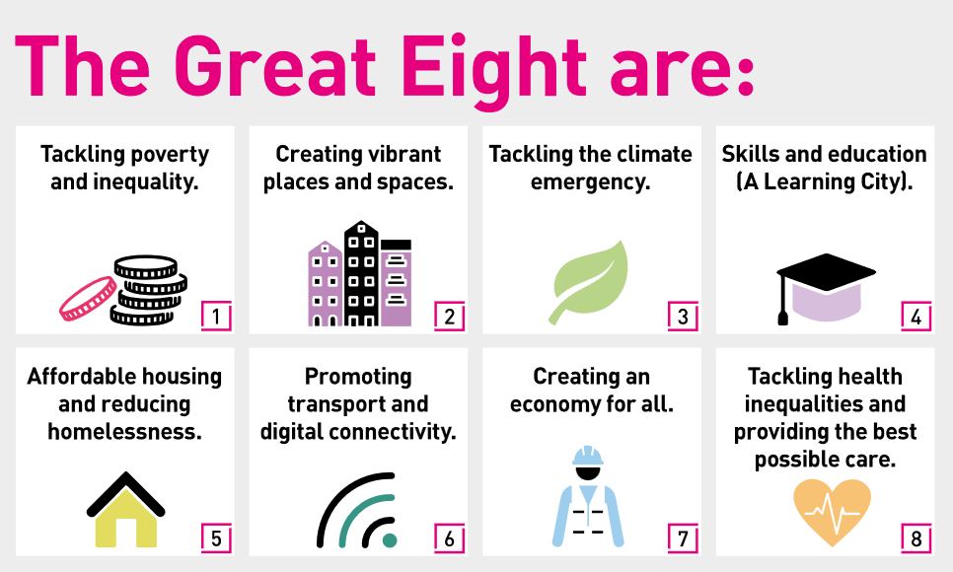

Our organisation’s values
We have four values: Pride, Passion, People, Personal responsibility.
Our four values are central to the way we communicate about the council and the way in which we behave with colleagues, customers, and partners - so that we live and breathe our values each day.



Application guidance
We are a values-based organisation so reflecting our values or a values-based approach in your evidence will support your application.
The different sections of this role profile are there to give you an understanding of the purpose of the role. The ‘what we need from you’ section outlines the minimum criteria you will need to meet within your application.

Role details
Completed by:
Date:
Job code:
Job score:
Date of evaluation:

