
Governance Professional
Service | Reporting to | Location | Grade
Governor Services | Governor Services Manager | Salford Civic Centre/Schools/Hybrid | 2C

About the role
Effective governance provides strategic direction and control to schools and academies. It creates robust accountability, oversight and assurance for their educational and financial performance and is ambitious for all children and young people to achieve the very best outcomes.

As a governance professional, you will provide efficient governance advice, administrative and professional clerking support to school and academy boards to ensure statutory duties are met. You will plan, prepare and organise meetings and hearings ensuring governors receive the information they need in a timely manner to allow the board to make effective use of their time and focus on strategic matters.

You will be able to work under your own initiative, manage deadlines and be responsible for maintaining comprehensive governing board records, including governing board minutes and reports and full governing board membership and training records in accordance with data protection, freedom of information and school governance regulations with the ability to remain impartial and respect confidentiality at all times.

You will establish strong working relationships with the Chair of the Board, the Headteacher and the Board members of your assigned schools, your aim being to establish a relationship based on mutual respect and trust.

Key outcomes
- In collaboration with the Chair/Vice Chair and the Headteacher ensure meetings are planned efficiently over the course of the school year.
- Ensure governing boards receive papers and accurate meeting minutes which contain a clear record of debate and decisions, within the timescales specified in the SLA.
- Ensure governing boards are properly constituted according to School governance regulations.
- Provide governing boards with timely accurate advice and guidance about statutory duties, compliance and effective governing practice directly contributing to their efficient conduct.
- Support the governing board chair in enabling and facilitating strategic debate and decision-making.
- Maintain accurate governing board records.
- Complete the Leading Governance Development for clerks programme within 18 months of taking up the post.
- Build and maintain professional working relationships with the board which is the foundation for providing impartial advice and support and establish open communication to ensure smooth information flow.

What we need from you
- To model and demonstrate our values and behaviours.
- 4 GCSE's (grades A-C) including English Language, or ability to demonstrate attainment at NVQ Level 2 or equivalent
- Professional credibility through proven relevant experience
- Excellent planning and organisational skills in order to meet all statutory and SLA timescales
- Excellent written and verbal communication and interpersonal skills in order to intervene in meetings and keep governing board meetings on track when necessary
- The ability to be able to deal with matters of a sensitive and confidential nature
- The ability to work accurately under pressure
- A very high level of administrative and keyboarding skills
- The ability to work as part of a team as well as alone and with minimum supervision
- The ability to work flexibly
- A willingness to undertake training for the role
- A willingness to demonstrate our values and behaviours

What we can offer you
Your ongoing professional development and success in your role is important to us, and that is why we provide a variety of learning and development opportunities. Within the sections below you will find development options tailored to you which will enable you to further develop your existing skills and learn new ones at a pace that suits you best. If you are joining us now, your development will form part of ongoing discussions with your manager. If you are an existing employee, you should use your Personal Development Reviews to discuss your development with your manager and create your development journey. It’s important you also take full advantage of any informal learning available to you during the course of your work.

Online learning
Develop your knowledge across a wide range of areas through our Me-Learning platform, with over 200 free courses to choose from. To have the best possible start and comply with current legislation, you must complete the following modules: Welcome to Salford, Health and Safety in the Office, GDPR, Equality Essentials, and Safeguarding Children and Adults. You may also benefit from a variety of courses in categories such as Business Skills, IT and Project Management which are available to learn at your own convenience and pace.

Professional Development
Gain role specific skills and time to learn through a wide range of development opportunities. Learn whilst working and get support towards your qualification through an apprenticeship standard. Access professional development ranging from entry level to master’s type qualifications, including achieving a role appropriate qualification. Details can be found on the Institute of apprenticeships website.

Tailored Development
Ongoing training to support governance and educational changes.

A digital organisation
Developing your digital skills
Our ambition is to provide our workforce with the right level of digital capabilities needed to be successful. Whatever your current digital abilities are, we can provide development ranging from essential workplace skills to specialist workplace skills. These will be delivered through our Digital Skills Academy using both self-directed and guided learning opportunities to enable you to develop. Additionally, you can access free online courses through the iDea website.

Sharing your digital skills
Our goal is to support you to share your digital knowledge with other people. Our Digital Eagles programme has been designed to cover basic digital skills and build your confidence to assist others. By the end of this programme you will join hundreds of staff members who already are digital eagles, and be able to help colleagues, customers, residents, or people in your personal life with all things digital.

Our vision and priorities

Our vision
The council has a vision is to create 'A fairer, greener and healthier Salford'. To help us achieve this vision we have identified some key priorities to tackle the problems people in Salford are currently facing, the Great Eight.
Salford is beginning a journey of economic transformation, with the mapping out of the city’s economic future through key pieces of city council work. We’re calling this The Salford Way.
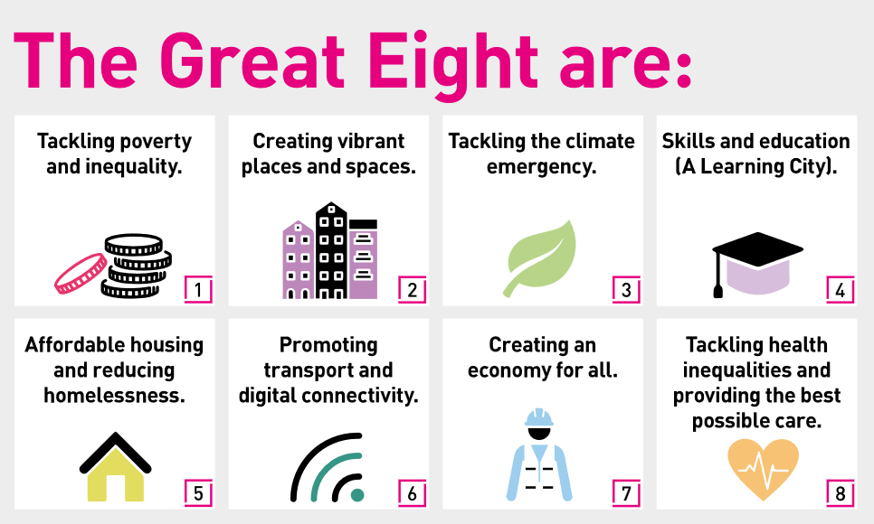

Our organisation’s values
We have four values: Pride, Passion, People, Personal responsibility.
Our four values are central to the way we communicate about the council and the way in which we behave with colleagues, customers, and partners - so that we live and breathe our values each day.



Application guidance
We are a values-based organisation so reflecting our values or a values-based approach in your evidence will support your application.
The different sections of this role profile are there to give you an understanding of the purpose of the role. The ‘what we need from you’ section outlines the minimum criteria you will need to meet within your application.

Role details
Completed by:
Date:
Job code:
Job score:
Date of evaluation:

