
Senior Engineer Highway Design
Service  Engineering and Landscape Design | Reporting to  Group Leader | Location  Salford Civic Centre and Home Working | Grade 4B  £47,181 to £50,269  36 hours per week

About the role
- You will support the Group Leader to manage and undertake the feasibility studies, conceptual, preliminary and detailed design, procurement and supervision of the construction of a range of Engineering projects.
- You will have responsibility for managing the work of Engineers, Technicians, temporary and seconded staff within the team.
- You will have knowledge and understanding of the relevant legislation, standards and procedures and possess a working knowledge of standard engineering specifications, conditions of contract and methods of measurement.
- You will be required to liaise with stakeholders and the public on projects;
- You will be able to demonstrate recent experience in the following:
- The ability to deal appropriately and effectively with external organisations and statutory bodies;
- Management and delivery of feasibility studies including preparing reports, cost estimates, investigating problems, and identifying of options;
- A good understanding of all relevant standards, Codes of Practice, Health & Safety Legislation and current relevant design methods;
- Initiative and ingenuity in solving engineering problems;
- Excellent communication skills, both orally and in writing, both at a general and technical level;
- Extensive experience in the use of AutoCAD software in the preparation of designs and drawings, including a 3D environment.

Key outcomes
- Support the Group Leader to ensure delivery of project outputs to meet the City’s programme deadlines;
- Undertake all the technical aspects required for project delivery including feasibility, concept design, detailed design, preparation of tender and contract documentation, invitation of tenders and supervision of construction works on site;
- Implement projects to meet the requirements of quality, health and safety, environmental standards, and time to both national and corporate standards;
- Support the Group Leader in arranging the procurement of highway improvement works through competitive tendering. Prepare, manage, report and maintain project cost plans;
- Prepare schemes for tender using: the NEC3 & NEC4 ECC Forms of Contract; Manual of Contract Documents for Highway Works; Specification for Highway Works and the Standard Method of Measurement.
- Supervise and monitor of works on site including making valuations for payment assessments; chairing and managing progress meetings; identification and assessment of additional payments due to variation orders or compensation events; determination of project final accounts and satisfactory completion of the defects period;
- Ensure compliance of the team’s work with a high regard to Health and Safety, the application of the CDM Regulations and other relevant legislation;
- Supervision of and responsibility for junior members of the team, including programming and allocating work, assisting in the training and development of staff, setting goals and monitoring performance;
- Abide by the objectives and targets of both the section and the department and follow procedures and practices utilised in all aspects of the work, including computerised and manual systems and the maintenance of relevant records;
- Set and work to personal deadlines and targets to meet the requirements of programmes of work, to meet clients’ needs and to respond to targets set by others.

What we need from you
- Achiever - proven technical skills and ability in the role
- Assured - demonstrates initiative, confidence and personal responsibility for action
- Credible - professional credibility through proven experience in an infrastructure environment
- Curious - understands the bigger picture and broader context and is able to translate to a local setting
- Determined - tenacious and consistently persists with actions to achieve outcomes
- Diplomat - open to the views of others - able to constructively challenge and be challenged
- Evidence Seeker - demonstrates analytical skills using data insight to inform workforce strategies and plans
- Leader - leads people/projects, with an ability to motivate, engage and develop people to deliver shared outcomes
- Optimist - remains positive under challenging circumstances.
- People Person - skilled communicator who communicates with clarity, conviction and enthusiasm and is able to demonstrate integrity, create rapport and build trust and confidence.
- Self-development - demonstrates a commitment to continual professional development and continuous service improvement
- Solutions Seeker - understands the local context and able to identify outcomes focussed solutions to meet needs
- Resource Weaver - brings together multi-faceted activities to improve performance and/or resolve business critical issues
- Values-based - models and demonstrates our values and leadership behaviours
- Experienced – you will possess
  - a bachelor’s or master’s degree in Civil Engineering or a related subject.
  - Qualified Membership of a professional engineering institution or be working towards this status.
  - You will have a minimum of 5 years post qualification experience in the design, implementation, and supervision of Engineering projects.
  - You will have a proven record of the delivery of projects with a focus on Highway Design.
  - The ability to deal appropriately and effectively with external organisations.
  - You will have experience of managing junior staff.
  - Excellent communication skills, both orally and in writing, both at a general and technical level.
  - Experience of the development and implementation of projects to budget and programme.

What we can offer you
Your ongoing professional development and success in your role is important to us, and that is why we provide a variety of learning and development opportunities. Within the sections below you will find development options tailored to you which will enable you to further develop your existing skills and learn new ones at a pace that suits you best. If you are joining us now, your development will form part of ongoing discussions with your manager. If you are an existing employee, you should use your Personal Development Reviews to discuss your development with your manager and create your development journey. It’s important you also take full advantage of any informal learning available to you during the course of your work.

Developing your leadership skills
We want to equip our leaders with the knowledge, skills and behaviours outlined in our #LeadingSalford programme. Our aim is to support you to lead highly engaged, motivated teams in today’s rapidly changing environment. This will be achieved through a range of bite-size Master Classes designed to help you meet the expectations that we have of our Salford leaders. In addition to the core Master Classes, we also provide accredited leadership programmes which let you build on your experience, learn about emerging approaches, and further develop your leadership practice.

Online learning
Develop your knowledge across a wide range of areas through our Me-Learning platform, with over 200 free courses to choose from. To have the best possible start and comply with current legislation, you must complete the following modules: Welcome to Salford, Health and Safety in the Office, GDPR, Equality Essentials, and Safeguarding Children and Adults. You may also benefit from a variety of courses in categories such as Business Skills, IT and Project Management which are available to learn at your own convenience and pace.

Professional Development
Gain role specific skills and time to learn through a wide range of development opportunities. Learn whilst working and get support towards your qualification through an apprenticeship standard. Access professional development ranging from entry level to master’s type qualifications, including achieving a role appropriate qualification. Details can be found on the Institute of apprenticeships website.

Tailored Development
Support to achieve and maintain your professional qualification will be available working with those already professionally qualified across the council. Opportunities to maintain the continuing professional development requirements of a registered institution will also be supported alongside the wider development programme outlined above.

A digital organisation
Developing your digital skills
Our ambition is to provide our workforce with the right level of digital capabilities needed to be successful. Whatever your current digital abilities are, we can provide development ranging from essential workplace skills to specialist workplace skills. These will be delivered through our Digital Skills Academy using both self-directed and guided learning opportunities to enable you to develop. Additionally, you can access free online courses through the iDea website.

Sharing your digital skills
Our goal is to support you to share your digital knowledge with other people. Our Digital Eagles programme has been designed to cover basic digital skills and build your confidence to assist others. By the end of this programme, you will join hundreds of staff members who already are digital eagles, and be able to help colleagues, customers, residents, or people in your personal life with all things digital.

Our vision and priorities

Our vision
The council has a vision is to create 'A fairer, greener and healthier Salford'. To help us achieve this vision we have identified some key priorities to tackle the problems people in Salford are currently facing, the Great Eight.
Salford is beginning a journey of economic transformation, with the mapping out of the city’s economic future through key pieces of city council work. We’re calling this The Salford Way.
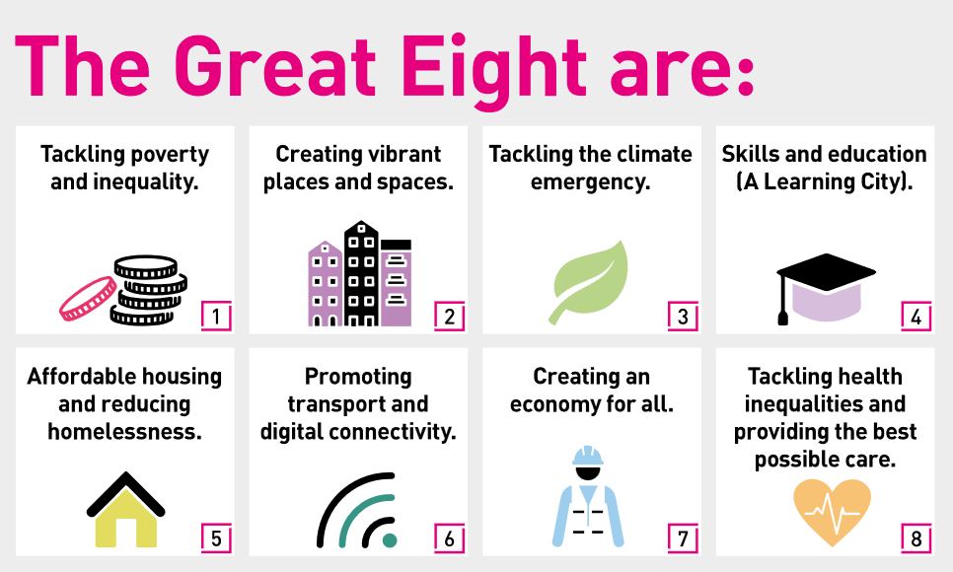

Our leadership behaviours
As a values-based leader you will:
- Model the values and embed them into the way your team delivers services.
- Hold people accountable for demonstrating the values.
- Respect and care for others, treating everyone fairly, valuing and welcoming diversity, respecting people’s identity, listening and acting on the things people say to enable everyone to achieve their full potential.
- Be honest, taking responsibility for your actions and decisions.
- Use resources that you are trusted with wisely.
To lead others, you will:
- Listen to understand, not to defend.
- Give people the freedom to use their initiative.
- Provide opportunities for people to discuss and solve problems and issues – focussed on learning, not blame.
- Regularly provide coaching and support to others to help them achieve their objectives and potential.
- Appreciate and build on people’s strengths.
- Motivate, engage, encourage and inspire others in order to be the best they can be.
- Build lasting productive relationships with residents, partners and elected officials.
To lead outcomes, you will:
- Be visible, inject pace, vigour and purpose.
- Expect high standards; mediocrity is not acceptable.
- Take an evidence and whole system approach in making decisions.
- Maximise technology and models to deliver quicker, easier, better services.
- Have a digital mindset, fully utilising digital systems and solutions to deliver services efficiently and effectively.
- Set context and challenging goals that will motivate people to take ownership, maximise performance, and develop.
To build and communicate a vision for the future you will:
- Be optimistic and ambitious for the city and its people, helping others to understand the need to change how we do things.
- Build strong collaborative relationships to find creative ways to make services more sustainable and flexible.
- Recognise and value the strengths of people and places, taking a strengths-based approach to make the most of opportunities.
- Support people through change, in undertaking new things, and taking risks.
- Take a place and whole system approach in designing, delivering, and leading services developing solutions with our partners.
- Ensure inclusion is integral to service delivery and organisational performance and develop a resilient, diverse workforce who reflect the increasing diversity of our city.
- Be optimistic and ambitious for the city and its people, helping others to understand the need to transform public services.

Our organisation’s values
We have four values: Pride, Passion, People, Personal responsibility.
Our four values are central to the way we communicate about the council and the way in which we behave with colleagues, customers, and partners - so that we live and breathe our values each day.



Application guidance
We are a values-based organisation so reflecting our values or a values-based approach in your evidence will support your application.
The different sections of this role profile are there to give you an understanding of the purpose of the role. The ‘what we need from you’ section outlines the minimum criteria you will need to meet within your application.

