
Assistant Functions Manager
Service  Place Directorate | Reporting to  Functions Manager | Location  Various across Salford | Grade  3A + 2 SCP 23  Salary £34,434 to £37,280

About the role
- To contribute towards the development and maintenance of an efficient and effective commercial catering service which meets the customers needs, profitability and exceed their expectations.
- Regular evening and weekend shift work.
- Assist in ensuring that the highest standard of customer service excellence is provided and maintained
- Effective menu planning, ordering, production and stock control to minimise wastage whilst constantly controlling the stock and expenditure levels inline with pre-determined targets.
- Experienced to safely prepare, cook and instruct staff to serve evening buffets when the service requires.
- Ensuring all trading targets are met including recommending any remedial action required. Monitoring and be responsible for all controllable costs especially labour.
- Demonstrate compliance with all relevant policies, codes of practice, procedures and legislation.
- Participate in the staff recruitment and selection process.
- Accurate and prompt completion of records and returns as required, enabling the collation of information required to produce periodic unit trading reports
- Take appropriate action to ensure the safety of staff, customers and buildings and all other resources via inspections of facilities (both internally and externally) and equipment
- Lead by example whilst continually coaching and mentoring staff to meet identified training needs, maintaining an acceptable level of performance and to develop a team culture
- Effectively deploy staff to required locations
- Contribute ideas to promote and market the service, identifying and meeting customer needs, on all social media platforms

Key outcomes
- Maintaining the highest level of contact and communication with customers, staff and relevant officers to ensure confidence in and satisfaction with the service.
- The development and implementation of the marketing and business plans for the service.
- Monitoring, leading and directing staff within the service to maintain an acceptable level of performance and to develop a team culture.
- Carry out their duties with full regard to the City Council’s Equal Opportunities, Health and Safety and Community Strategy policies
- To contribute and demonstrate a commitment to the City Council’s Crime and Disorder Reduction Strategy
- Effective people management in line with the City Council’s policies and procedures
- Ensuring a safe and legislatively compliant service is delivered to all customers
- Safe and effective management of functions

What we need from you
- NVQ/HND or equivalent in Hospitality Management is essential
- Qualified with a Food Safety Hygiene certificate is essential
- A full clean driving licence and own transport is essential
- Personal licence holder is desirable
- Excellent communication skills to effectively engage with customers, staff and relevant officers to ensure confidence and satisfaction is maintained
- Professional credibility through proven relevant bar and cellar management experience
- As we are a small team we require an ‘hands on’ manager who isn’t afraid to jump in and assist the service when needed, we will need you to lay up, wait and serve a table, occasionally silver serve, and pull a pint.
- Experience in creating and delivering bespoke Weddings and/or events would be advantageous
- To model and demonstrate our values and behaviours.
- Proven technical skills and ability in the role with a record of accomplishment for delivering outcomes
- Ability to work effectively as part of a team in a fast-paced environment and be able to work alone at times
- An individual who thrives on exceeding our customers’ expectations

What we can offer you
Your ongoing professional development and success in your role is important to us, and that is why we provide a variety of learning and development opportunities. Within the sections below you will find development options tailored to you which will enable you to further develop your existing skills and learn new ones at a pace that suits you best. If you are joining us now, your development will form part of ongoing discussions with your manager. If you are an existing employee, you should use your Personal Development Reviews to discuss your development with your manager and create your development journey. It’s important you also take full advantage of any informal learning available to you during the course of your work.

Online learning
Develop your knowledge across a wide range of areas through our Me-Learning platform, with over 200 free courses to choose from. To have the best possible start and comply with current legislation, you must complete the following modules: Welcome to Salford, Health and Safety in the Office, GDPR, Equality Essentials, and Safeguarding Children and Adults. You may also benefit from a variety of courses in categories such as Business Skills, IT and Project Management which are available to learn at your own convenience and pace.

Professional Development
Gain role specific skills and time to learn through a wide range of development opportunities. Learn whilst working and get support towards your qualification through an apprenticeship standard. Access professional development ranging from entry level to master’s type qualifications, including achieving a role appropriate qualification. Details can be found on the Institute of apprenticeships website.

A digital organisation
Developing your digital skills
Our ambition is to provide our workforce with the right level of digital capabilities needed to be successful. Whatever your current digital abilities are, we can provide development ranging from essential workplace skills to specialist workplace skills. These will be delivered through our Digital Skills Academy using both self-directed and guided learning opportunities to enable you to develop. Additionally, you can access free online courses through the iDea website.

Sharing your digital skills
Our goal is to support you to share your digital knowledge with other people. Our Digital Eagles programme has been designed to cover basic digital skills and build your confidence to assist others. By the end of this programme you will join hundreds of staff members who already are digital eagles, and be able to help colleagues, customers, residents, or people in your personal life with all things digital.

Our vision and priorities

Our vision
The council has a vision is to create 'A fairer, greener and healthier Salford'. To help us achieve this vision we have identified some key priorities to tackle the problems people in Salford are currently facing, the Great Eight.
Salford is beginning a journey of economic transformation, with the mapping out of the city’s economic future through key pieces of city council work. We’re calling this The Salford Way.
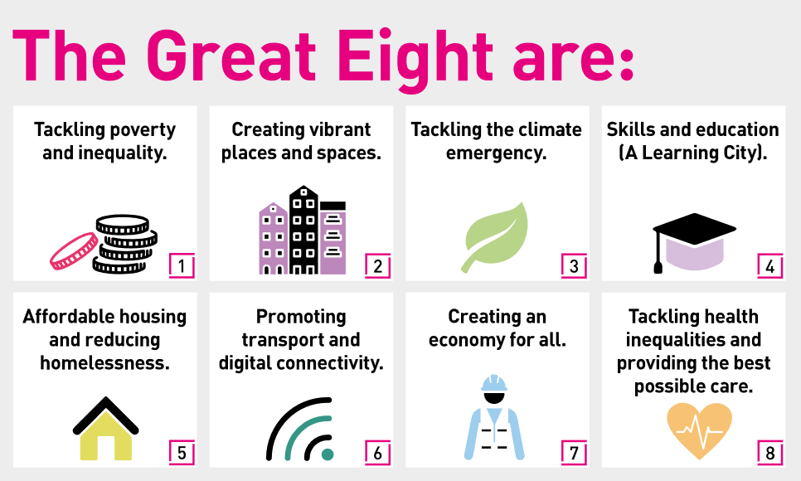

Our organisation’s values
We have four values: Pride, Passion, People, Personal responsibility.
Our four values are central to the way we communicate about the council and the way in which we behave with colleagues, customers, and partners - so that we live and breathe our values each day.



Application guidance
We are a values-based organisation so reflecting our values or a values-based approach in your evidence will support your application.
The different sections of this role profile are there to give you an understanding of the purpose of the role. The ‘what we need from you’ section outlines the minimum criteria you will need to meet within your application.

Role details
Completed by: Simon May
Date:12/08/2026
Job code: 50060471
Job score: 421 - 450
Date of evaluation: November 2023.

