
Fostering Family Support Worker
Service | Reporting to | Location | Grade | Salary | Hours
Fostering Service | Practice Manager | Unity House, Swinton, Salford | 3A  SCP20-24 | £32,597 - £35,412 | 36

About the role
Salford fostering Service want to support children, young people and fostering families.

- Work within the Fostering Service to provide practical support to approved foster carers and the children in their care. This may be listening ear or practical support in response to individual needs, access to other services, training support and guidance.

- Undertake time limited, reviewed, direct support, with carers and children in their care in line with the referral and contribute to the review of the identified support.

- Help foster carers to plan how they will care for a particular child they are looking after in line with their placement plan and any emerging individual needs, in line with our therapeutic approach.

- Work with other members of the Fostering Service, other teams, services, and partners to ensure a high standard of provision and assume specific responsibilities of designated areas of work, including support groups, organising of activities and events in conjunction with our partners.

- Under take Staying Put annual reviews and support for carers who are no longer foster carers in line with Staying Put arrangements, DfE, HMRC and DWP Guidance 2013.

- Full time equivalent of 36 hours, which will include some evening and weekend work in accordance with the needs of the service.

- You will need to travel within the city and around the Greater Manchester area on a regular basis. You must have a driving licence valid in the UK or satisfy the Council that you can make acceptable alternative arrangements, you must declare any previous or pending endorsements on you licence and undertake an enhanced DBS and declare any events that could impact on your DBS.

Key outcomes

- Support recruitment of foster carers in line with the Fostering Recruitment and Retention Strategy Objectives and the action plan for these objectives being achieved. Feeding into processes for monitoring of actions from such plans.

- Support the development and production of fostering materials and information for prospective and existing carers. Work closely with the recruitment officer and coms teams to promote events for the recruitment and retention of foster carers.

- Support the completion of DBS checks for applicant carers and approved carers.

- Facilitate and support, activity groups for carers, their children, cared for children and whole foster family events, facilitating guest speakers as well as social activities to support the building and strengthening of social and support networks amongst foster carers, their children and cared for children.

- Liaise with other services to support the implementation of planned activities, such as the Youth Services, Salford Foster Care Association, ACE group, DBT and commissioned services.

- Help and support both within the home and the community, including with routines, transport, and unforeseen needs which may include in responding to such requirements which arise out of normal office hours including weekends.

- Support carers with accessing online training, finance accounts and with TSD for new carers, promote training opportunities that arise and may benefit carers and the children in their care.

- Support delivery of the 4-session therapeutic model, within group delivery and 1-2-1 subject to individual assessed need. Support planned work with carers in conjunction with supervising social workers to support their learning as identified through their annual reviews and PDP. Maintain clear records of the planned work, review of the initial referral and any further actions.

- Maintain your own training in order to ensure you are able to support carers, children, and young people to understanding and implement trauma informed care.

- Work with internal and external partners in developing polices which support fostering and joint pieces of work.

- Be available to guide and support carers through periods of instability, providing enhanced support, guidance, and interactions. Aid and be part of the support plan, to support placements at risk of breakdown, supporting carers to implement and reflect what they have learned within training.

- Support carers to access therapeutic consultation sessions.

- Undertake staying put reviews for carers who no longer foster, support, supervisions, health and safety, ongoing monitoring of Staying Put placement.

- Contribute to chronologies, for specific pieces of work undertaken as per referral and review point.

- Updating of family profiles.

- Support children and young people, undertaking planned life story work, were there is already an existing relationship, details directed by the allocated worker that helps children and young people understand their background and current care plan.

- Support the development of foster carers skills, understanding of ACES and how these impact on both mental physical health and the development of children and young people.

- Support children to attend family time, school runs or significant appointments in circumstances which carers are unable to do so. Contribute to the review of the contact if you are involved in any way.

- Support carers to meet the child focused national minimum standards that will feed into the assessment of their competency in practical childcare tasks and assist in the development of their skills in these areas.

- Contribute to foster carers annual reviews and cared for children reviews by providing feedback off to work and support undertaken. Attend care planning, 72hrs meetings, transition planning and introduction planning meetings to support the meeting of children’s needs.

- Regularly record and maintain accurate records to reflect the work undertaken ensuring the supervising social worker and social worker for the child are updated and informed of the progress of the work being undertaken.

What we need from you

- Whilst you will have a named based you will be expected to work flexibly around the city.

- Ability to work some evening and weekends as part of your working week.

- You will be creative; person centred and have a flexible approach to support and problem solving.

- You will model and demonstrate our values and behaviours.

- Demonstrated ability to manage a complex caseload and to work at an appropriate level of independence.

- Demonstrated ability to assess needs and risks and formulate plans based on best welfare.

- Monitoring of outcomes, data and information and data to feed into reports.

- Effective communication skills and ability to work in partnership with foster carers, children and young people, members of the public, colleagues, and other agencies.

- Demonstrable commitment to anti-discriminatory practice

- Ability to reflect upon and develop own professional practice.

- Ability to present information effectively and compile written reports.

- Excellent recording and time management skills.

- Desirable or willing to learn electronic systems such as Liquid Logic

What we can offer you
Your ongoing professional development and success in your role is important to us, and that is why we provide a variety of learning and development opportunities. Within the sections below you will find development options tailored to you which will enable you to further develop your existing skills and learn new ones at a pace that suits you best. If you are joining us now, your development will form part of ongoing discussions with your manager. If you are an existing employee, you should use your Personal Development Reviews to discuss your development with your manager and create your development journey. It’s important you also take full advantage of any informal learning available to you during the course of your work.

Online learning
Develop your knowledge across a wide range of areas through our Me-Learning platform, with over 200 free courses to choose from. To have the best possible start and comply with current legislation, you must complete the following modules: Welcome to Salford, Health, and Safety in the Office, GDPR, Equality Essentials, and Safeguarding Children and Adults. You may also benefit from a variety of courses in categories such as Business Skills, IT and Project Management which are available to learn at your own convenience and pace.

Professional Development
Gain role specific skills and time to learn through a wide range of development opportunities. Learn whilst working and get support towards your qualification through an apprenticeship standard. Access professional development ranging from entry level to master’s type qualifications, including achieving a role appropriate qualification. Details can be found on the Institute of apprenticeships website.

Tailored Development
Family Partnership Model of Practice
Trauma informed practice
Staying Put Reviews Training
4 Session Therapeutic Parenting

A digital organisation
Developing your digital skills
Our ambition is to provide our workforce with the right level of digital capabilities needed to be successful. Whatever your current digital abilities are, we can provide development ranging from essential workplace skills to specialist workplace skills. These will be delivered through our Digital Skills Academy using both self-directed and guided learning opportunities to enable you to develop. Additionally, you can access free online courses through the iDea website.

Sharing your digital skills
Our goal is to support you to share your digital knowledge with other people. Our Digital Eagles programme has been designed to cover basic digital skills and build your confidence to assist others. By the end of this programme, you will join hundreds of staff members who already are digital eagles, and be able to help colleagues, customers, residents, or people in your personal life with all things digital.

Our vision and priorities

Our vision
The council has a vision is to create 'A fairer, greener and healthier Salford'. To help us achieve this vision we have identified some key priorities to tackle the problems people in Salford are currently facing, the Great Eight.
Salford is beginning a journey of economic transformation, with the mapping out of the city’s economic future through key pieces of city council work. We’re calling this The Salford Way.
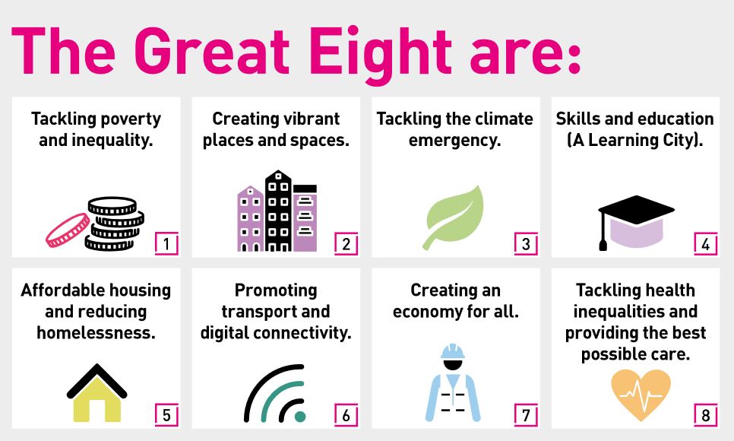

Our organization’s values.
We have four values: Pride, Passion, People, Personal responsibility.
Our four values are central to the way we communicate about the council and the way in which we behave with colleagues, customers, and partners - so that we live and breathe our values each day.



Application guidance
We are a values-based organisation so reflecting our values or a values-based approach in your evidence will support your application.
The different sections of this role profile are there to give you an understanding of the purpose of the role. The ‘what we need from you’ section outlines the minimum criteria you will need to meet within your application.

