Job Application Pack
Level 2 Teaching Assistant
(Religious Education)





Thank you for taking the time to consider applying for the post of Level 2 Teaching Assistant.
At St Patrick’s, it is our mission to ensure that children experience a truly great Catholic education that enables them to flourish academically and shine personally, preparing them for a happy and successful adult life. We are committed to helping every child become the very best version of themselves.
Our school motto is ‘amazing things happen here’ and you only have to spend five minutes in our school to realise that this is absolutely true. We have a strong and dedicated team of professionals who challenge and support students to achieve amazing things and they work hard to create an environment, built on mutual respect, whereby students rise to the challenges set for them. Our strength comes from our drive for excellence in all that we do and our consistent and persistent approach.
We are committed to providing an inclusive workplace where staff feel valued and trusted, and where collaborative working is at the heart of everything we do. We also recognise the importance of supporting our staff to continuously develop in order for them to achieve their own professional career goals.
If you meet the role criteria, are an excellent practitioner and believe that a great education can transform a child’s life and future, we would love to hear from you!
Mrs Alison Byrne
Headteacher
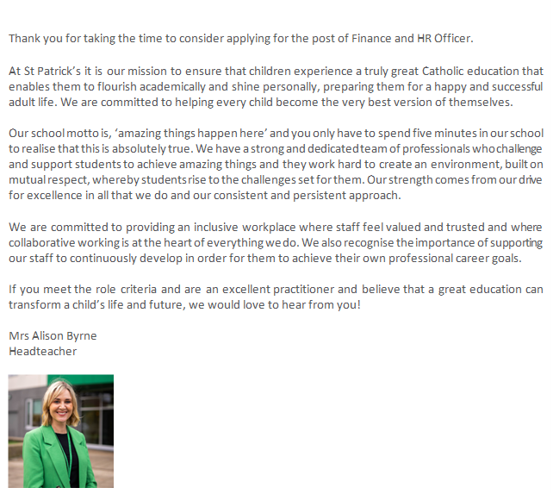

Why St Patrick’s?
Our People Values
Our core people values are at the heart of every decision that we make as an employer. Our aims are:
- To fulfil our Catholic mission, to ensure our children and staff live life to the full.
- To attract, recruit, develop and retain high performing staff, to ensure that we allow pupils to become the best version of themselves.
- To provide a workplace where staff feel valued and trusted.
- To develop and support the growth of leadership and management.
- To promote a culture focused on diversity, inclusivity and wellbeing by creating a healthy work environment to enable staff to perform at their best.
- To provide strong and consistent HR services for all staff, across all school areas.
- To serve the wider education system and provide opportunities for our staff to lead across other schools.

Our Benefits
We have a range of employee benefits available to all our staff. We are always looking at ways in which we can improve our offering to ensure the benefits are valued by our staff.
CPD
We have a strong focus on CDP for our employees, ensuring that learning and development opportunities are offered throughout the academic year. This includes exciting career opportunities to work across other schools.
Pension
An employee earning more than £10,000 and who is more than 22 years of age will automatically be enrolled into one of our workplace pension schemes with excellent employer contributions.
Family Leave
Enhanced family leave is available to support our staff with family commitments and emergencies.
Flexible working
Where possible, we support staff with the ability to work flexibly and recognise the need to work/life balance.
Subsidised Gym Membership
Via our payroll provider, Salford City Council, we are able to offer discount on Salford Council run leisure facilities.
Wellbeing strategy
We are focused on bringing staff wellbeing to the forefront of our people agenda. With an annual wellbeing calendar place, we run events throughout the year to celebrate staff and our school.
We also have an independent Employee Assistance Programme and Occupational health provider in place to support staff with any wellbeing needs.
We are always looking for ways to improve our offering and staff feedback is at the heart of this.

Job Title: Level 2 Teaching Assistant (RE)
Contract Details: Permanent
Hours of work: 8.00am start / 4.00pm finish. Monday – Friday, 35 hours per week. Term-time plus 5 days.
Salary/Grade: 2A
Start date: May 2026
The Governors of St Patrick’s RC High School are looking to appoint an excellent Level 2 Teaching Assistant, who is committed to ensuring our school continues to offer an inclusive environment for all pupils.

Duties will include providing support to teachers, working with pupils on an individual and small group basis to help with their learning in RE. Lesson cover may also be required after training in this area.
The successful candidate will:

- Have a love for education and learning.
- Feel passionately about inclusion for all.
- Have experience/a background in supporting pupils with additional needs.
- Have good subject knowledge of Religious Education within our Catholic context.
- Have high regard for their learning environment and resources.
- Have the desire to inspire, engage and enthuse students.
- Engage with professional development opportunities, training sessions and CPD.
Job Summary
To apply, please write a letter of application (no more than 2 sides of A4) detailing your suitability for the role with reference to the job description and person specification, and submit by email to dolan.e@stpatricksrchigh.co.uk

Closing date for applications: Friday 24th April 12.00pm.

Interviews: w/c 27th April 2026.

This school is committed to safeguarding and promoting the welfare of children and young people and expects all staff and volunteers to share this commitment.

The successful applicant will be required to complete an enhanced DBS check.

Job Description
Post Title: | Level 2 Teaching Assistant (Religious Education)
Salary/Grade: | 2A
Status: | The post holder is accountable to the designated SENDCo.
Purpose: | To provide high-quality support within the RE department, assisting teachers in raising pupil achievement by supporting teaching and learning activities. The successful candidate will work primarily with students who require additional support in developing literacy skills, including reading, writing, SPaG and comprehension across Key Stage 3 and Key Stage 4.  Safeguarding  The post holder must be aware of child protection issues and the need for confidentiality and to identify to the named child protection colleague in school, concerns in respect of individual children.  The post holder must carry out their duties with full regard to the City Council’s Equal Opportunities, Health and Safety, Community Strategy and Code of Conduct Policies.
Primary Responsibilities: | - Support students in RE lessons, under the direction of the Head of RE and class teachers.  - Develop, deliver and facilitate small group or 1:1 literacy interventions tailored to pupils’ specific needs.  - Help to prepare, adapt and organise resources to support inclusive quality first teaching and learning in RE.  - Promote pupil engagement and confidence in reading and writing, particularly with SEND and disadvantaged pupils.  - Monitor student progress and provide feedback to teachers and relevant staff.  - Assist with the supervision of students both in and out of the classroom as required.  - Assist with the development of bespoke learning plans for SEND pupils in conjunction with the SENDCO and relevant staff.  - Work collaboratively with staff across the RE department and the wider school to ensure the best possible outcomes for students.  - Contribute to maintaining a positive, safe, and inclusive learning environment.  - Support the role of parents in pupils’ learning and contribute to meetings with parents to provide constructive feedback on pupil progress/achievement etc.  - Support with general administrative tasks linked to pupil support and assessment tracking.  - Support with the organisation of enrichment and co-curricular activities linked to the RE department and Chaplaincy as appropriate.
Additional Responsibilities | - Cover Duties: On occasions where staff absence (teachers or teaching assistants) renders it necessary, the post holder must be prepared to cover lessons and/or in-class support.  - Catholic ethos: The postholder is required to support the Catholic life and mission of the school at all times. As a member of the RE department, this includes contributing towards Chaplaincy provision as reasonably directed by the Head of RE and Deputy Headteacher.  - Hours of work: The post holder may be required to undertake work outside of their normal working hours on occasion with due notice (e.g. for meetings and training events).

Person Specification

The Person Specification is an important part of the recruitment process. It should be read carefully as it will form the basis of shortlisting and ultimately, appointing the successful applicant. You must demonstrate therefore how you meet each of the following essential criteria in your application.

Criteria | Essential | Desirable | Measured by
Qualifications | Good numeracy/literacy skills.  Willingness to participate in development and training opportunities during and outside of contracted hours.  English at GCSE grade 4/C or above (or equivalency).  Maths at GCSE grade 4/C or above (or equivalency).  Appropriate SEND specific qualifications and/or professional development. | Religious Education GCSE grade 4/C or above.  Further Education and/or Higher Education qualifications in Religious Studies or a related course (i.e. post-16 study, undergraduate study, postgraduate study). | A / I
Skills | Ability to use basic technology i.e., computer, photocopier.  Ability to relate well to children and their families.  Ability to work collaboratively as part of a team.  Ability to prioritise tasks and be well organised.  Good communication and interpersonal skills.  Empathetic, patient, calm, nurturing and compassionate.  Ability to follow EHCPs and pupil passports/learning plans.  Ability to track pupil attainment and progress over time.  Excellent record-keeping.  Strong literacy skills and confidence in supporting the secondary RE curriculum (KS3 and KS4 / GCSE). | Knowledge of additional needs commonly catered for within mainstream schools across all areas of need.  Knowledge of different strategies to support pupils in accessing the RE curriculum and developing their religious literacy.  Ability to deliver appropriate interventions relevant to this area of the curriculum.  Ability to implement the use of specific equipment, resources and technology to improve pupils’ access to learning and enrichment.  Should the above not be possessed, the candidate must have the willingness to undertake training to acquire these skills. | A / I / R
Experience | Working with or caring for children of relevant age.  Experience supporting pupils to improve their RE and religious literacy.  Experience of supporting pupils who have EHCPs. | Experience of supporting the RE department in a secondary school setting.  Experience of working collaboratively with teachers and Curriculum Leaders.  Experience in producing and reviewing individual learning plans. | A / I / R
Other | Fulfilment of the Teaching Assistant Standards to a high standard.  The school is committed to safeguarding and promoting the welfare of children and expects all staff and volunteers to share this commitment.  Commitment to the Catholic Life and Mission of the School. | Practising Catholic.  Experience leading or supporting Chaplaincy initiatives. | A / I / R

St Patrick’s RC High School is committed to safeguarding and promoting the welfare of children and young people and expects all staff to share this commitment. The successful applicant will be subject to enhanced DBS clearance and satisfactory references.

