
Administration Officer
Service  Children’s Services | Reporting to  Office Manager | Location  Unity House | Grade  2A

About the role
This role will be an integral part of the Education and Early Help administration service. It will provide an effective and efficient administration support to internal and external customers and support the office manager and service manager to standardise systems, process, and practices in response to changes.
The role will work closely with practitioners and support staff from council and other organisations and actively support integrated ways of working.
To record and maintain client information systems will be updated and maintained ensuring that all information is validated before it is entered onto Salford Council Information systems
Meetings will be attended, and minutes taken and distributed in a timely manner as asked by the office manager.
The team will provide support and be required to type a range of documents to an excellent standard

Key outcomes
- You will support the SEN service area, business processes that contribute to the work of the service, third party and partner organisations
- You will record and maintain client information systems and validate all information before entering onto Salford city council’s information systems.
- You will liaise appropriately and effectively with officers from other service areas where business processes interrelate
- You will respond efficiently and courteously to telephone enquiries, ensuring the information conveyed is accurate, callers signposted to other service areas where appropriate, or accurate messages taken in the absence of officers from the service
- You will undertake such additional duties as are reasonably commensurable with the level of the post
- You will provide administration support within the SEN admin service area to a good standard
- You will accurately maintain, organise, and action work emanating from the Council’s document system and client databases used by the service, third parties and partner organisations.
- You will attend and participate in supervision, development and consultation meetings with the Office Manager and provide regular updates on the day-to-day activities of the service area
- You will treat all information in accordance with Salford City Council’s policies on confidentiality and Data Protection

What we need from you
- To model and demonstrate our values and behaviours.
- Proven technical admin skills and a record of accomplishment for delivering admin outcomes
- Excellent IT Skills, to enable the authorities’ systems to be updated and all information validated, and confidentiality is adhered to.
- To be able to take actions with accuracy within the teams SEN panel meetings and distribute within timescales
- To be an excellent communicator using various mediums to achieve the best results.
- To remain positive under challenging circumstances
- To deal effectively with people at all levels from a broad range of organisations
- Good interpersonal skills dealing with enquiries by telephone
- To work flexibly as a member of the team and be willing to offer support to colleagues
- To follow set procedures and make suggestions for change
- Ability to contribute to ongoing improvement by responding proactively to change and continuously reviewing working methods and procedures to ensure that they remain effective
- To be able to record and process information accurately
- To work across Children’ Services to support other areas in times of demand
- Ability to prioritise and organise your own workload to meet deadlines, and to work with minimum supervision using initiative.
- Commitment to providing a high-quality customer focussed service

What we can offer you
Your ongoing professional development and success in your role is important to us, and that is why we provide a variety of learning and development opportunities. Within the sections below you will find development options tailored to you which will enable you to further develop your existing skills and learn new ones at a pace that suits you best. If you are joining us now, your development will form part of ongoing discussions with your manager. If you are an existing employee, you should use your Personal Development Reviews to discuss your development with your manager and create your development journey. It’s important you also take full advantage of any informal learning available to you during the course of your work.

Online learning
Develop your knowledge across a wide range of areas through our Me-Learning platform, with over 200 free courses to choose from. To have the best possible start and comply with current legislation, you must complete the following modules: Welcome to Salford, Health and Safety in the Office, GDPR, Equality Essentials, and Safeguarding Children and Adults. You may also benefit from a variety of courses in categories such as Business Skills, IT and Project Management which are available to learn at your own convenience and pace.

Professional Development
Gain role specific skills and time to learn through a wide range of development opportunities. Learn whilst working and get support towards your qualification through an apprenticeship standard. Access professional development ranging from entry level to master’s type qualifications, including achieving a role appropriate qualification. Details can be found on the Institute of apprenticeships website.

Tailored Development
Full training will be given to complete the required work across each service supported within the Education and Early Help Service.

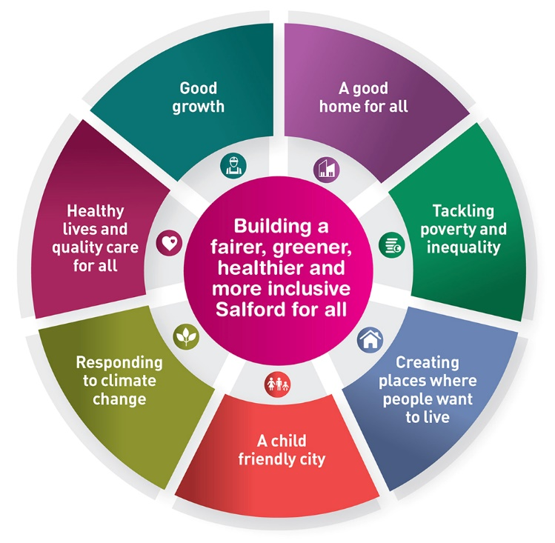

A digital

organisation
Developing your digital skills
Our ambition is to provide our workforce with the right level of digital capabilities needed to be successful. Whatever your current digital abilities are, we can provide development ranging from essential workplace skills to specialist workplace skills. These will be delivered through our Digital Skills Academy using both self-directed and guided learning opportunities to enable you to develop. Additionally, you can access free online courses through the iDea website.

Sharing your digital skills
Our goal is to support you to share your digital knowledge with other people. Our Digital Eagles programme has been designed to cover basic digital skills and build your confidence to assist others. By the end of this programme you will join hundreds of staff members who already are digital eagles, and be able to help colleagues, customers, residents, or people in your personal life with all things digital.

Our vision and priorities

Our vision

The council has a vision is to create 'A fairer, greener and healthier Salford'. To help us achieve this vision we have identified some key priorities to tackle the problems people in Salford are currently facing, the Great Eight.
Salford is beginning a journey of economic transformation, with the mapping out of the city’s
economic future through key pieces of city council work. We’re calling this The Salford Way.

Our organisation’s values
We have four values: Pride, Passion, People, Personal responsibility.
Our four values are central to the way we communicate about the council and the way in which we behave with colleagues, customers, and partners - so that we live and breathe our values each day.



Application guidance
We are a values-based organisation so reflecting our values or a values-based approach in your evidence will support your application.
The different sections of this role profile are there to give you an understanding of the purpose of the role. The ‘what we need from you’ section outlines the minimum criteria you will need to meet within your application.

Role details
Completed by: Sue King
Date: 20.01.2023
Job code:
Job score:
Date of evaluation:

