Springwood Primary School




Teaching Assistant Level 1

Job Description Person Specification

Information about Springwood Primary School

Springwood is a large primary age Special School (375 pupils aged 5 – 11) based over a number of sites, which caters for pupils with moderate, severe and complex needs. Springwood is part of The LINK Education Trust.

Pupils who are Nursery - Y2 age attend our Craig Hall Site in Irlam, those who are Y2-Y6 attend our site in Swinton. Additionally, we have small groups of pupils based at our Belvedere, Grosvenor Road and Little Hulton sites. Depending on pupil need and peer group, the decision is made annually as to which site pupils are based at.

Despite being split across various sites, the school is a cohesive learning environment with the same provision and expectations across the whole school.

Vision Statement

Springwood Primary School provides a safe, stimulating environment in which all pupils have the opportunity to succeed

At Springwood we respect each other, our pupils and their families. We have a curriculum that is meaningful, inspiring and enjoyable, promoting achievement for all. Through carefully planned holistic learning, pupils are enabled to achieve their best.
Springwood Primary School’s mission statement is Believe, Enjoy, Succeed, Together. At Springwood BEST is embodied through everything that we do.
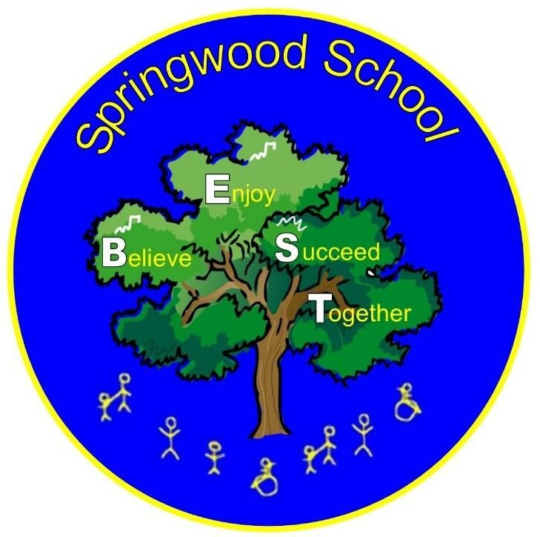
JOB DESCRIPTION
SCHOOL: Springwood Primary School
JOB DETAILS:
Job Title: |  | Teaching Assistant - Level 1
Grade: |  | Grade 1B (pt 4-5) plus SNA 1 allowance
Directly responsible to: |  | Head of School / Class Teacher / other employee within school
Directly responsible for: |  | N/A
Hours of Duty: |  | 32.5hrs per week
Summary of Role:
To work under the direct instruction of teaching/senior staff and usually in the classroom with a teacher to support access to learning for pupils and provide general support to the teacher in the management of pupils and the classroom.
Main Duties and Responsibilities/Accountabilities:
Support for the Teacher
1. | Assisting with the display of pupils’ work and the preparation of the classroom and equipment as directed for lessons and clear up afterwards.
2. | Organisation and preparation of classroom resources in accordance with lesson plans and assist pupils in their use.
3. | Maintenance of pupil records as necessary and gather/report information from/to parents/carers as directed.
4. | Promote good pupil behaviour, dealing with incidents in line with established policy and support the teacher in managing pupil behaviour, reporting difficulties as appropriate.
5. | Be aware of pupil barriers/progress/achievements and report to the teacher as agreed.
Support for the Pupils
1. | Provide support for pupils, specifically those with special educational/health needs, ensuring their safety and access to learning. Promote self- esteem and encourage pupils to act independently as appropriate.
2. | Undertake structured and agreed learning activities, recording achievement and progress and feeding back to the teacher.
3. | Promote the inclusion and acceptance of all pupils.
4. | To assist and encourage pupils in self-help and self-care and to be part of the self- care team engaged in toileting, changing and training all pupils requiring this type of care, and to undertake laundry/cleaning duties.
5. | Attend to pupil’s personal needs and implement related personal programs, including social, health, physical, hygiene, First Aid and welfare matters.

6. | Establish good relationships with pupils, acting as a role model and being aware of and responding to individual needs.
7. | Assist the teacher to supervise and support pupils ensuring their safety and access to learning.
8. | Encourage pupils to interact and engage in activities led by the teacher.
Support for the Curriculum
1. | Support pupils to understand instructions from the teacher.
General Tasks
1. | To undertake the physically demanding aspects of the role that includes but is not limited to a lot of moving and handling of children whom have very unpredictable and often physically challenging behaviours.
2. | Provide clerical/administration support e.g. photocopying, typing, filing, collecting money, contacting parents etc.
3. | Be aware of and comply with policies and procedures relating to Child Protection, health, safety and security, confidentiality and data protection, reporting all concerns to an appropriate person.
4. | Contribute to the overall ethos/work/aims of the school.
5. | Attend relevant meetings as required and participate in training and other learning activities and performance development as required.
6. | Assist with the supervision of pupils during lesson times, including before and after school and at lunchtimes where appropriate.
7. | Accompany teaching staff and pupils on trips and visits and other school activities as required.
8. | Safeguarding  The post-holder must be aware of child protection issues and the need for confidentiality and to identify to the named child protection colleague in school, concerns in respect of individual children.
Review Arrangements:
The details contained in this Job Description reflect the content of the job at the date it was prepared. It should be remembered, however, that it is inevitable that over time, the nature of individual jobs will change, existing duties may no longer be required and other duties may be gained without changing the general nature of the duties or the level of responsibility entailed. Consequently, the Trust will expect to revise this Job Description from time to time and will consult with the post-holder at the appropriate time.

PERSON SPECIFICATION
Job title | Grade | School | Location
Teaching Assistant Level 1 | Grade 1B (pt 4-5) SNA 1 | Springwood Primary School | As per job advert
Note to applicantsWhilst all criterions below are important, those under the Essential heading are the key requirements. You should pay particular attention to these areas and provide evidence of meeting them. Failure to do so may mean that you will not be invited for interview.
(*See grid overleaf)
Essential criteria | Necessary requirements – skills, knowledge, experience etc. | * M.O.A.
1. | Good Numeracy Literacy skills. | A/I
2. | Participate in development and training opportunities. | A/I
3. | Use basic technology - computer, video, and photocopier. | A/I/T
4. | Ability to relate well to children and adults. | A/I
5. | Work constructively as part of a team, understanding classroom roles and responsibilities. | A/I
6. | Ability to undertake the physically demanding aspects of the role that involves a lot of moving and handling of children whom have very unpredictable and often physically challenging behaviours | A/I

Desirable criteria | Necessary requirements – skills, knowledge, experience etc. | * M.O.A.
1. | Willing to complete the Teaching Assistant Introductory Training. | A/I
2. | Willing to work towards Supporting Teaching and Learning Level 2 Certificate | A/I
3. | Willing to work towards Supporting Teaching and Learning Level 3 Certificate | A/I
4. | Appropriate knowledge of first aid | A/I
5. | Working with or caring for children of relevant age. | A/I
Method of assessment (* M.O.A.)A = Application form, C = Certificate, E = Exercise, I = Interview, P = Presentation, T = Test, AC = Assessment centre

Springwood Primary School
Barton Road
Swinton
Manchester
M27 5LP
☎ 0161 778 0022 – opt 1

Website: Springwood Primary School Facebook: Springwood Primary School Facebook Twitter: Springwood Twitter - @SpringwoodSch

