
Job title
Service | Reporting to | Location | Grade | Salary | Hours
Ethnic Minority and Traveller Achievement Service (EMTAS) | Service Manager for EMTAS | Peripatetic | 2C | Enter pro-rata salary range  £21,748 | 32.5

About the role
To provide direct 1-1 or small group support for pupils with English as an additional language, Gypsy Roma Traveller and asylum and refugee children in Salford schools across the age and ability range. This will include:
Travelling across the city to different schools to meet demand where it arises.
Planning intervention sessions in liaison with class teachers and EMTAS teaching staff
Delivering highly motivating and stimulating sessions to children
Helping children to develop their listening, speaking, reading and writing skills in English
Tracking and recording individual progress
Using a variety of stimulating resources including digital resources
Developing good relations between schools and the service
Maintaining records impacting on the assessment of learning and informing future learning.

To promote local, regional, and national inclusion events in schools and support with resources for such events as Black History Month, Refugee week and Gypsy Roma Traveller History Month and many more.

Key outcomes
__________________________________________

Improved educational outcomes for English as an additional language, Gypsy Roma Traveller and asylum/refugee children across the age and ability range.
Improved awareness and knowledge of staff in schools of the needs of English as an additional language, Gypsy Roma Traveller, and asylum/refugee children.
Teaching and support staff will feel confident when working with English as an additional language, Gypsy Roma Traveller and asylum refugee children and will develop greater cultural competency.
English as additional language, Gypsy Roma Traveller and asylum/refugee children will have better access to the wider curriculum and extracurricular activities.
Better integration of English as an additional language and asylum/refugee children through accelerating English language acquisition.
There will more opportunities for the voice of English as an additional language, Gypsy Roma Traveller, and asylum/refugee children to be heard, shaping policies and decisions at a senior level. The children will feel valued and know that their ideas and contributions will be listened to.
Schools will have a greater understanding of the importance of inclusive events and the celebration of diversity, culture, and heritage.
Schools will be more inclusive and cohesive.
Improved awareness of the emotional health and wellbeing needs of English as an additional language, Gypsy Roma Traveller, and asylum/refugee children, including trauma.

English as an additional language, Gypsy Roma Traveller and asylum/refugee children are thriving, happy and confident learners

What we need from you

Proven high quality mainstream experience

Experience in teaching children with additional needs such as English as an additional language

Excellent communication skills, both oral and written, with an ability to relate to and communicate with a wide range of people, including parents, teachers, Head teachers, local authority colleagues, and professionals from other agencies.

Excellent presentation skills either in person and virtual.

An ability to work in a team environment, being supportive, adaptable, and flexible.

Ability to work independently within agreed service priorities and taking an active role in self-review.

A champion for equality and diversity and a willingness to challenge negative stereotypes and perceptions when necessary.

A creative approach when problem solving and a can-do attitude at all times

Ability to travel throughout the city during normal working hours, a current driving licence and access to a car during normal working hours is essential. (Reasonable adjustments will be made for candidates with a disability)

Enhanced DBS check as per current legislation

To maintain confidentiality and observe data protection and associated guidelines where appropriate.

To carry out any other reasonable duties and responsibilities within the overall function, commensurate with the grading and level of the responsibilities of the post.

To model and demonstrate our values and leadership behaviours
What we can offer you
___________________________________________
Your ongoing professional development and success in your role is important to us, and that is why we provide a variety of learning and development opportunities. Within the sections below you will find development options tailored to you which will enable you to further develop your existing skills and learn new ones at a pace that suits you best. If you are joining us now, your development will form part of ongoing discussions with your manager. If you are an existing employee, you should use your Personal Development Reviews to discuss your development with your manager and create your development journey. It’s important you also take full advantage of any informal learning available to you during the course of your work.

Online learning
Develop your knowledge across a wide range of areas through our Me-Learning platform, with over 200 free courses to choose from. To have the best possible start and comply with current legislation, you must complete the following modules: Welcome to Salford, Health and Safety in the Office, GDPR, Equality Essentials, and Safeguarding Children and Adults. You may also benefit from a variety of courses in categories such as Business Skills, IT and Project Management which are available to learn at your own convenience and pace.

Professional Development
Gain role specific skills and time to learn through a wide range of development opportunities. Learn whilst working and get support towards your qualification through an apprenticeship standard. Access professional development ranging from entry level to master’s type qualifications, including achieving a role appropriate qualification. Details can be found on the Institute of apprenticeships website.

A digital organisation
Developing your digital skills
Our ambition is to provide our workforce with the right level of digital capabilities needed to be successful. Whatever your current digital abilities are, we can provide development ranging from essential workplace skills to specialist workplace skills. These will be delivered through our Digital Skills Academy using both self-directed and guided learning opportunities to enable you to develop. Additionally, you can access free online courses through the iDea website.

Sharing your digital skills
Our goal is to support you to share your digital knowledge with other people. Our Digital Eagles programme has been designed to cover basic digital skills and build your confidence to assist others. By the end of this programme you will join hundreds of staff members who already are digital eagles, and be able to help colleagues, customers, residents, or people in your personal life with all things digital.

Our vision and priorities

Our vision
The council has a vision is to create 'A fairer, greener and healthier Salford'. To help us achieve this vision we have identified some key priorities to tackle the problems people in Salford are currently facing, the Great Eight.
Salford is beginning a journey of economic transformation, with the mapping out of the city’s economic future through key pieces of city council work. We’re calling this The Salford Way.
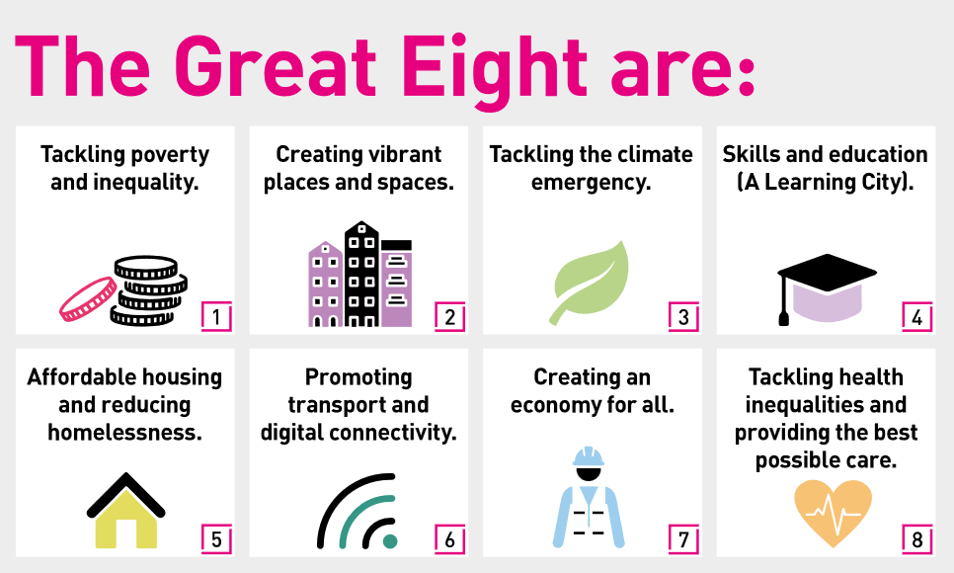

Our organisation’s values
We have four values: Pride, Passion, People, Personal responsibility.
Our four values are central to the way we communicate about the council and the way in which we behave with colleagues, customers, and partners - so that we live and breathe our values each day.



Application guidance
We are a values-based organisation so reflecting our values or a values-based approach in your evidence will support your application.
The different sections of this role profile are there to give you an understanding of the purpose of the role. The ‘what we need from you’ section outlines the minimum criteria you will need to meet within your application.

