
Principal Programme Manager
Service | Reporting to | Location | Grade
Place | Group Leader, Regeneration | Civic Centre | 5A

About the role.
Your Key Areas of Responsibility:
- Leads and directs regeneration programmes and projects in accordance with agreed programme/project objectives and outcomes in consultation with key stakeholders.
- Ensures that programmes/ projects produce the required products in accordance with agreed programme/project scope, quality, timescale and budgetary criteria.
- Ensures that the programme produces results which are capable of achieving the strategic outcomes and benefits defined in the agreed programme documentation.
- Assists the Group Leader in the development, management and monitoring of the Regeneration capital programme, revenue budget and Directorate Business Plan.
- Delivers the strategic vision of the Regeneration programme working alongside Elected Members, Strategic Directors and key partners.
- Works with senior management and across the service group to develop and effectively programme manage the programmes and projects.
- Establishes programmes from outset in terms of vision, scope, outcomes, products, governance in accordance with Salford standards and as agreed with programme SROs and Boards where appropriate.
- Leads, coordinates and manages overall programme of related projects throughout all development and delivery stages.
- Creates overall team structures, stakeholders and other necessary resources and brief (as above).
- Leads in delivering effective communication, liaison and negotiation and with a wide range of stakeholders and partners, ensuring they are appropriately involved in critical decisions. Develop and maintain effective relationships with stakeholders and partners.
- Research, prepare and present reports and papers for consideration by City Mayor, Deputy City Mayor, and Assistant Mayors and to advise them on matters of strategic policy, budget monitoring and resource procurement issues affecting the City.
- Represents the City Council and Service Group both internally and externally on the programme as necessary.
- Gives professional advice at all levels of the Corporate Regeneration governance arrangements to ensure the successful delivery of the project objectives.
- Represents the interests of Salford City Council in matters on inter authority organisations/meetings and other external bodies as directed by the Group Leader.

Key outcomes
- Works in partnership with the private sector to develop and deliver innovative ways to secure commercial and public finance and investment funding to deliver tangible benefits that promote growth and transformation.
- Leads delivery of complex multi-agency regeneration projects
- Plans, monitors and manages projects and programmes identifying and mitigating any commercial, financial or legal risks.
- Manages and delivers complex, multi stakeholder projects or programmes to time and budget, ensuring highest level of communication and relationship management across all levels.
- Leads procurement exercises, ensuring best value for money and adherence to appropriate financial arrangements.
- Manages and monitors budgets and financial risks associated with programmes and projects to ensure effective management and financial propriety.
- Leads change management activities including change impact assessment, stakeholder management, managing resistance, building change capacity, designing and defining roles and responsibilities.
- Ensures that projects remain compliant with any legislative or governance changes at a Salford, Greater Manchester and national level.
- Manages and supervises the day to day work of subordinate team members as directed by the Group Leader.

What we need from you
- To model and demonstrate our values and leadership behaviours.
- Proven technical skills and ability in the role with a record of accomplishment for delivering outcomes
- Professional credibility through proven relevant experience
- Models and demonstrates our values and leadership behaviours
- 3 years experience of leading, implementing and managing a range of multi-agency complex projects to deliver physical and economic regeneration
- Experience of developing and implementing effective project management systems to deliver successful major projects
- Experience of and working in the development industry with private sector partners, a strong understanding of development finance and commercial awareness with the ability to engage with developers and investors to secure growth
- Political awareness in a city region context.
- Commercial awareness and market knowledge across sectors
- In-depth knowledge and understanding of planning and urban regeneration initiatives, Government funding initiatives and programmes, external funding programmes and initiatives
- Highly developed organisational awareness and ability to understand any sensitivities within a complex multi-stakeholder structure; and think strategically to overcome obstacles to co-operation and progress
- In-depth knowledge and understanding of planning and urban regeneration initiatives, Government funding initiatives and programmes, external funding programmes and initiatives.

What we can offer you
Your ongoing professional development and success in your role is important to us, and that is why we provide a variety of learning and development opportunities. Within the sections below you will find development options tailored to you which will enable you to further develop your existing skills and learn new ones at a pace that suits you best. If you are joining us now, your development will form part of ongoing discussions with your manager. If you are an existing employee, you should use your Personal Development Reviews to discuss your development with your manager and create your development journey. It’s important you also take full advantage of any informal learning available to you during the course of your work.

Developing your leadership skills
We want to equip our leaders with the knowledge, skills and behaviours outlined in our #LeadingSalford programme. Our aim is to support you to lead highly engaged, motivated teams in today’s rapidly changing environment. This will be achieved through a range of bite-size Master Classes designed to help you meet the expectations that we have of our Salford leaders. In addition to the core Master Classes, we also provide accredited leadership programmes which let you build on your experience, learn about emerging approaches, and further develop your leadership practice.

Online learning
Develop your knowledge across a wide range of areas through our Me-Learning platform, with over 200 free courses to choose from. To have the best possible start and comply with current legislation, you must complete the following modules: Welcome to Salford, Health and Safety in the Office, GDPR, Equality Essentials, and Safeguarding Children and Adults. You may also benefit from a variety of courses in categories such as Business Skills, IT and Project Management which are available to learn at your own convenience and pace.

Professional Development
Gain role specific skills and time to learn through a wide range of development opportunities. Learn whilst working and get support towards your qualification through an apprenticeship standard. Access professional development ranging from entry level to master’s type qualifications, including achieving a role appropriate qualification. Details can be found on the Institute of apprenticeships website.

A digital organisation
Developing your digital skills
Our ambition is to provide our workforce with the right level of digital capabilities needed to be successful. Whatever your current digital abilities are, we can provide development ranging from essential workplace skills to specialist workplace skills. These will be delivered through our Digital Skills Academy using both self-directed and guided learning opportunities to enable you to develop. Additionally, you can access free online courses through the iDea website.

Sharing your digital skills
Our goal is to support you to share your digital knowledge with other people. Our Digital Eagles programme has been designed to cover basic digital skills and build your confidence to assist others. By the end of this programme, you will join hundreds of staff members who already are digital eagles, and be able to help colleagues, customers, residents, or people in your personal life with all things digital.

Our leadership behaviour framework
Leadership is action, not a position. It’s not just what we do but how we do it.
Whatever your role at Salford, we all strive to achieve our vision and the best outcomes for the residents and communities of Salford.
As leaders, we all have an important part to play in achieving our organisational and service priorities. These priorities give us direction and a shared purpose in our roles and should be the focus when making decisions.
We can help make these priorities a reality by living and breathing our Salford values and leadership behaviours.
This framework is broken down into three main areas:
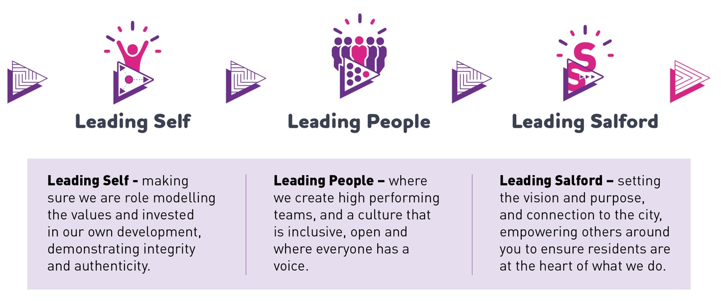
This behaviour framework will support us all to reflect and hold ourselves, and each other to account, as we strive for continuous improvement.
Full details of how this framework shapes our Leaders and is delivered in the workplace can be found on the Salford Leadership pages of our greater.jobs website.

Our organisation’s values
We have four values: Pride, Passion, People, Personal responsibility.
Our four values are central to the way we communicate about the council and the way in which we behave with colleagues, customers, and partners - so that we live and breathe our values each day.



Application guidance
We are a values-based organisation so reflecting our values or a values-based approach in your evidence will support your application.
The different sections of this role profile are there to give you an understanding of the purpose of the role. The ‘what we need from you’ section outlines the minimum criteria you will need to meet within your application.

Role details
Completed by: Peter O’Hare
Date:
Job code:
Job score:
Date of evaluation:

