# Education Advisor – Virtual School

| **Service** | **Reporting to** | **Location** | **Grade** |
| --- | --- | --- | --- |
| **Virtual School** | Lead Education Advisor - (Extended Duties) | Unity House/Hybrid | 3B  Term Time plus 10 days |

## About the role

* You will provide advice, guidance and training to a range of agencies promoting the education of children in the following cohorts, primarily those who are not cared for:
  + Children on Child Protection or Child in need plans.
  + Children who were previously Looked After and were Adopted, subject to a Child Arrangement Order or a Special Guardianship Order directly from care.
  + Children in formal Kinship Arrangements who are not and have never been looked after.
  + Other cohorts who may come under the remit of the Virtual School.
* You will be the point of contact within the Virtual School team for queries relating to the education and inclusion of the above cohort and provide professional advice around statutory processes to schools, social worker and parents and special guardians.
* You will support in the planning and delivery of training to a variety of audiences
* You will contribute to the development of materials and information relevant to the needs to supporting the needs of the cohort, ensuring that best practice is developed and adopted.
* You will understand and be passionate about the importance of belonging, inclusion and trauma responsive and relational practices and be able to use this to provide advice and advocacy.
* You will support the Lead Advisor in attendance at local and regional network meetings and represent Salford Virtual School and keep abreast of current developments and good practice.

## Key outcomes

* Accurate and timely advice is given to ensure that statutory and non statutory duties of the local authority are fulfilled in order to ensure that all formal legal requirements are discharged and all locally agreed operational procedures are maintained.
* Relationships with other professionals, young people and their parents/carers are productive and set high expectations for the young person, taking into account their views and advocating on their behalf.
* Complex operational relationships with schools and partner agencies are managed well and ensure that the child remains at the centre of decision making..
* Advice, guidance, support and good communication practices engage all partners.
* Good practice is disseminated effectively and implemented across all services.
* Sensitive and effective dealing of, sometimes difficult and challenging, telephone and written queries and complaints.

## What we need from you

* Passion and determination to ensure that our children achieve the best possible educational outcomes.
* Experience of working with or in schools, with the ability to establish and manage good working relationships with colleagues at all levels.
* Knowledge of Education legislation and statutory and non-statutory guidance relating to admissions, attendance and exclusions as well as guidance relating to the work of the Virtual School.
* Experience of working in an education setting or local authority in a role relating to school attendance and / or inclusion.
* A flexible approach to work and a high level of reliability, initiative and creativity with a solution-focused approach to working.
* Good levels of literacy and numeracy and ability to work accurately with attendance and other data, having a good eye for detail.
* A good level of competency in basic computer skills including the use of Excel, Teams, management information systems such as Liquid Logic, having regard to the GDPR and associated policies.
* Good interpersonal skills, with the ability to quickly build relationships, to work independently and in a team situation
* Deal with confidential information discreetly with in the requirements of GDPR
* Established written and verbal communication skills appropriately and sensitively applied and adapted to a variety of audiences
* Experience of working with people in sometimes highly charged and/or emotional situations
* Systematic approach to planning and prioritising competing demands, whilst working accurately to tight deadlines
* Commitment to and understanding of inclusion, diversity and equality
* Willingness to work outside normal hours from time to time
* Ability to drive and willingness to attend occasional meetings in schools and other settings and deliver training.
* You will carry out your duties to the highest standard, with full regard to the City Council’s and Service’s policies, procedures, protocols and Code of Conduct
* Willingness to apply for an enhanced disclosure check is required

## What we can offer you

Your ongoing professional development and success in your role is important to us, and that is why we provide a variety of learning and development opportunities. Within the sections below you will find development options tailored to you which will enable you to further develop your existing skills and learn new ones at a pace that suits you best. If you are joining us now, your development will form part of ongoing discussions with your manager. Develop your knowledge across a wide range of areas through our Me-Learning platform, with over 200 free courses to choose from. To have the best possible start and comply with current legislation, you must complete the following modules: Welcome to Salford, Health and Safety in the Office, GDPR, Equality Essentials, and Safeguarding Children and Adults. You may also benefit from a variety of courses in categories such as Business Skills, IT and Project Management which are available to learn at your own convenience and pace.

**Professional Development**

Gain role specific skills and time to learn through a wide range of development opportunities. Learn whilst working and get support towards your qualification through an apprenticeship standard. Access professional development ranging from entry level to master’s type qualifications, including achieving a role appropriate qualification. Details can be found on the Institute of apprenticeships website.

**Tailored Development**

You will have access to support and development from within the team and our commissioned partners, as well as the National Association for Virtual School Heads.

**A digital organisation**

**Developing your digital skills**

Our ambition is to provide our workforce with the right level of digital capabilities needed to be successful. Whatever your current digital abilities are, we can provide development ranging from essential workplace skills to specialist workplace skills. These will be delivered through our Digital Skills Academy using both self-directed and guided learning opportunities to enable you to develop. Additionally, you can access free online courses through the iDea website.

**Sharing your digital skills**

Our goal is to support you to share your digital knowledge with other people. Our Digital Eagles programme has been designed to cover basic digital skills and build your confidence to assist others. By the end of this programme you will join hundreds of staff members who already are digital eagles, and be able to help colleagues, customers, residents, or people in your personal life with all things digital.

## Our vision and priorities

### Our vision

The council has a vision is to create **'A fairer, greener and healthier Salford'.** To help us achieve this vision we have identified some key priorities to tackle the problems people in Salford are currently facing, the Great Eight.

Salford is beginning a journey of economic transformation, with the mapping out of the city’s economic future through key pieces of city council work. We’re calling this The Salford Way.

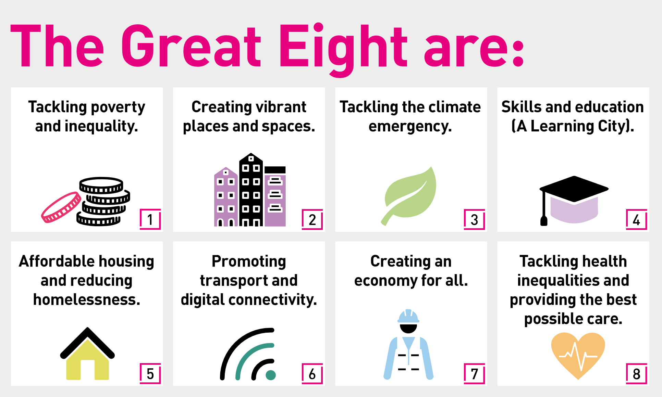

## Our organisation’s values

**We have four values: Pride, Passion, People, Personal responsibility.**

Our four values are central to the way we communicate about the council and the way in which we behave with colleagues, customers, and partners - so that we live and breathe our values each day.



## Application guidance

We are a values-based organisation so reflecting our values or a values-based approach in your evidence will support your application.

The different sections of this role profile are there to give you an understanding of the purpose of the role. The ‘what we need from you’ section outlines the minimum criteria you will need to meet within your application.

### Role details

Reviewed by: Sue Johnson/Catherine Hindley

Date: July 2024