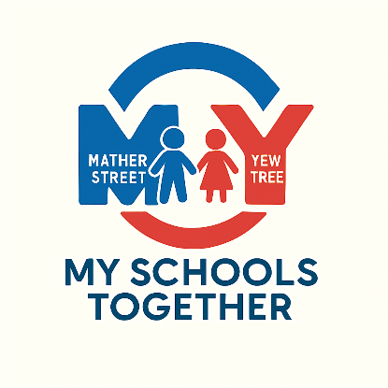

Dear Teacher,

We are pleased that you have spotted our advertisement for Assistant Head SENDCO of the MY Schools Together federation. This position is based at Yew Tree Community School and is a non-class based strategic role.
The federation, which came into effect in September 2012 comprising two schools; Mather Street Primary School of 220 students and Yew Tree Community School of 650 students.
Both schools are under Oldham Local Authority and are approx. 2.3 miles in distance apart.
Our staff have a positive impact across the federation. We concentrate on teaching and learning, staff development, satisfying career aspirations, supporting innovation and pastoral care for our children, their families and for ourselves.
If this is the kind of working environment that appeals to you, please look at the job description and person specification (found in the application pack) and decide if the role is for you.
I would be grateful if you return your completed application form to steve.mould@yewtree.oldham.sch.uk

The closing date for the application is Thursday 23rd April. Interviews will be on Friday 1st May.

An informal visit to the school is offered and will be arranged on Thursday 16th April at 2 pm or Friday 17th April at 10 am.
Please contact the school on 0161 284 5464 to book on the visit. If you are unavailable to attend the dates above but would still like to visit the school. Please contact the office to arrange an appointment.
Yours faithfully,

Mrs M R Buckley
Executive Headteacher

