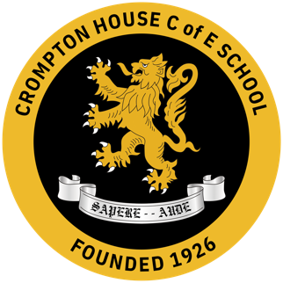
Psychology is a subject area within Social Science department at Crompton House School

The Social Science department (Psychology, Sociology, and Health) is a dynamic and successful team that consistently achieves outstanding outcomes for students. Staff work collaboratively to deliver high-quality learning experiences and support student success. GCSE Sociology results are consistently strong, alongside excellent outcomes in A Level Psychology, Sociology and BTEC Health. The department has also recently expanded its provision to include Key Stage 4 courses in both Psychology and Health.

We are seeking to appoint a Social Science teacher who will be a strong asset to the teaching of Psychology, with the potential to contribute to Sociology and/or Health and Social Care at Key Stages 4 and 5. The successful candidate will embrace the challenges and flexibility of working within a diverse team and, above all, demonstrate a genuine enthusiasm for these subjects.

The Departments members of staff:
Head of Subject - Mrs Lomas
Second in charge - Mrs Owen
Teachers of Social Science - Mrs Ward (Head of PSHE)
- Miss Lockwood
- Mrs Thirlwall
- Mrs Baker

Curriculum Time (per fortnight in hours)
Years 7, 8 and 9 0
Years 10/11 5 over 2 weeks (Psychology, Sociology and Health and Social Care as option subjects)
Years 12/13 9/10 over 2 weeks (4/5 per teacher) – 8 groups for Psychology, 5 groups for Sociology and 2 groups for Health and Social Care across both year groups.
Rooming
There are designated Psychology, Sociology and Health and Social Care classrooms within the Humanities area, which teachers share. The rooms are of an excellent standard, each fitted with an interactive whiteboard, digital projector and storage for the subject areas class sets of textbooks.

Extra-curricular Activities
We feel we offer a rich and diverse learning experience for pupils, both within the curriculum and beyond. The Social Science department organises a range of trips and activities throughout the year, including a Research Methods project at Chester Zoo, attendance at Criminology conferences, and occasional educational visits such as trips to Shrewsbury Prison. The department also has an active subject prefect team who support other students, contribute to student voice, and assist staff within the department.
Across the wider school, students benefit from lively drama productions, a strong sporting programme, and a wide range of musical and artistic opportunities, alongside Duke of Edinburgh and many other activities and residential trips. We would welcome a teacher who is interested in contributing to and developing the department’s extra-curricular provision.

