Person Specification/Selection Criteria for
Assistant Head/ SENDCO at MY Schools Together – Yew Tree Community School

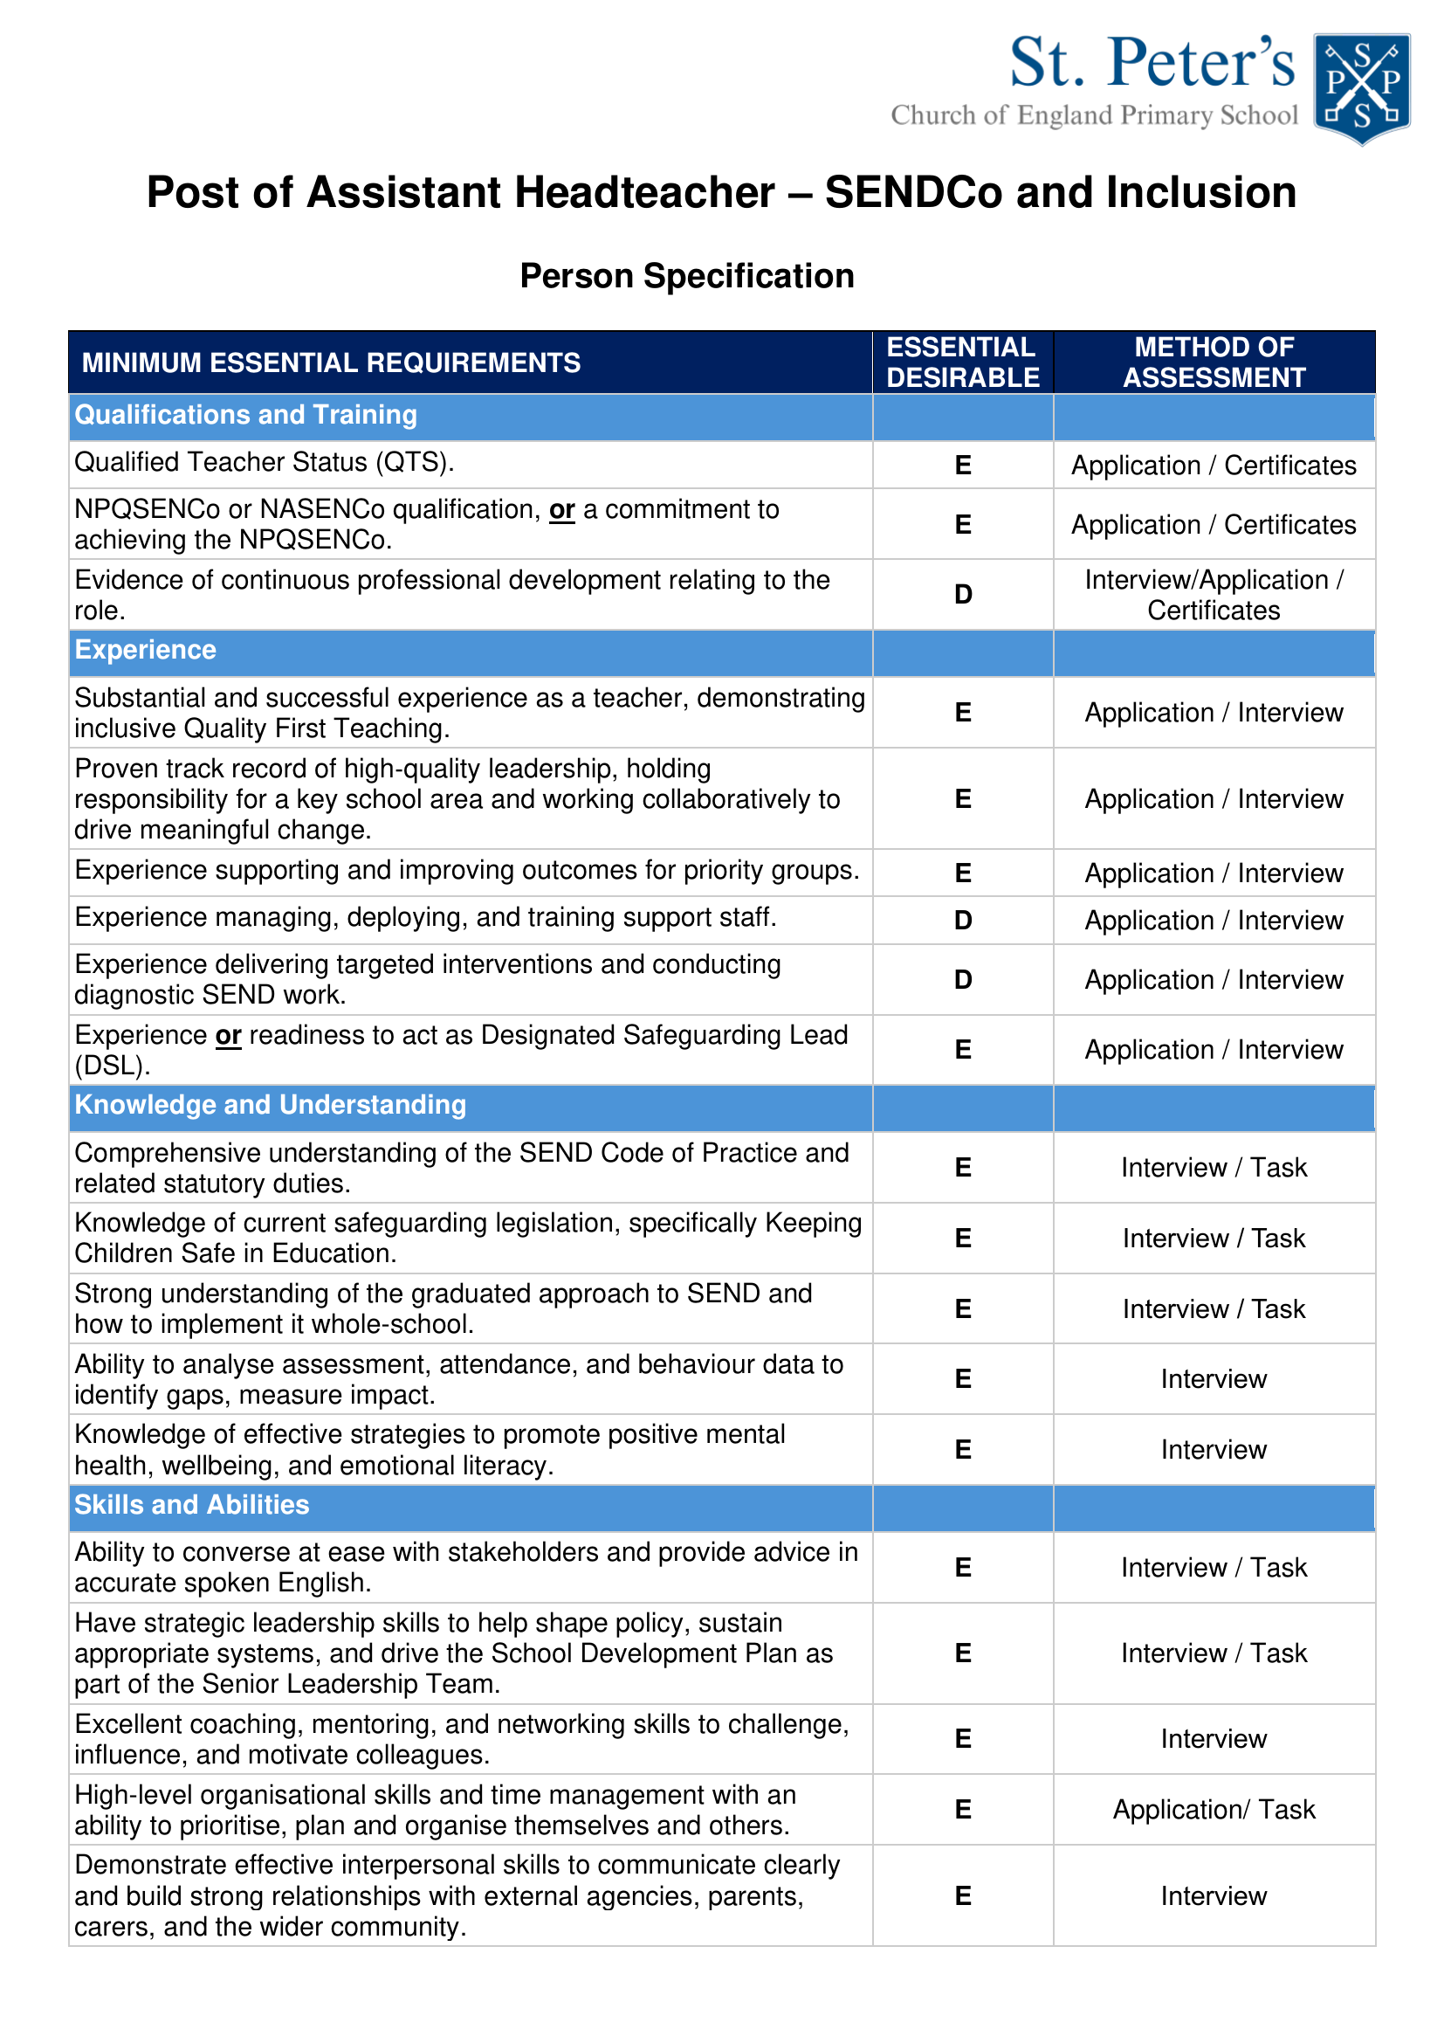

TEACHING APPLICATION FORM
This Local Authority is committed to safeguarding and promoting the welfare of children, young people and expects all staff and volunteers to share this commitment.

Vacancy Details
Job Title: | Assistant Head/ SENDCO (Non Class Based)

Job reference number:
School/Location: | MY Schools Together – Yew Tree Community School
Advertising origin
Where did you hear about this vacancy?

It is the Council’s policy to ensure that all appointments are made on merit. This part of the form is for monitoring purposes only and will be kept separate from any members of the shortlisting or interviewing panel. In order to monitor the effectiveness and success of this policy it would be helpful to us if you provide the information requested below regarding your personal details. The details supplied by you on this form are confidential, but will form part of the personnel record of the successful candidate.

Personal Details
Title:
First name(s):
Last name:
Previous Name (s):
Date of Birth:
Address:
Postcode:
Contact Number:
Email address:
National Insurance Number:

Date of achieving QTS/Probationary Period:
If you hold NPQH please state date obtained:
DCSF/TRN Number:
Are you registered with the GTC?  www.gtce.org.uk  If yes please provide: | YES No  Registration Number:  Expiry Date of Registration:
Are you a member of the Teachers Pension? | YES NO

Eligibility to work in the UK
Current legislation means that it is a criminal offence to employ a person who is subject to immigration control, unless he or she has documentary proof showing an entitlement to work in the UK. If selected for interview you will asked to provide proof of your work entitlements.
Do you have an entitlement to work in the UK? YES NO

MONITORING EQUALITY AND DIVERISTY

Gender
Male Female
Is your gender identity the same as the gender you were assigned at birth?
Yes No

Ethnic Origin
White | British
 | Irish
 | Traveller of Irish Heritage
 | Gypsy/Roma
 | Polish
 | Other White European
 | Other White
Mixed | White and Black Caribbean
 | White and Black African
 | White and Indian
 | White and Pakistani
 | White and Bangladeshi
 | Other mixed
Asian or Asian British | Indian
 | Pakistani
 | Bangladeshi
 | Kashmiri
 | Other Asian
Black or Black British | Caribbean
 | African
 | British
 | Somali
 | Other black
Chinese or other | Chinese
 | Other ethnic group
 | Unknown

Religion/Belief
Buddhist |  | Muslim
Christian |  | Sikh
Hindu |  | Other
Jewish |  | No Religion

Sexual Orientation
Bisexual |  | Gay man
Heterosexual/Straight |  | Gay Woman/Lesbian

Caring Responsibilities
Is there anyone who relies upon you for care and attention AND that you assist with their daily routine?
Yes No
If yes, please indicate who you provide such care for?
Adults (18 over) Children

REHABILITATION OF OFFENDERS
This post involves working with children, young people or vulnerable adults and is therefore exempt from the Rehabilitation of Offenders Act. You must therefore respond to the question below – failure to disclose such information could result in dismissal but will not necessarily be a bar to employment with us.
Declaration
Do you have any convictions, cautions, reprimands or final warnings that are not “protected” as defined by the Rehabilitation of Offenders Act 1974 (Exceptions) Order 1975 (as amended in 2013)? | Yes No
If yes, please state;
Do you have any previous offences/s? If so please give details
Nature of Offence/s (i.e. Conviction, caution, bind–over, reprimand, warning or allegation) | Offence/s | Date of Offence/s | Disposal (if known)

OTHER APPLICANT DETAILS

Are you currently, or have you previously been employed by this organisation? | Yes No
If yes, please provide dates from and to and reasons for leaving (if applicable): | Date from:
 | Date to:
 | Reason for leaving (if applicable):

Are you related to a Councillor, Governor or senior officer of this organisation? | Yes No
If yes, please provide details: | Name:
If yes, please provide details: | Relationship to you:

Dismissed

Have you ever been dismissed from any employment for any reasons other than redundancy?

YES NO
If YES please give details, including dates, reasons and employer.

DECLARATIONS
I confirm that I am not subject to any immigration controls or restrictions, which prohibit my working in the UK.
I confirm that the information supplied by me in this application is complete and correct to the best of my knowledge
I understand that any false information, any relevant omission or misleading statements may disqualify me from employment or result in my dismissal.
YES

REFERENCES

Please provide the names and contact details of at least two referees who can comment on your suitability for this position. One should be your current or most recent employer. (If you are not currently working with children but have done so in the past the second referee should be the employer by whom you were most recently employed in work with children. References will not be accepted from relatives, or persons who only know you as a friend.)

References will be sought prior to interview, the references will ask your current/previous employer/tutor about any disciplinary offences relating to children. Please note that for Headteacher and Deputy Headteacher appointments a reference will automatically be sought from your current L.A.

Current or most recent employer
Referee name:
Job title (if applicable):
Organisation:
Address:
Postcode:
Contact Number:
Email address:
In what capacity do you know the referee?
Are you related to, or the partner of this referee: | Yes No

Previous Employer
Referee name:
Job title (if applicable):
Organisation:
Address:
Postcode:
Contact Number:
Email address:
In what capacity do you know the referee?
Are you related to, or the partner of this referee: | Yes No

Disclosure

In line with the Data Protection Act 1998, in signing the declaration you agree to us disclosing information such as your name to the Job Centre and New Deal participants for statistical purposes, this information will not be retained or processed for any other purpose. Once the recruitment process is completed the hard copy data will be kept for 6 months and the computerised record of these details kept for 18 months.

We have a duty to protect public funds and may use this information to prevent and detect fraud. We may also share this information, for the same purposes, with other organisations that handle public funds.

I confirm that the information contained in this application is correct, I understand that my application may be rejected or that I may be dismissed without notice for withholding, or giving false information. I also give my consent to the processing of data contained or referred to in this application in accordance with the Data protection Act 1998 and subsequent legislation.
Signed:
Date:

Disability
Equality Act (2010)

This Act protects people with disabilities from unlawful discrimination. We actively encourage applications from people with disabilities.

The Equality Act defines a disabled person as someone who has a physical or mental impairment which has a substantial and adverse long term effect on his or her ability to carry out normal day to day activities.

Do you consider yourself to be disabled according to this definition?
Yes No
If yes, how would you define this disability?
Please specify any arrangements we can make to assist you if you are invited for interview/assessment.

.

TEACHING EXPERIENCE
Please list all teaching jobs held starting with the most recent, including any previous or current employment with this authority (whether directly or through an employment agency). There should be no gaps in your employment and education history. Please indicate where you were and the dates of any gaps you may have.
Current/Previous Teaching Posts
Name of school/employer:
Job Title:
Salary:
Date first went through threshold, if applicable:
Date from (dd/mm/yyyy):
Date to (dd/mm/yyyy) (if applicable):
Age Range taught:
Status/Curriculum/Responsibilities/Subjects
Period of notice required (if applicable):
Reason for leaving:
Please provide brief details of duties and responsibilities:

Previous Teaching Post
Name of school/employer:
Job Title:
Salary:
Date from (dd/mm/yyyy):
Date to (dd/mm/yyyy) (if applicable):
Age Range taught:
Status/Curriculum/Responsibilities/Subjects
Reason for leaving:
Please provide brief details of duties and responsibilities:

Previous Teaching Posts
Name of school/  employer: | Job Title &  Salary | Date from -  Date to  (dd/mm/yyyy) | Age Range taught | Status/  Curriculum/  Responsibilities /Subjects | Reason for leaving | Please provide brief details of duties and responsibilities

Employment history other than teaching
Job Title: | Name and Address of employer: | Tel Number: | Date from – Date to (dd/mm/yyyy) | Reason for leaving
If there are any periods of time that have not been accounted for, for instance, periods of travel, or caring for others please give details of them here with dates. The information provided must provide a complete chronology from the age of 16; please ensure that there are no gaps in the history of your employment and other experience.

EDUCATION AND TRAINING
Apart from giving details of formal education and qualifications, mention any short/non-qualification courses that you may have attended to improve your knowledge and skills, if they are relevant to the job you are applying for. Successful applicants will be required to provide proof of qualifications.
EDUCATION (formal qualifications)*
College / University | Qualification/Result/Grade | Date Obtained

Type of Teacher Training (Please tick)* | Early Years | Primary | Middle
Type of Teacher Training (Please tick)* | Secondary | Special | FE

Relevant Training
Date | Course Title | Organising Body

MEMBERSHIP OF PROFESSIONAL BODIES
Name of Professional Body | Type of membership | Date of Membership | Membership Number

SUPPORTING INFORMATION

Skills, Knowledge and Experience
This section of the application form is very important, as this is where you demonstrate your suitability for the job. Read through the advertisement and the job description to get a clear view of what the job involves. The person specification describes the necessary skills, experience and qualifications we are looking for. Pay particular attention to those areas on the person specification described as essential.

Make sure that you tell us how you match the requirements of the job. Therefore, give examples of any relevant ability, experience and qualifications. This may be from your current or previous job, or from community or voluntary work, or from skills transferable from other life experience, particularly if you have been out of paid employment for some time. For example, you may have considerable domestic responsibilities, or may organise social or community activities in your spare time.

- Ensure that the information you provide is well organised and relevant.
- It should show to that extent you have gained the skills and experience necessary for the post.
- Give specific examples of the work you have been involved in, how you went about it and the outcome.
- Always remember to specify your responsibilities rather than those of your section or department

