

Job Description & Person Specification
School Administrator Level 1

Job Description
Job Title: | School Administrator – Level 1
Pay Grade / Scale / Range: | NJC SCP 3
Benefits & Perks: | Flexible Working, occupational pension scheme, occupational sickness scheme, health benefit scheme
Working hours: | 36 hours 40 minutes per week  - Term Time only (195 days)  Hours: 8am - 4pm
Location: | New Bridge School. You may be required to work at any site of the New Bridge MAT
Special circumstances: | Some out-of-hours working required at busy times.
Staff responsible to: | Head of Site / School Business Leader / Senior Admin
Staff responsible for: | None
Accountable to: | CEO
Probationary period: | 26 working weeks


Responsibilities

The post holder must:

Perform his/her duties om accordance with Equality and Diversity Policy.

Be able to render regular and efficient service to undertake the duties of this post.

Principal Duties

To provide administrative support to the Head of Site/ /Business Leader/Senior Administrative Officer.

To undertake general administration duties e.g., photocopying, filing, emailing, and completing routine forms.

To use word to process school documentation, including the production of letters, reports, and schedules.

To accurately input information to databases/spreadsheets and maintain manual and computerised records and management information systems.

To sort and distribute internal and external email.

To collate registers and complete returns as required.

To act as a first point of contact, undertaking reception duties and answering telephones and face-to-face enquiries.

To welcome visitors to the school, ensuring that health and safety and safeguarding procedures are followed, including signing visitors in/out, issuing badges and escorting visitors as required.

To respond to general day to day queries from staff pupils, parents, and external visitors.

To make arrangements for external visitors, for example the school nurse, photographer and parents, in liaison with the Head of Site/Senior Staff.

Secondary Duties

To make a positive contribution to the school, supporting and promoting its ethos, aims and the developments/improvement plan.

To be aware of and comply with policies and procedures relating to child protection, health, safety and security, confidentiality, and data protection, reporting all concerns to an appropriate person (in line with relevant policies).

To promote equality and diversity.

To participate in training and other learning activities and performance development as required.

To attend and support the role of other professionals.

To undertake such duties and responsibilities of an equivalent nature as may be determined by the Head of Site (or nominated representative).

Our organisation is committed to safeguarding and promoting the welfare of children, young people and vulnerable adults and expects all staff and post holders to share this commitment. For child protection purposes an enhanced disclosure will be required for this post.

PLEASE SUBMIT EVIDENCE OF PREVIOUS EXPERIENCE, SKILLS AND ABILITIES ONLY AGAINST THE CRITERIA EMBOLDENED BELOW

Person Specification
Selection Criteria Essential | Selection Criteria Desirable | Assessed By
Qualifications and Experience
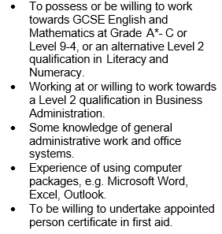 |  | AF/I
Skills and Knowledge
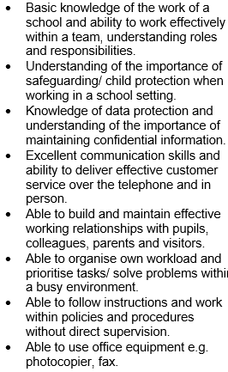 |  | AF / I
Special Working Conditions
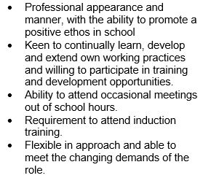 |  | AF / I

Abbreviations: AF = Application Form; I = Interview

N.B. Any candidate with a disability who meets the essential criteria will be guaranteed an interview.

