

Dear prospective candidates

On behalf of the Governing body, I thank you for your interest in Buckstones Primary School. After 23 successful years our Head Teacher has chosen to retire. Our community school is in excellent shape with a strong teaching and support set up. We are very proud of our School, the SATs and Phonics results show the capability of our children but along side that we have created an environment where learning is fun and there is a sense of community surrounding the school.
The governing body has the responsibility of recruiting the new Head Teacher. This will not be an easy task and one the School has not gone through in over two decades. We aim to make this a positive experience for both candidates and the school and have taken a lot of time to ensure the process will be thorough and fair.
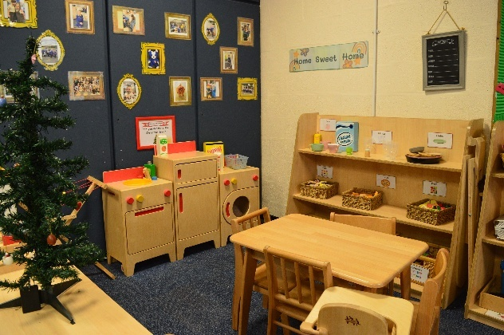
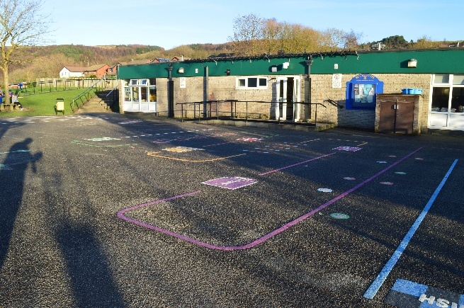

We are a strong and committed governing body made up of varying experience and backgrounds. The governors spend time in school and are involved with many aspects of everyday school life.
This is an exciting opportunity for an experienced and passionate educational leader to build on the strong foundations already in place and to work closely with governors, staff, pupils, parents and the wider community to secure the highest standards of teaching, learning and wellbeing for all.
We look forward to receiving applications from candidates who share our commitment to excellence and who have the vision and leadership skills required to guide Buckstones confidently into the future.
Yours faithfully,
James Woodward
Chair of the Governing Body
On behalf of the Governing Body of Buckstones Primary School

