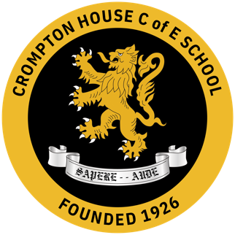

Religious Studies at Crompton House School

Crompton House is an 11 to 18 Church of England Academy, and the Religious Studies department plays a significant role in developing the students’ knowledge of the Christian faith, as well as promoting respect and understanding for people of other faiths and none. The RS team is a lively and conscientious team who consistently produce outstanding results, working together effectively to provide the best learning experience for the students. There are currently 6 Specialist RS teachers in the team. Religious Studies is compulsory up to GCSE level and is offered at Sixth Form as an A Level subject. We find that students really enjoy and engage with RS lessons and look forward to it on their timetable.

Key Stage 3 RS:
Students are initially set into 3 bands according to ability based on the KS2 SATS results in English and have 3 lessons per fortnight of RS. Year 7 students begin their studies with a unit of work called ‘The Island’, where they look at the concept of community and explore how the 3 main world religions develop community. They then explore the incarnation through a unit of work called Christmas, before starting the ‘Big Bible Stories.’ This is followed by an exploration of Islam and Sikhism in the summer term. Year 8 commences with a unit of work on Jesus and Faith in action, before exploring Human Rights, Buddhism and Ultimate Questions. In Year 9 our students start to explore our GCSE religion of Judaism. We explore the question of ‘is religion a power of peace or cause of conflict?’ before looking at a study of Ethics and Philosophy. We also explore a unit on planet earth and Christian beliefs, ensuring that our pupils are ‘GCSE ready’ for Year 10.

GCSE Religious Studies
RS is a compulsory GCSE at Crompton House. It is a part of our core curriculum. All students are entered for the GCSE exam. Students have 4 hours a fortnight across Years 10 and 11 to study AQA’s Spec A (from 2016) studying Christianity, Judaism and 4 themes. In addition to consistently achieving above the national average, GCSE results are among the best in the school as well as Oldham borough, making us a very proud department. Yearly we achieve an outstanding number of grade 9’s at GCSE level.

A Level Religious Studies
We deliver the WJEC/Eduqas Religious Education specification (first teaching from 2016) comprising 3 components: Christianity; Philosophy of Religion; and Ethics.

Resources
All teaching rooms have interactive boards and the school has class IT suites you can book out, if available. We have schemes of work, lesson plans and resources to aid outstanding teaching and learning for all units of study in years 7-11 and we are developing the KS5 units.

Extra-curricular
The RS department has contributed to our extra-curricular programme e.g. Prayer Spaces, visiting speakers and festival celebrations. We are looking, to increase our trips to places of worship.

