
Recruitment Pack (2025)

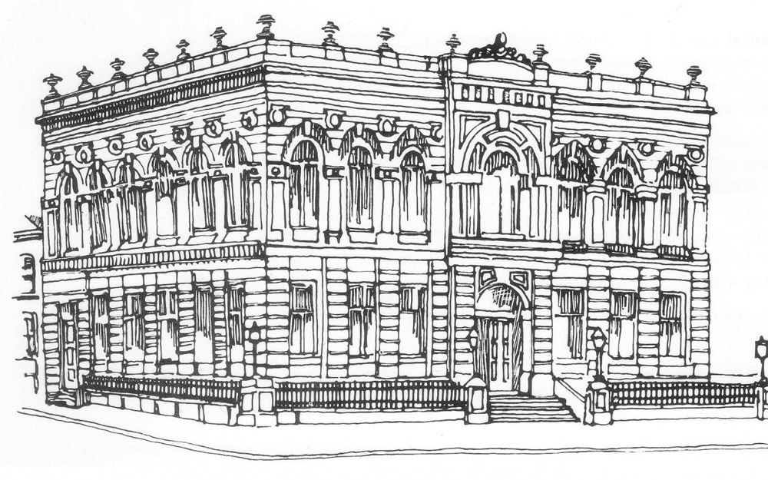
Strategic Lead

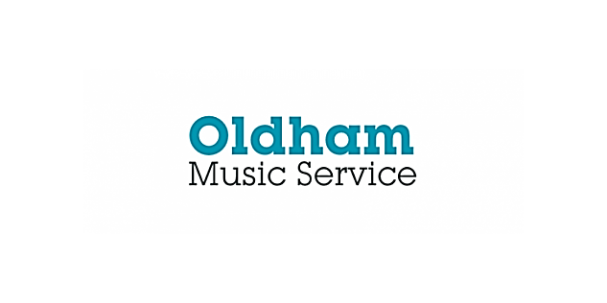



Job Description: Strategic Lead, Oldham Music Service
Location: Oldham Music Service, Lyceum Building, Oldham, Greater Manchester
Salary: Soulbury £61,271 - £66,724
Contract Type: Full-time, Permanent
Reports To: Assistant Director, Education and Early Years
Closing Date: 5/10/25
Start Date: 21/9/25

About Oldham Music Service
Oldham Music Service is a vibrant, inclusive and high-performing organisation with a proud history of delivering outstanding music education for our residents. As a founding member and local Lead Partner of the Greater Manchester Music Hub, we work with schools, community groups, and regional partners to ensure that children and young people from the borough have access to life-changing musical experiences.
This is an exciting time to lead and develop our local music education strategy, delivering on the National Plan for Music Education, working with partners within the Hub, and expanding our reach and impact through diverse and inclusive music-making. We are seeking an ambitious and visionary strategic leader to help shape the next chapter of our story.

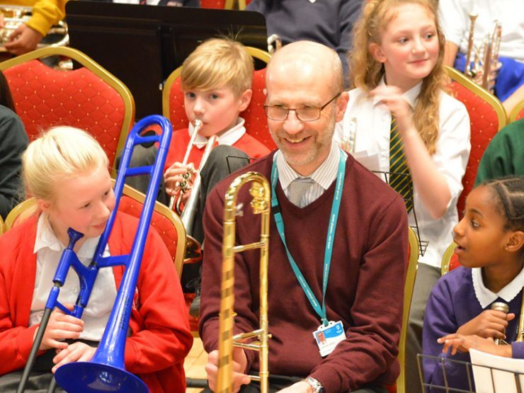

The Role
The Strategic Lead for Music will lead the strategic and operational direction of Oldham Music Service, ensuring the delivery of high-quality, inclusive, and progressive music education in schools, communities, music centre and beyond. You will be a key figure in the borough’s cultural and educational landscape, building on a legacy of musical excellence and achievement, whist also ensuring our music service meets the needs of our diverse and dynamic local population.

Key Responsibilities

1. Strategic Leadership
- Lead and deliver a clear refreshed vision for music education in Oldham, aligned to local and national priorities and underpinned by analysis of local need.
- Act as lead officer for the Oldham, contributing to Greater Manchester-wide strategies and partnership as part of the regional Music Hub.
- Drive innovation and growth in delivery models, curriculum design, and inclusion frameworks to best serve Oldham’s residents and their children.
- Champion the service across schools, regional networks, cultural organisations, and Council.

2. Service Management and Development
- Oversee the day-to-day management of the service, ensuring high standards of teaching, learning, and musical development.
- Manage a multi-disciplinary team of teaching and support staff, providing strong strategic leadership and professional development of the local music education workforce.
- Lead quality assurance processes, including lesson observation frameworks, staff appraisal, and professional development programmes, improving service procedures as well as following council-wide initiatives and strategies.
- Maintaining and regularly reviewing robust safeguarding procedures and act as the Designated Safeguarding Lead for the music service.

3. Financial and Operational Oversight
- Lead strategic budget planning and financial management in collaboration with the local authority finance team.
- Monitor income generation (e.g. grants, school SLA contracts, events and fundraising) to ensure ongoing financial sustainability for the service.
- Oversee appropriate management of capital assets including musical instruments, IT systems, and premises (including music centre).
- Ensure compliance with statutory and local policy in health and safety, GDPR, HR, and safeguarding, collaborating with Council teams as appropriate.

4. Schools, Partnerships and Curriculum
- Lead and develop strong relationships with stakeholders, including headteachers, curriculum leaders, and governors, to support effective school music provision across the borough.
- Ensure a high-quality, inclusive offer for whole class instrumental teaching, small group tuition, ensembles, and curriculum support.
- Develop and foster new and existing partnerships with cultural organisations, higher education providers, charities, and regional networks (e.g. RNCM, Hallé) to address local areas of need.
- Lead on the local delivery of the National Plan for Music Education, including progression pathways and compliance with reporting requirements as a Local Lead Partner within the regional Music Hub.

5. Inclusion, Access and Engagement
- Embed equity, diversity, and inclusion in all aspects of the service’s work, with a particular focus on supporting children with SEND, care-experienced children, and those from disadvantaged backgrounds facing barriers.
- Expand the service’s musical offer, ensuring that the needs of the borough’s diverse population are represented and met, and the service is reflective of local Children and Young People and their musical interests.
- Ensure access is available to musical learning for all Children and Young People, particularly those facing financial barriers to participation, through a range of interventions.
- Engage with families and carers to promote access, celebrate progress, and build a culture of lifelong musical learning within Oldham.

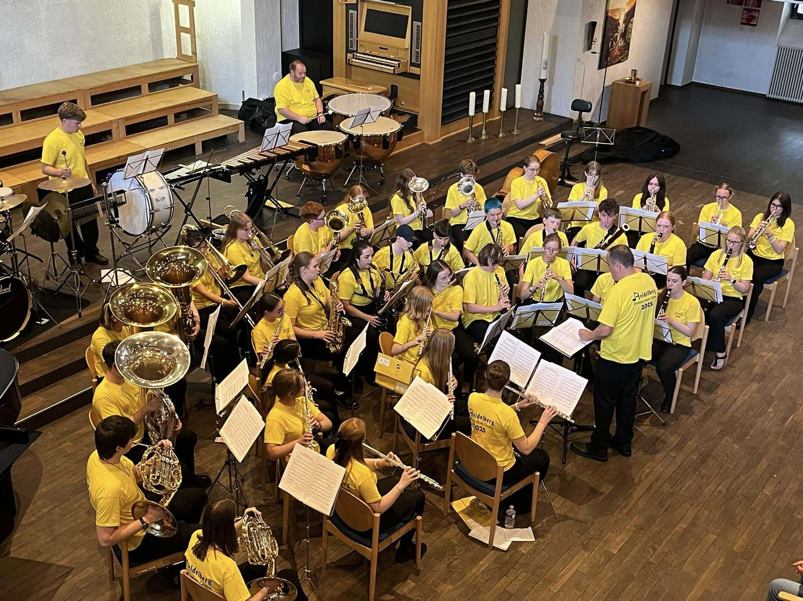

Person Specification

Essential Experience and Qualifications
- Significant leadership experience in music education (e.g. Head of Service, Deputy Head, Strategic Lead, Head of Department).
- Educated to post-graduate degree level or equivalent in music, education, or a relevant field.
- Demonstrable experience of managing teams, budgets, and service operations.
- Demonstrable experience in leading change management initiatives and a range of complex multi-faceted projects.
- Proven success in building partnerships and delivering strategic impact across a range of settings.

Skills and Knowledge
- In-depth understanding of national music education policy and educational landscape, including the National Plan for Music Education and Music Hub responsibilities.
- Knowledge of inclusive teaching practices and barriers to engagement in music.
- Strong interpersonal and communication skills, including advocacy and public presentation skills.
- Ability to interpret and manage complex data, evaluation, reporting and planning cycles.

Personal Attributes
- A passionate advocate for music as a transformative force in young people’s lives.
- Strategic thinker with a track record of delivering measurable impact for children and young people.
- Inclusive leader who champions diversity and empowerment across teams and communities.
- Flexible, collaborative, and resilient in the face of change and challenge.

Working for Oldham Music Service: What We Offer
- A unique opportunity to lead one of Greater Manchester’s most respected music education services.
- Committed and talented staff with a deep passion for musical excellence.
- Access to regional and national networks and development opportunities.
- Comprehensive benefits package including pension, flexible working, and training.
- A local authority that values cultural education and public service.

Our Values & Behaviours
It is not just about what we achieve but how we achieve it.
We have a clear set of values and behaviours that outline how we do business. We share these borough-wide with our residents, partners and businesses.
Our 3 values define who we are and how we operate. They are:

Proud
We take pride not only in what we deliver for the residents of Oldham but also in how we deliver it.

Ambitious
We recognise the challenges we face and are committed to setting high aspirations to overcome them, with determination and focus.

Together
We believe in shared solutions, working across sectors and with our communities to achieve common goals and deliver the quality services Oldham deserves.
Our 5 behaviours outline how we would like all our staff to show up in their everyday work. They are:

Working with a resident focus
A vital part of working for any local authority is working with a resident focus.
Whether you opt to apply for a role in which you’ll meet residents every day or one that doesn’t have direct contact, that doesn’t change.
We want all our staff to approach their job in the right way and consider if their decisions are in the best interests of residents.

Support local leaders
It’s important that we support our elected local leaders and help them to achieve their aims and ambitions for the town.
Whether that means simply doing your job well and contributing to the smooth running of the organisation or directly assisting councillors with tasks, it’s vital we do so and do so well.

Committed to the borough
Whether in or out of work, we want all Oldham Council employees to be role models and committed to our wonderful town.
We’re very proud to work for Oldham and we want you to be too.
There are some fantastic things happening here and we want everyone to be proud of that and share our message.

Take ownership and drive change
We live in a fast-paced, rapidly changing world which makes it vital that we understand the need for change and be open and positive about new ways of working and learning.
We want our team members to anticipate the needs of residents, look for improvements in the way we support them and think about how we could do so more effectively.

Deliver high performance
It’s important to ensure we set clear targets and look to be efficient in everything we do.
We want our team members to challenge existing practices and ways of working and take responsibility for their personal development.

Application Process
Please find details of how to apply on the link below.
Strategic Lead for Music Service in Oldham | greater.jobs
If you wish to arrange a conversation or visit to the Music Service, please contact Assistant Director for Education & Early Years, Tony Shepherd at tony.shepherd@oldham.gov.uk

