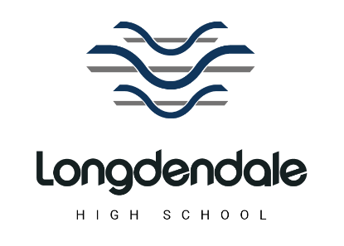
JOB TITLE: Cleaner
SCHOOL: Longdendale High School
DEPARTMENT: Education
RESPONSIBLE TO: Site Management/Operations Manager
GRADE: Grade A – SCP 2

PURPOSE OF POST:
Provide a cleaning service that complies with standards and ensures a safe and clean environment for students, staff and visitors in accordance with health and safety requirements.

General Cleaning Duties
- Cleaning all surfaces, fixtures and fittings, mats, by appropriate method, within the designated area of work. (Apart from any technical equipment cleaned by other departments as will be specified).
- Use correct chemicals, cleaning materials, equipment and follow appropriate procedures.
- Washing of walls, internal glass and partitions and internal woodwork up to reaching height, using appropriate equipment where necessary.
- Washing and cleaning of light shades/diffusers after removal and prior to replacement by the Site Manager.
- Cleaning of kitchen areas apart from any cleaned by other departments.
- Cleaning of all hard and soft floor surfaces within the designated area by the appropriate method and using machinery where necessary.
- Cleaning of sanitary areas, toilets, showers, changing rooms, sluices, sick units by the appropriate method and as required.
Other duties
- Collecting and bagging of waste, ready for disposal. Washing and cleaning of waste bins.
- Replenishing supplies of soap, paper towels, toilet rolls and waste disposal bags as
required and ensuring the Site Team are aware of consumable items that may be needed.
- Ensuring that all cleaning equipment used is cleaned before returning to the stores and safely secured.
- Reporting of faulty cleaning equipment and any conditions that may require the attention of maintenance staff to your line manager.
- Ensuring that windows are closed, lights turned off and doors locked before leaving the area.
- Covering for other cleaners if necessary in the event of staff shortage.
- Ensuring that health and safety guidelines are followed at all times whilst on the premises.
- Ensuring that all users of the building are treated with care and consideration.
- To take every opportunity to promote a favourable image of the school to all users of the building and lead by example through demonstrating the schools core values at all times.
Supervisory Responsbility
- The job may involve the demonstration of duties to support and train new employees or trainees.

Physcial Effort
- Physical effort is required at frequent intervals, including standing, walking, lifting, carrying, pushing and pulling and working in awkward positions.


