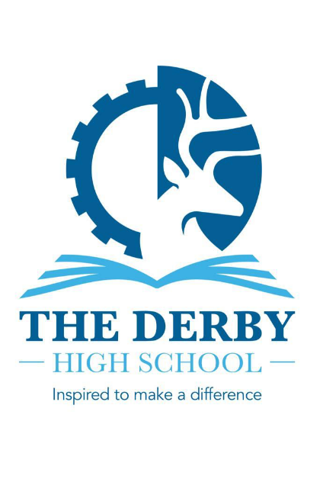

Information about the English Department

This post represents a tremendous opportunity for the right applicant. We are seeking to appoint an excellent practitioner to contribute further to our present success within the English Department. Our vision is to provide an engaging and enriching learning environment which promotes a love of English. We do this through our thematic Key Stage 3 curriculum, which interleaves key knowledge and skills, ready for students to embark on their journey to success at Key Stage 4. We pride ourselves on the breadth of our curriculum and consider it important that students are challenged and exposed to a wide range of high-quality literary texts.

All students are timetabled for four lessons of English each week at Key Stage 3 and five lessons of English each week at Key Stage 4.

The English Department is a collegiate, talented and hardworking team. Achievement in English is strong, and teachers have a record of supporting students to achieve excellent outcomes; in 2025, 80% of Year 11 students gained Grade 4+ in English with 62% at Grade 5+.

(Note – we teach to the AQA specification for English Language and English Literature).

The Head of English is supported by a Second in English and our Lead Practitioner for Literacy across the school, with Literacy being a growing strength at The Derby High School. Two HLTAs (Literacy) deliver our highly impactful phonics and reading comprehension programmes. Other key members of the team include a full time, fully qualified, school librarian, who manages the library and provides excellent resources and enrichment activities. Teachers have their own classrooms which are based together so there are many opportunities to work collaboratively, and all participate in regular subject-specific CPD in Department Meetings.

We also pride ourselves on the broad range of unique opportunities we offer our students as part of The Derby Diploma, including working with writers and artists and partaking in a wide range of competitions and initiatives to promote and encourage reading. This academic year, Year 11 students have enjoyed a theatre workshop performance of Macbeth and all year groups have had opportunities to visit the theatre to see live performances of the texts that we study.

If you are successful in your application, you will be joining a successful and continuously improving team which will provide excellent support and opportunities for your next career stage.

