**Rumworth School**

**Permanent Cleaner**

**(Grade A, Scale Point 2 to 3)**

**Required as soon as possible**

**Employer:** Bolton Council  
**Location:** Bolton  
**Salary:**  £23,656 (Point 2) to £24,027 FTE (Point 3) (rate is based on 2024-2025, and is also pending confirmation of new rate from April 2025)

**Salary Grade:** Grade A

**Working Pattern:**Full year  
**Working Hours:**37 hours weekly

**Contract Type:** Permanent

**Closing Date:** 3:00 pm on Wednesday 3rd September 2025  
**Job Type:** Education School based  
**Interview Date:** Thursday 11th September 2025, exact timings TBC

We are looking to recruit a permanent Cleaner to join our staff team in order to help us to continue to maintain a high quality standard of cleaning across our Rumworth school site.

You will join our dedicated cleaning team who provide a high standard of cleaning throughout the school day across our school site, which includes our newly opened Sixth Form block. You will also then work after school hours as this is a 37 hours per week post.

Due to the nature of this role, it is a full year-round post, which means you be would working non-term time, with your annual leave to be taken in the school holidays.

Rumworth School is a highly regarded Local Education Authority maintained special school in Bolton with an excellent reputation for providing an outstanding provision for all students. Visitors to our school always comment on the “lovely feeling and buzz” and the calm & purposeful learning environment. In September 2025 we will have around 370 students with a range of needs. Our students are aged 11-19 and they all have an EHCP because they have a range of SEND (Special Educational Needs and Disabilities) which may include: Moderate and Severe Learning Difficulties, Complex Needs, Autistic Spectrum Conditions, Hearing and Visual Impairment, Physical Disability and Social, Emotional and Mental Health Needs. What our students most definitely do all have is a wonderful sense of fun, a love of learning, a high regard for each other and the adults who work with them, and they can’t wait to meet you!

Our ethos is “Start with the young person” therefore you will be a champion for education as the vehicle to improve the life chances and outcomes for our students. Our vision is “You can do it, we will help” - in order to meet the needs of our students, we do have small teaching group sizes and high adult to student ratios.

**Information relating to the wider school:**

Rumworth School is a highly regarded Local Education Authority maintained special school in Bolton with an

excellent reputation for providing an outstanding provision for all students. Visitors to our school always

comment on the “lovely feeling and buzz” and the calm & purposeful learning environment. In September

2025 we will have around 370 students with a range of needs. Our students are aged 11-19 and they all have

an EHCP because they have a range of SEND (Special Educational Needs and Disabilities) which may include:

Moderate and Severe Learning Difficulties, Complex Needs, Autistic Spectrum Conditions, Hearing and Visual

Impairment, Physical Disability and Social, Emotional and Mental Health Needs.

Our ethos is “Start with the young person”. As a member of our staff team, you will be a champion for

education as a vehicle to improve the life chances and outcomes for our students. Our vision is “You can do

it, we will help” and so you will embody our philosophy of supporting young people to be more “Confident,

Resilient and Independent”.

In Year 7, all students have a more class-based curriculum with their class teacher delivering the majority of

their learning within our “Foundation Year” setting. Year 7 students also access specialist rooms and may be

taught by other staff for lessons such as Forest Schools, Art, Music, Dance, PE, Science, ICT, and Design

Technology.

Students in Years 8 to 11 then follow a differentiated curriculum model, according to their needs:-

* Some follow a more formal curriculum with a modified mainstream approach
* Some have less transition and spend more time on the consolidation of basic skills
* Some have particular SLD / ASD / SEMH needs and may benefit from working in smaller groups at times

All students access appropriate external accreditation at the end of KS4 and during KS5, and our offer

includes GCSEs, ASDAN, BTEC, Functional Skills and Entry Level Certification, dependent upon student

ability.

In KS5, students continue to follow the most suitable curriculum pathway for their ability and their aspirations,

and we then offer a Year 14 Transition where some students continue on to the “Pathway to Employment”

route, and those with more severe learning difficulties and complex needs would usually follow a “Pathway

to Independence” route.

We are always keen to recruit staff of the highest calibre, and what matters most to us is that you are the

“right fit” for our students. We welcome applications from people with experience in primary schools, as

well as those with secondary school experience, and those with SEND special school experience.

**Visits to our school:**

Visits are strongly recommended prior to application, as this is helpful when tailoring a letter of application in order to evidence how you best meet the selection criteria. Please do not send a generic letter or a CV with your application.

Please contact our School Office on 01204 333600 in order to arrange a visit.

**How to apply:**

Please download and complete the application form and outline your suitability for this post at Rumworth School in your letter of application, within a maximum of two sides of A4 paper.

This post is also advertised on the “Current Vacancies” tab on our school website, and can be found at http://www.rumworth.co.uk/vacancies

All applications should please be returned electronically to Ms Marsha Andrews, the Headteacher’s PA: mandrews@rumworth.bolton.sch.uk

**Closing date:** 3:00 pm on Wednesday 3rd September 2025

**Shortlisting:** Thursday 4th September 2025

Shortlisted candidates to be informed by 3:00 pm on Thursday 4th September 2025

**Interview Date:** Thursday 11th September 2025, exact date and timings TBC

We are committed to safeguarding and promoting the welfare of children and young people, therefore as part of our Safer Recruitment process, references will be requested for all shortlisted applicants.

Appointments are also subject to the outcome of an enhanced DBS check and being able to provide evidence of your qualifications.

Rumworth School, Armadale Road, Bolton BL3 4TP

Telephone: 01204 333600

**Rumworth School**

**Cleaner (Grade A)**

**Applicant Information Pack**

|  |  |
| --- | --- |
| **Our Ethos** | **START WITH THE YOUNG PERSON** |
| **Our Vision** | **‘YOU CAN DO IT, WE WILL HELP’**  Supporting young people to be more  Confident, Resilient, Independent |
| **Our Inclusion Principles** | **EQUALLY DIFFERENT, DIFFERENTLY EQUAL**  At Rumworth, everyone is valued and welcomed as belonging to our school community. Difference and diversity are accepted and nurtured  as contributing to all our achievements. We foster participation and  mutual respect as part of everyday life in our school |
| **Our Mission** | We believe that everything we do should start with the young person.  For them, we aim to create a happy, safe and effective learning community, in which all stakeholders are valued. We aim to provide our students with a wealth of learning opportunities which will not only give them an enriching school experience, but will also equip our students with the skills to give every young person the chance to progress smoothly towards a life of opportunity. |

**Rumworth School**

**Cleaner (Grade A)**

**Job Description**

**Job Title** CLEANER

**Grade** Grade A

**Primary Purpose of** Ensuring that premises are maintained in a clean and hygienic

**the Job** condition.

**Responsible to** Senior School Business Manager / Head Teacher

**Responsible for** n/a

**Principal Responsibilities** To maintain a high quality cleaning service within a specified

building, or area of a building.

|  |  |
| --- | --- |
| **MAIN DUTIES** | |
| 1. | **Support for the School Premises Team** |
| **a** | To deliver a cleaning service against an agreed specification, meeting appropriate hygiene standards. |
| **b** | To keep cleaning equipment in a safe and clean condition and to report any unsafe electrical equipment to the office immediately. |
| **c** | To store cleaning products, chemicals and consumables in a safe and secure place and to ensure efficient and effective usage. |
| **d** | To order cleaning products, chemicals and consumables as necessary either through a Lead Cleaner or through the requisition system ensuring that stock levels do not fall to an unacceptable level. |
| **e** | To inform line management of problems actual or potential relating to delivery of cleaning service. |
| **f** | To promote customer relationship with onsite students, staff and visitors. |
| **g** | To complete any appropriate documentation in relation to work completed. |
|  |  |
|  |  |
| **2** | **Support for the wider school** |
| **a** | Be aware of and comply with Rumworth School policies and procedures relating to safeguarding, child protection, health, safety and security, confidentiality and data protection. Report all concerns to the appropriate named person (as named in the policy concerned) |
| **b** | Be aware of and support difference |
| **c** | Appreciate the role of other professionals within school |

The post holder may reasonably be expected to undertake other duties commensurate with the level of responsibility that may be allocated, at the discretion of the Head Teacher and to meet the needs of the school.

**Date Job Description prepared:** 1st October 2018, Schools’ HR

**Job description last updated:** 18th July 2025, Jenny Dunne, Headteacher

**Rumworth School**

**Person Specification**

**Job Title** Cleaner (Grade A)

**STAGE ONE** Disabled Candidates are guaranteed an interview if they meet the essential criteria

|  |  |  |
| --- | --- | --- |
| **MINIMUM ESSENTIAL REQUIREMENTS** | | **\* Method of**  **Assessment** |
| **1. Skills and Knowledge** | | |
|  | Conscientious attitude towards work duties. | A / I |
|  | Able to maintain a high standard of work. | A / I |
|  | Sufficiently literate and numerate to cope with routine job documentation. | A / I |
|  | Ability to work under own initiate and as a member of a team. | A / I |
|  | Ability to accept and understand verbal and written communication. | A / I |
|  | Ability to prioritise tasks. | A / I |
|  | Awareness of Health and Safety. | A / I |
|  | Please note the school’s competencies, which are considered to be essential for all roles, are in the attached Core Competencies document. | I |

|  |  |  |
| --- | --- | --- |
| **2. Experience/Qualifications/Training etc.** | | |
| 2.1 | Able to operate associated equipment. | A / I |

|  |  |  |
| --- | --- | --- |
| **3. Work Related Circumstances** | | |
|  | Able to work during the school day, and after school as required. | A / I |
|  | This post is subject to an enhanced disclosure and a barred list check from the Disclosure and Barring Service. | A / I |

|  |  |
| --- | --- |
| **STAGE TWO** | Will only be used in the event of a large number of applicants meeting the minimum essential requirements |

|  |  |  |
| --- | --- | --- |
| **ADDITIONAL REQUIREMENTS** | | **\* Method of**  **Assessment** |
| **1. Skills and Knowledge** | | |
| 1.1 | There are no additional requirements for this section |  |

|  |  |  |
| --- | --- | --- |
| **2. Experience/Qualifications/Training etc.** | | |
| 2.1 | Previous experience in a school | A |

**For Method of Assessment** * A = Application *I = Interview

**Note to Applicants:**

Please do try to show within your application form and your supporting letter how best you meet these requirements

**General Information about Rumworth School**

This positive and successful secondary special school is ambitious, high-achieving, supportive and happy; the school ensures that the impact is high on improvement for all of our students, who are at the heart of everything we do. We have around 340 students in 35 classes across Years 7 to 14, and next academic year this will increase to 370 as we are continuing to expand towards offering 400 places. We have just completed a building programme to accommodate this planned growth, which will further enhance the space and wide range of facilities available on our site in order to offer an appropriate secondary special school curriculum for our students who have a wide range of SEND (Special Educational Needs and Disabilities).

Staff work in close partnership with parents and other professionals to ensure we offer a broad, relevant curriculum which builds on objectives recorded in EHCPs and takes account of the full range of the interests, needs and aspirations of our students. Governors, parents and staff are very supportive of the school and responses in surveys are overwhelmingly positive. All staff embody our vision of "You can do it, we will help".

Our Shared Vision is integrated into all aspects of school development and evaluation, and it is the vehicle by which we strive to deliver those commitments we made to our children and young people and everyone in our community. The Senior Leadership Team and the Governing Body have high expectations for what all of our students can achieve, whilst seeking to ensure they become more "Confident, Resilient and Independent". We work collaboratively with our senior middle leaders and middle leaders who make up the Extended Leadership Team, and also with all staff in order to ensure high standards of provision and care for students.

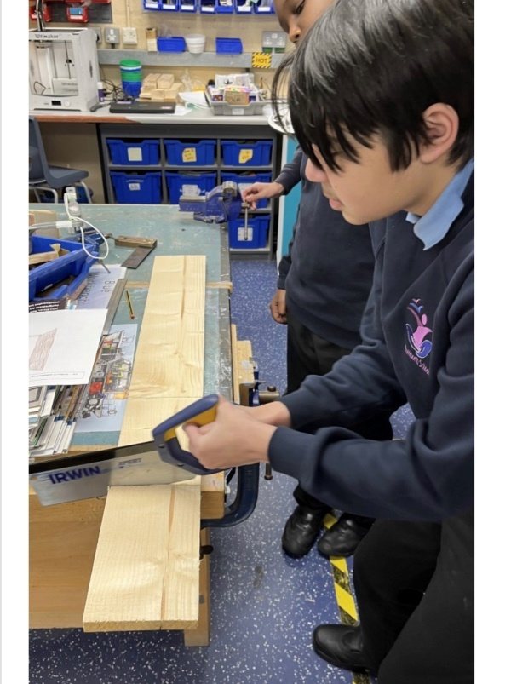Our academic provision runs in Key Stages and then as strands according to student needs; the differing curricula provide excellent opportunities for all students to reach their potential across the full range of their needs, including SMSC. All students access appropriate external accreditation at the end of KS4 and during KS5 in our Sixth Form, and our accreditation offer includes a wide range of GCSEs, Functional Skills, ASDAN, BTEC, and Entry Level Certification, dependent upon student ability.

In Year 7, students have a more class-based curriculum with their class teacher delivering the majority of their learning within a “Foundation Year” setting. Year 7 students also access specialist rooms and may be taught by other staff for lessons such as Forest School, Art, Music, PE, Science, ICT, and Design Technology.

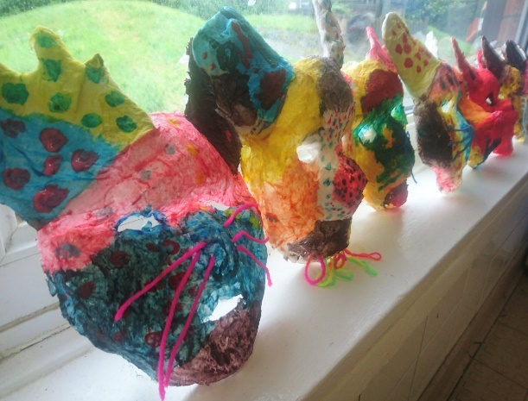From Years 8 to 11, students then follow a differentiated curriculum model, according to their needs:-

* Some follow a more formal curriculum with a

modified mainstream approach

* Some have less transition and spend more time on the consolidation of basic skills
* Some have particular SLD / ASD / SEMH needs

and benefit from smaller groups at times

Students may have support from other professionals, who

work collaboratively with our form team staff.

During KS5 in our Sixth Form, students follow the most suitable curriculum pathway for their ability and for their vocational aspirations, and we then offer a Year 14 Transition Year which further supports our students towards an appropriate post-19 destination, which may which may be LifeBridge - the Post-19 setting that was developed a number of years ago by current and retired members of our Senior Leadership Team.

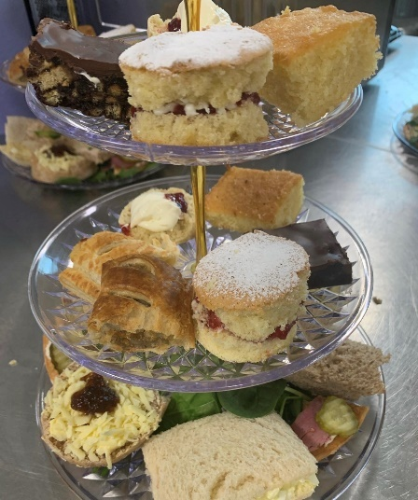We have made significant investments in our vocational facilities and in our curriculum offer to support & promote opportunities for employability, independence and enrichment.

“Rummies” Bistro is open daily and Sixth Form students are involved in preparing and serving a wide range of drinks, snacks and meals, including barista coffees and our renowned cakes and afternoon teas.

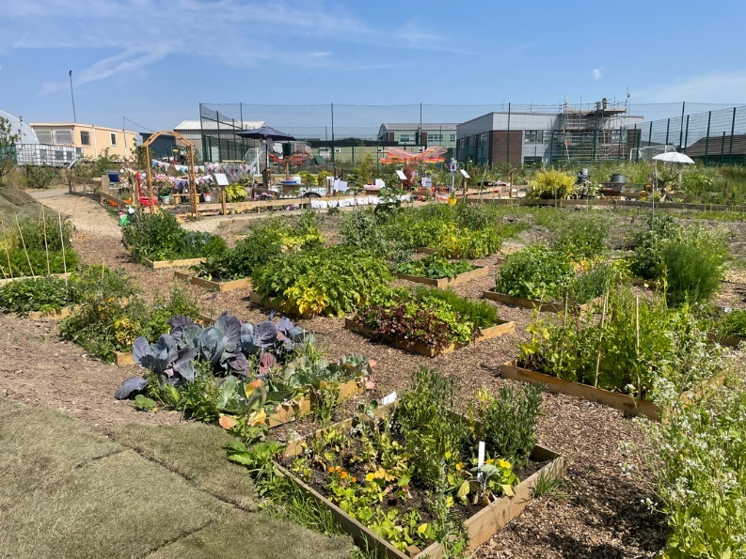

The recent extensive development of our outdoor “Growing Places” area includes a new outdoor classroom area, an industrial-scale growing polytunnel and planting areas with raised beds. Every form class has a small outdoor garden and then each year group takes part in designing an annual ‘show garden’ as part of the Rumworth School Grand Show competition.

The Forest School area, our large fishing lake, accessible outdoor trail paths, the outdoor gym and two outdoor multi-use games areas (MUGAs) all offer secure outdoor spaces to promote health and well-being. Students have the opportunity to develop new skills and access team building activities which support the holistic development of confidence and communication. Students are also taught to swim and have access to therapy sessions in our hydrotherapy pool which has a wave function, and sound & light facilities.

