

Cleaner
Bishop Bridgeman CE Primary School
Salary: NJC Grade B Point 3-4
Part Time: 12.5 hrs/wk all year round
Term of contract: Permanent
Required for: ASAP

We have the following vacancy for a Cleaning Operative to keep our school clean on a daily basis. Duties will include cleaning, buffing, sweeping, vacuum cleaning and other general domestic cleaning duties. You will receive the 24 days holiday. (Please be aware you do not get all school holidays and all holidays must be taken within the school holiday calendar.)

To fulfil this very rewarding and valuable role you will need:
- Experience of cleaning
- Patience, resilience and an ability to nurture;
- A calm, organised and flexible approach to team working;

We can offer:
- a caring and inclusive school with supportive, enthusiastic and dedicated school leaders and staff
- children who are polite and well mannered
- a commitment to high quality professional development
- the opportunity to work as part of an enthusiastic and dynamic team

To apply please complete the downloadable application form and email to digglek@archbishoptempletrust.co.uk or, in the event of difficulty, contact Mrs K. Diggle on 01204 333 466.

Archbishop Temple Trust, Rupert Street, BL3 6PY

Closing date: Monday 8th June 2026 9am
Observations & Interviews: Monday 15th June 2026 – please note this date cannot be changed

This school is committed to safeguarding and promoting the welfare of children and young people and expects all staff and volunteers to share this commitment. Successful candidates will be subject to an Enhanced Disclosure by the Disclosure and Barring service.

Visits to the school are welcomed. Please contact Kirsty Diggle, digglek@archbishoptempletrust.co.uk

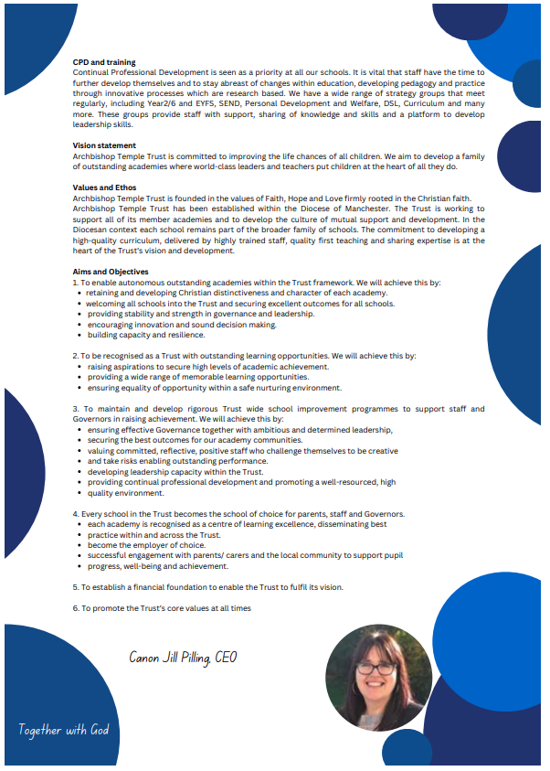

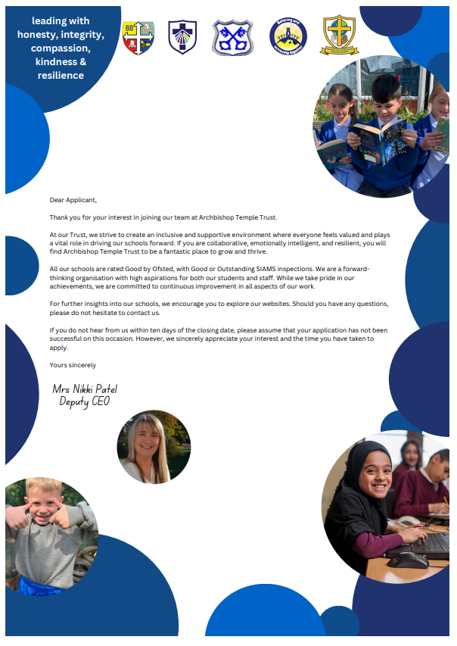


Archbishop Temple Trust
Cleaner - Job Description

Salary
Grade B Point 3-4

Line of responsibility
The Cleaner is directly responsible to the Headteacher/Site Manager.

Job content

Strategic purpose

- To undertake cleaning duties to the satisfaction of the line manager.

Operational responsibilities

- Remove and replace furniture as required.

- Collect and take waste to a disposal point.

- Vacuum rooms

- Clean toilets, sinks and cloakrooms

- Mop and sweep floors in cloakroom and toilets

- Wipe tables

- Clean sinks in classrooms

- Clean staff toilets and mop floors

- Wipe window ledges

- Vacuum entrance hall/ foyer

- Any spot/emergency cleaning

- Undertake seasonal duties as required.

- Follow health and safety requirements as agreed.

- Comply with relevant regulations, rules and conditions.

- Undertake additional cleaning duties as required in emergencies. If additional hours are agreed, these will be paid for at the agreed overtime rate.

Job description of Cleaners during holidays

- Clean all rooms on a rolling programme including: -
- Scrub and polish floors
- Wipe dirty marks off walls and doors
- Polish shelves
- Wipe tops of units
- Dusting all surfaces

Conditions of employment

The above responsibilities are subject to the general duties and responsibilities contained in the written statement of conditions of employment (the Contract of Employment).

S/he shall be subject to all relevant statutory and institutional requirements.

To uphold the school's policy in respect of child protection matters.

The postholder may be required to perform any other reasonable tasks after consultation.

This job description allocates duties and responsibilities but does not direct the particular amount of time to be spent on carrying them out and no part of it may be so constructed.

This job description is not necessarily a comprehensive definition of the post. It will be reviewed at least once a year and it may be subject to modification at any time after consultation with the postholder.

All staff participate in the school’s performance appraisal systems.



Archbishop Temple Trust

Department | Bishop Bridgeman CE Primary School
Job Title | CLEANING OPERATIVE

STAGE ONE | Disabled Candidates are guaranteed an interview if they meet the essential criteria

MINIMUM ESSENTIAL REQUIREMENTS |  | METHOD OF ASSESSMENT
1. Skills and Knowledge
1. | Conscientious attitude towards work duties. | Application Form/Interview
2. | Able to maintain a high standard of work. | Application Form/Interview
3. | Sufficiently literate and numerate to cope with routine job documentation. | Application Form/Interview
4. | Ability to work under own initiate and as a member of a team. | Application Form/Interview
5. | Ability to accept and understand verbal and written communication. | Application Form/Interview
6. | Customer Care – Listen and respond to customer need, seek out innovative ways of consulting service users and engaging partners. Network with others to develop services for the benefit of the service users. | Application Form/Interview
7. | Valuing Diversity – Listen, support and monitor the diverse contributions made to service development without prejudice. Challenge behaviours and processes which do not positively advance the diversity agenda whilst being prepared to accept feedback about own behaviour. Recognise people’s strengths, aspirations and abilities and help to develop their potential. Understand how Valuing Diversity can improve our ability to deliver better services and reduce disadvantage. | Application Form/Interview
8. | Developing Self and Others - Ability to question, and request right training and development that links to the post, to seek opportunities that add to skills and knowledge, to respond positively to opportunities that arise. And to support others’ learning and share learning with others | Application Form/Interview

2. Experience/Qualifications/Training etc
1 | Able to operate associated equipment | Application Form/Interview

3. Work Related Circumstances
1. | Able to work early mornings and late evenings | Application Form/Interview

Note to Applicants: Please try to show in your application form, how best you meet these requirements

Date Person Specification prepared/updated | 2025
Person Specification prepared by | Michael Lonsdale
These core competencies are considered essential for all roles within Bolton Council. Please be prepared to be assessed on any of these during the interview process and, for the successful applicant, throughout the probationary period.

Developing Self & Others
Promote a learning environment to embed a learning culture. Support others to develop their skills and knowledge to fulfil their potential. Actively pursue your own development. Support and promote the principles of Investors in People.

Civil Contingencies
Bolton Council has a statutory duty under the Civil Contingencies Act to respond in the event of an emergency. If Bolton Council’s Emergency Management Plan is activated, you may be required to assist in maintaining key Council services and supporting the community. This could require working outside of routine working hours and working from places other than your normal place of work.

Equality & Diversity
Uphold the principles of fairness and the Equality Act in all undertakings as a Bolton Council employee, including providing a fair, accessible service irrespective of customer’s race, religion, gender, sexuality, disability or age.

Customer Care
The ability to fully understand, assess and resolve the needs of all customers including those who present with complex situations, in a manner that respects dignity and expresses a caring & professional image.

Health & Safety
Take responsibility for the health and safety of yourself and others who may be affected by your acts or omissions, and comply with all health and safety legislation, policy and safe working practice, including participating in training activities necessary to your post.

Data Protection and Confidentiality
Ensure that any personal data or confidential data you hold is kept securely and is not disclosed, whether electronically, verbally or in writing, to any unauthorised third party. Follow Council policies and procedures on dealing with personal information and information assets, including The Code of Conduct, Data Protection, Acceptable Use and Information Security policies. Personal or confidential data should only be accessed or used for council purposes.

Fluency Duty
Should you be required, as a regular and intrinsic part of your role, to speak to members of the public in English, you must be able to converse at ease with customers and provide advice in accurate spoken English, as required by The Immigration Act 2016.

Working Hours
The nature and demands of the role are not always predictable and there will be an expectation that work will be required outside of normal hours from time to time.

Safeguarding
This Council is committed to safeguarding and promoting the welfare of children, young people and vulnerable adults and expects all staff and volunteers to share this commitment. Should the role involve working with the above groups, you will be subject to an Enhanced Disclosure and Barred List check by the Disclosure & Barring Service.
The values of an organisation are those key principles by which people are expected to work to day to day. They’re our culture and help define what is expected of each and every one of us.



How to apply
We hope that you have enjoyed reading about the Archbishop Temple Trust and our school and that you will feel able to apply for this post.

Please complete the downloadable application form. Please do not send CVs or open references as part of your application as these will not be considered.

It is important that you provide a complete employment history from when you left full time education. If the application form is not fully completed or has unexplained gaps in your employment history, your application will not be considered. Copies of your qualifications will be required at the interview stage; please do not send these with your application.

Please also write a letter of no more than two sides of A4 to explain why you want to work within our Trust, why you are the best candidate for the post and what you would contribute to our schools, with examples from your recent work if possible.

Please let us have both the supporting letter and the application form by 9am on Monday 8th June 2026 as we will not be able to consider applications received after that.

In accordance with the Data Protection Act, the details provided in the application form will be used for selection and interview procedures, and for employment records if your application is successful.

If you are disabled, please give details of how we can ensure that you are offered a fair selection and interview process.

Successful candidates will be asked to provide, prior to taking up the appointment, documentary evidence (including National Insurance number) showing their entitlement to work in the UK. We will also carry out an enhanced DBS and declaration of health check. References will also be required in line with Keeping Children Safe in Education 2019.





Bishop Bridgeman is a special place where “we work, we play, we care and we pray…”

At Bishop Bridgeman, we aim to inspire minds. The primary years are the most important in a child’s life and are certainly the most exciting. The sense of wonder and discovery children experience as they start their learning journey here is a privilege to observe and to be a part of.

The school is a friendly, happy place, buzzing with activity and positive energy. The atmosphere within school is very supportive and purposeful, which is what underpins our pupils’ successes and enables them to find their unique talents and strengths.

Our staff are committed to developing in each pupil a love of learning and developing the skills and values to support their all-round development. This allows them to make a positive contribution to the school community and become responsible members of society.

Providing our children with the very best education possible is our primary aim. Staff provide our children with exciting opportunities, enabling them to grow into confident young people. Giving them the life skills to succeed in whatever they choose to do makes me proud, of not only our children, but the staff who go over and beyond to make Bishop Bridgeman a special place.

The school works closely with a dedicated team of governors and executive leaders, as well as parents, who challenge and support the school to be the best it can be. Bishop Bridgeman is an Academy within the Archbishop Temple Trust. We work as part of a family of schools to raise standards and to enable children to achieve and surpass their potential. Together we ensure children are given the educational opportunity of a lifetime.



Mr Mike Lonsdale
Headteacher

