

Teaching Assistant - Level 2
Little Saints – 2 Year Old Nursery
Salary: NJC Grade D Point 6-11
Part Time: 32 hrs/wk (Term Time +5)
Term of contract: Permanent
Required from: As soon as possible

The Governors of St James CE Primary School invite applications for the above post from suitably qualified or experienced people who enjoy working with children. The person appointed will work for 32 hours/week (Monday to Friday) and will provide learning support in the Little Saints Nursery (2 year olds). To fulfil this very rewarding and valuable role you will need:
- To be an excellent practitioner with high expectations of children’s achievements and standards in all areas of school life;
- Have a passion for Early Years Education;
- Be knowledgeable about the Early Years Statutory Framework and can put it into practice;
- The ability to make positive relationships with young children, their parents and staff.

Application forms and job descriptions can be obtained from the “Greaterjobs” website.

CLOSING DATE: Please return completed forms to Mrs Kirsty Diggle (Finance/HR Officer) at Archbishop Temple Trust by 9am on the closing date by Friday 20th November 2026

Email: digglek@archbishoptempletrust.co.uk
Post: St James CE Primary School, Hillside Avenue, Farnworth, Bolton, BL4 9QB

Interviews and observations will take place on Tuesday 1st December 2026
This school is committed to safeguarding and promoting the welfare of children and young people and expects all staff and volunteers to share this commitment. Successful candidates will be subject to an Enhanced Disclosure by the Disclosure and Barring service.

Visits to the school are warmly welcomed and appointments must be made in advance. Please contact Mrs Williamson the Senior Administrator at the school office on 01204 572587.


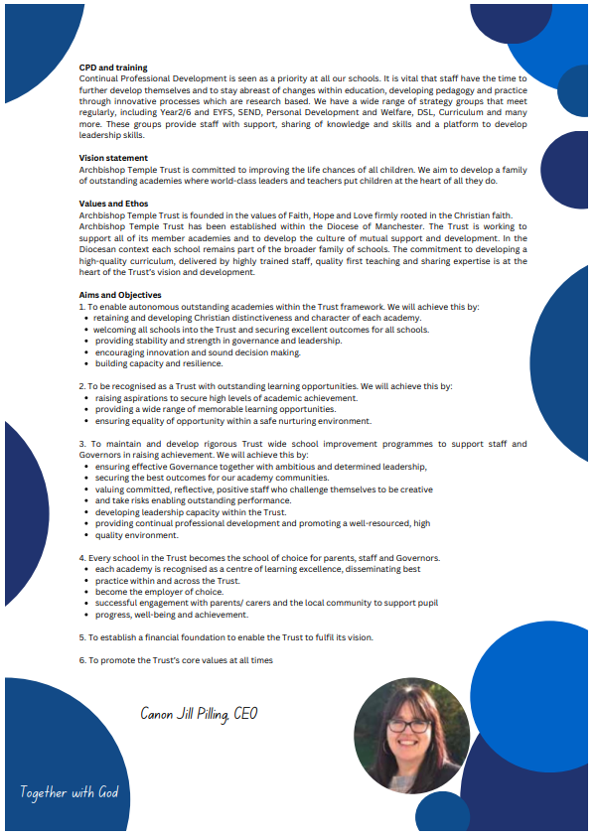

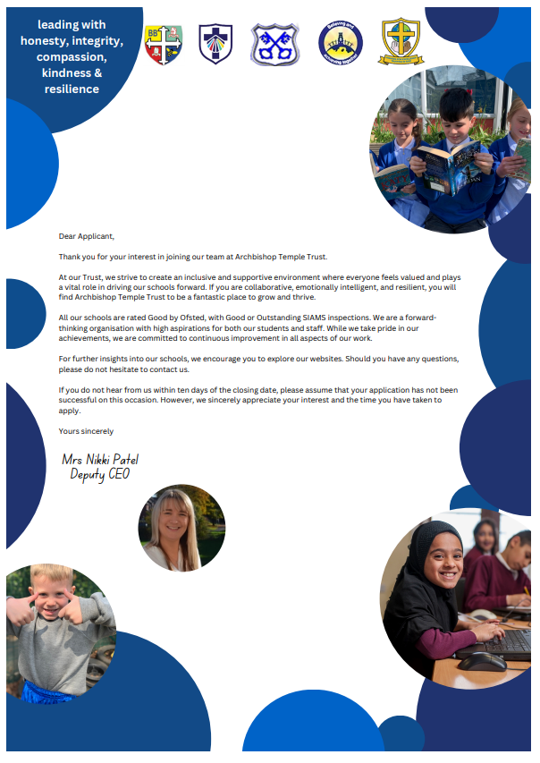


Job Description

Job Details
School Name | St James CE Primary School
Job Title | Clerical Assistant
Grade | Grade B
Primary Purpose of Job | To provide administrative and organisational support for staff and the school under the direction or instruction of teaching and senior staff.
Responsible to | Senior Administrative Assistant/Chief Finance Officer
Responsible for | Not Applicable
Principal Responsibilities | Provide general clerical, administrative financial support to the school.

Main Duties

Organisation
Undertake reception duties, including answering the telephone and face to face enquiries and signing in visitors.
Assist with pupil first aid/welfare duties, looking after sick pupils, liaising with parents and staff etc.
Assisting with arrangements for visits by school nurse, photographer etc.

Administration
Provide routine clerical support e.g. photocopying, filing, faxing, email and the completion of routine forms.
Maintain manual and computerised records/management information systems as appropriate.
Undertake typing, word-processing and other IT based tasks.
Undertake routine administration e.g. distribution and collection of registers and the administration surrounding school meals etc.

Resources
Operate office equipment e.g. photocopier, computer, fax machine.
Arrange orderly and secure storage of supplies.
Undertake routine financial administration, e.g. collect and record money.

Responsibilities
Be aware of and comply with policies and procedures relating to child protection, safeguarding, health and safety and security, GDPR, confidentiality and data protection, reporting all concerns to an appropriate person.
Contribute to the overall ethos, work and aims of the school.


Job Description
Department | St James CE Primary School
Job Title | Teaching Assistant Level 2
Grade | Grade D Point 6-11
Primary Purpose of Job | Provide effective support for teaching and learning in school
Reporting To | Little Saints Room Leader/EYFS Lead/Head teacher

Main Duties
1 | Provide support for learning activities within the EYFS, predominantly in the Little Saints room for 2-year olds.
2 | Support children’s development through the Early Years Statutory Framework.
3 | Help to keep children safe, including maintaining a safe environment, dealing with accidents, supporting safeguarding.
4 | Encourage children’s positive behaviour.
5 | Contribute to positive relationships with children and adults through communication and interaction.
6 | Provide effective support for colleagues.
7 | Be a keyworker for a group of 2 year old pupils.
8 | Support the use of information and communication technology for teaching and learning.
9 | Use information and communication technology to support pupils’ learning.
10 | Observe and report on pupil performance, including the completion of the 2 year old check.
11 | Work with the Little Saints team to provide a high quality learning environment for children, including display work.
12 | Escort and supervise pupils on educational visits and out-of-school activities.
13 | Contribute to maintaining pupil records.
14 | Contribute to monitoring and maintaining curriculum resources.
15 | The post holder may reasonably be expected to undertake other duties commensurate with the level of responsibility that may be allocated, at the discretion of the Head Teacher and to meet the needs of the school.
Date Job Description prepared/updated: |  | 06.11.26
Job Description prepared by: |  | C Booth

Person Specification
Department |  |  | St James ce primary school
Job Title |  |  | teaching assistant level 2
Stage One |  |  | Candidates who are care leavers, have a disability, are ex-armed forces or are a carer (see Carers-Charter-FINAL.pdf (gmhsc.org.uk) are guaranteed an interview if they meet the essential criteria for the role
The Minimum Essential Requirements for the above Post are as Follows: |  |  |  |  | Method of Assessment
1. | Skills and Knowledge
1. | Ability to support the room leader in planning, delivering and evaluating learning activities to ensure effective teaching and learning. Ability to give feedback in a constructive manner. |  |  |  | Application Form/Interview
2. | Ability to listen and observe children/young people and share observational findings effectively. |  |  |  | Application Form/Interview
3. | Ability to keep children and young people safe during day-to-day work activities. Ability to assess the balance between safety and risk, challenge and protection, and adjust own behaviour and accordingly. |  |  |  | Application Form/Interview
4. | Ability to praise and encourage children/young people according to their age, needs and abilities. Ability to deal sensitively with challenging behaviour (in line with setting/school policy and procedures). Act as a role model for positive behaviour. |  |  |  | Application Form/Interview
5. | Ability to interact and respond positively to children, young people and adults. Ability to establish and maintain rapport with pupils. Ability to demonstrate verbal and non-verbal communication skills when dealing with children, colleagues, parents, carers, families and other practitioners. |  |  |  | Application Form/Interview
6. | Ability to become an effective member of staff. Ability to work effectively with colleagues and other practitioners. Ability to take an active role in developing own skills and expertise. |  |  |  | Application Form/Interview
7. | Ability to help pupils, under the direction of the room leader, to participate in whole class, group and individual learning activities. |  |  |  | Application Form/Interview
8. | Ability to operate ICT resources safely and effectively as a learning resource. Ability to access and use learning programmes and information. |  |  |  | Application Form/Interview
9. | Ability to encourage and support pupils in using ICT during learning activities and feedback on their progress and response. |  |  |  | Application Form/Interview
10. | Value people equally, supporting an inclusive ethos. |  |  |  | Interview
11. | Excellent numeracy and literacy skills. |  |  |  | Application Form/Interview
12. | Understanding of roles and responsibilities for supporting young children’s learning and implications for the support you can provide. |  |  |  | Application Form/Interview
13. | Knowledge and understanding of children and young people’s development in relation to the ages covered by the setting/school. |  |  |  | Application Form/Interview
14. | Awareness of safeguarding principles and safe working practices. |  |  |  | Application Form/Interview
15. | Displays commitment to the protection and safeguarding of children and young people. |  |  |  | Interview
16. | Knowledge and understanding of importance of consistent behaviour management. |  |  |  | Application Form/Interview
17. | Knowledge and understanding of the key features of effective communication. |  |  |  | Application Form/Interview
18. | Knowledge and understanding of appropriate software packages e.g. Tapestry |  |  |  | Application Form/Interview
 | Competencies – Please note the council’s corporate competencies, which are essential for all roles, are below in the Core Competencies section |  |  |  | Interview
2. Experience/Qualifications/Training etc
1. |  | Work experience with children within specified age range/subject area. |  | Application Form/Interview
2. |  | Holder of GCSE Mathematics and English qualification Grades A-C or 9-4 or the equivalent. |  | Application Form/Certificate
3. |  | Holder of a full and relevant qualification such as NVQ Level 2, BTEC Level 2 or equivalent in Teaching Assistant or Supporting Teaching and Learning in Schools. |  | Application Form/Interview
3. Work Related Circumstances
1. |  | To attend staff training days, twilight training sessions and relevant out of hours training and events. |  | Application form/Interview
2. |  | This post is subject to an enhanced disclosure and a barred list check from the Disclosure & Barring Service. |  | Application Form / Interview

STAGE TWO |  | Will only be used in the event of a large number of applicants meeting the minimum essential requirements
Additional Requirements |  |  |  | Method of Assessment
1. Skills and Knowledge
1. | Be familiar with and able to set in motion accident/emergency, safety, safeguarding and welfare procedures, according to school/setting policies and procedures |  |  | Application Form / Interview
2. | Ability to adapt learning activities to individual pupils’ needs and abilities |  |  | Application Form / Interview
3. | Ability to identify the purpose of learning displays and devise design and content accordingly. Ability to create the display with due regard for safety and future maintenance, and to evaluate its effectiveness. |  |  | Application form/Interview
2. Experience/Qualifications/Training etc
1. | Minimum of 2 years paid experience of working with &/or caring for children within specified age range (EYFS). |  |  | Application Form / Interview
2. | Experience of working with children in a 2 year old nursery/school setting. |  |  | Application Form / Interview
3. | Knowledge of the practical application of special educational needs strategies. |  |  | Application Form / Interview
Date Person Specification prepared/updated |  |  | 06.11.26
Person Specification prepared by |  |  | C Booth

These core competencies are considered essential for all roles within Bolton Council. Please be prepared to be assessed on any of these during the interview process and, for the successful applicant, throughout the probationary period.

Developing Self & Others
Promote a learning environment to embed a learning culture. Support others to develop their skills and knowledge to fulfil their potential. Actively pursue your own development. Support and promote the principles of Investors in People.

Civil Contingencies
Bolton Council has a statutory duty under the Civil Contingencies Act to respond in the event of an emergency. If Bolton Council’s Emergency Management Plan is activated, you may be required to assist in maintaining key Council services and supporting the community. This could require working outside of routine working hours and working from places other than your normal place of work.

Equality & Diversity
Uphold the principles of fairness and the Equality Act in all undertakings as a Bolton Council employee, including providing a fair, accessible service irrespective of customer’s race, religion, gender, sexuality, disability or age.

Customer Care
The ability to fully understand, assess and resolve the needs of all customers including those who present with complex situations, in a manner that respects dignity and expresses a caring & professional image.

Health & Safety
Take responsibility for the health and safety of yourself and others who may be affected by your acts or omissions, and comply with all health and safety legislation, policy and safe working practice, including participating in training activities necessary to your post.

Data Protection and Confidentiality
Ensure that any personal data or confidential data you hold is kept securely and is not disclosed, whether electronically, verbally or in writing, to any unauthorised third party. Follow Council policies and procedures on dealing with personal information and information assets, including The Code of Conduct, Data Protection, Acceptable Use and Information Security policies. Personal or confidential data should only be accessed or used for council purposes.

Fluency Duty
Should you be required, as a regular and intrinsic part of your role, to speak to members of the public in English, you must be able to converse at ease with customers and provide advice in accurate spoken English, as required by The Immigration Act 2016.

Working Hours
The nature and demands of the role are not always predictable and there will be an expectation that work will be required outside of normal hours from time to time.

Safeguarding
This Council is committed to safeguarding and promoting the welfare of children, young people and vulnerable adults and expects all staff and volunteers to share this commitment. Should the role involve working with the above groups, you will be subject to an Enhanced Disclosure and Barred List check by the Disclosure & Barring Service.
The values of an organisation are those key principles by which people are expected to work to day to day. They’re our culture and help define what is expected of each and every one of us.



How to apply
We hope that you have enjoyed reading about the Archbishop Temple Trust and our school and that you will feel able to apply for this post.

Please complete the downloadable application form. Please do not send CVs or open references as part of your application as these will not be considered.

It is important that you provide a complete employment history from when you left full time education. If the application form is not fully completed or has unexplained gaps in your employment history, your application will not be considered. Copies of your qualifications will be required at the interview stage; please do not send these with your application.

Please also write a letter of no more than two sides of A4 to explain why you want to work within our Trust, why you are the best candidate for the post and what you would contribute to our schools, with examples from your recent work if possible.

Please let us have both the supporting letter and the application form by 9am on Friday 20th November 2026 as we will not be able to consider applications received after that.

In accordance with the Data Protection Act, the details provided in the application form will be used for selection and interview procedures, and for employment records if your application is successful.

If you are disabled, please give details of how we can ensure that you are offered a fair selection and interview process.

Successful candidates will be asked to provide, prior to taking up the appointment, documentary evidence (including National Insurance number) showing their entitlement to work in the UK. We will also carry out an enhanced DBS and declaration of health check. References will also be required in line with Keeping Children Safe in Education 2019.



Dream | Believe | Learn | Achieve

My name is Chris Booth and I am the very proud Principal of our special ‘St James Family’. Each day is an absolute pleasure, working with the staff and parents who are committed to make a difference to the lives of the pupils with whom we work. Our children are nurtured through the Christian values of respect, peace, love, forgiveness, honesty and hope. As a result, our pupils are kind, caring and polite; visitors always feel a warm welcome when they walk through our front door. The children of St James are utterly delightful, with exemplary behaviour and a real credit to the school and their families.


St James is situated in a very vulnerable catchment area, with above-average pupil premium and SEND figures. However, this does not stop our pupils from achieving what we set out for them, nor does it stop us as practitioners believing that our children CAN DO. I am very lucky to serve a staff who work incredibly hard to ensure the children in our care receive the very best that we can offer them. We are big advocates that ‘team work makes the dream work’ and we ensure that we are there to support, challenge and motivate each other. Staff new to school, or on supply, always comment on how helpful and friendly the staff team of St James are. We are always eager to grow our workforce with like-minded individuals, who have a passion to make a difference. Our children deserve a great education, with great professionals to ensure we achieve this.


Working within the Archbishop Temple Trust has opened many doors for school improvement and networking. Staff at St James have benefited from many CPD opportunities for training and sharing best practice. Strong and supportive relationships across staff flourish within our MAT. The impact for the children is also positive, with the opportunity to visit other schools in contrasting environments and to work on joined-up projects.

Thank you for considering our school and MAT to either start or further your career in education. I look forward to hearing from you.

Mr Chris Booth
Headteacher

