
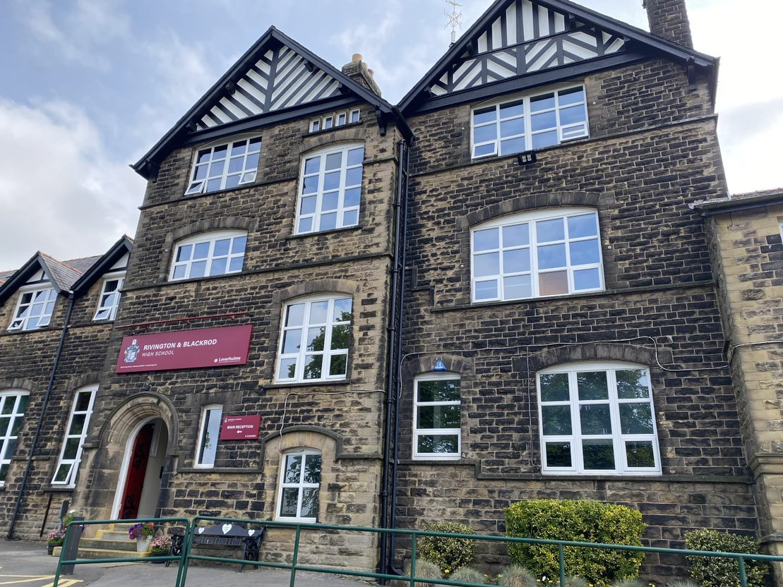
Application Pack
Teacher of Science


Dear Applicant,
Thank you for your interest in the position of Teacher of Science here at Rivington and Blackrod High School, part of the Leverhulme Academy Trust.
We are seeking an ambitious, inspirational, and enthusiastic Teacher of Science who is passionate about their subject and who is committed to inspiring our students, to reach their full potential. This is a fantastic opportunity to join a forward-thinking and supportive school community that places students at the centre of everything we do.
With a proud heritage of over 450 years, Rivington and Blackrod High School is deeply rooted in the local community and enjoys strong relationships with parents. You will be joining a committed, welcoming, and friendly staff team who work tirelessly to secure the very best outcomes for every student.
At the heart of our ethos are the values that guide everything we do: we encourage our students to take part, seizing opportunities both inside and outside the classroom; to work hard, showing resilience and determination in all that they do; and to do the right thing, demonstrating integrity, respect, and kindness. We expect our staff to embody and promote these values, creating an environment where young people feel a true sense of purpose and belonging.
We are ambitious for our students and determined to support them on their journey towards achieving their aspirations and transforming their lives. We celebrate success at every level and believe that personal development and academic progress go hand in hand. Our aim is to nurture well-rounded individuals who excel academically while also developing the character and confidence needed to succeed in life.
At Rivington and Blackrod, we provide a challenging, knowledge-rich curriculum supported by high-quality teaching and excellent pastoral care. As part of the Leverhulme Academy Trust, we are committed to collaboration, professional development, and continual improvement in order to secure the very best life chances for our students.

If you share our vision, live our values, and are excited by the opportunity to lead our English Department, we would be delighted to receive your application.
I look forward to the opportunity to meet you.
Yours faithfully,
Mrs Victoria Walmsley – Head of School

A Warm Welcome to Rivington and Blackrod High School
I would like to offer you a very warm welcome to Rivington and Blackrod High School and Sixth Form. Founded in 1566, our school has held an important place in this community for centuries. We are very proud of our tradition as a successful, forward thinking and caring school.
We pride ourselves on offering an excellent education in all areas of the curriculum and a wide range of learning and enrichment opportunities. Our Christian values underpin all that we do in ensuring that all of our students achieve the highest academic standards and develop spiritually, morally, socially and culturally.
Our aim is to ensure that all students feel safe, happy and grow as successful learners and caring global citizens. Insisting on high standards in all that we do, we strive to encourage students to achieve to their highest aspirations.
A School Built On Strong Foundations “Once a Rivi, always a Rivi.”
A simple phrase that not only reflects the lasting impact our school has on all those who have walked its corridors, but also speaks volumes about the character of the people who make up the Rivington and Blackrod school family. We are fortunate to have a beautiful school, but it has always been, and continues to be, the people who make our school truly special. Generations of students talk of a ‘family spirit’ that is founded on strong relationships and outstanding care, guidance and support. This spirit can be found throughout our current school community of approximately 1700 students and 200 staff.
Ofsted
Rivington and Blackrod High School and Sixth Form had a full Section 5 Ofsted inspection on 14th and 15th June, 2023.
The school received a judgement of Good across all areas. This is thoroughly well deserved, and sincere thanks go to all students, staff, parents and Governors for supporting the school in achieving this.
The report contains lots of positive information about our school. We are really pleased that the hard work over the years is having a positive impact on the students and their academic and personal development.
We are delighted that the inspection team recognised the improvements that had been made to the school over the recent years through the hard work of leaders at all levels, grading Leadership and Management as ‘Good’.
We were also praised for our strong emphasis on developing the whole child through our work with the house system, our careers programme and our extensive extra-curricular timetable and therefore, Personal Development was also judged to be ‘Good’.
Our Sixth Form continues to be a strength of the school, and it was also graded as ‘Good’, which we will continue to grow and build upon. To read the full report, please click here
“Discovering dreams, achieving ambitions and transforming lives.”
Rivington and Blackrod High School is part of Leverhulme Church of England and Community Trust. As a Trust, we work together to ensure that all students receive an excellent education irrespective of their starting point. We relish the opportunity to be a part of the much‐needed regeneration of areas we work in and wish to play a full role in the wider community.
Mission
Discovering dreams, achieving ambitions, and transforming lives.
Vision
The vision of Leverhulme is to provide the highest quality of education that creates a community of happy, successful and well‐rounded individuals who can flourish and make a difference in our world.
Staff Values
Our values underpin our mission and provide the basis on which we will achieve our vision.
- Students First: We put our students at the heart of all our decisions
- High Expectations: We have high expectations of both ourselves and others
- Integrity: We do the right thing

Student Values
- Take part
- Work hard
- Do the right thing
Mr Paul Roach – CEO
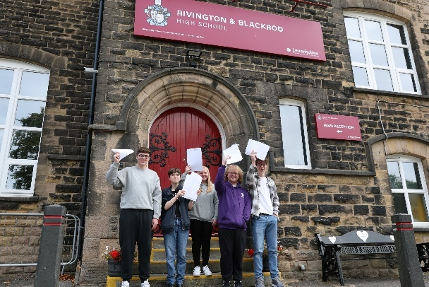
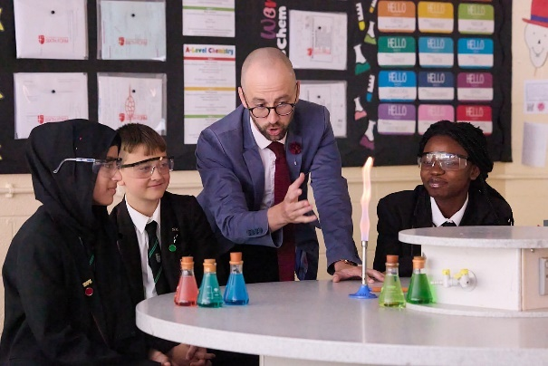

Our Staff Benefits

Working for Leverhulme is rewarding in lots of ways. In addition to a competitive salary, we offer a wide range of benefits to support your career development, health and wellbeing, finances and family.
Pension
We offer an excellent pension scheme with the Local Government Pension Scheme and Teachers Pension Scheme.
Continuous Service
Continuous service will be honoured for candidates moving from local authorities.
Salary Sacrifice Scheme
Employees can benefit from salary sacrifice schemes, including the Cycle to Work scheme.
Support Services
We provide access to an occupational health provider for advice and support.
Excellent Career Development
We are committed to providing excellent CPD with access to further training and the opportunity to stretch your abilities and advance your career.
Free Parking on Site
Employees can enjoy the benefits of free car parking across our site.
Electrical Vehicle Charging Points
Employees have the use of Electric Vehicle Charging Points on site.
Wellbeing Half Day
The opportunity to enjoy a half day off during term time to support staff wellbeing.
Free Access to Office 365
We have a dedicated IT Support Team to assist with any IT related queries.
Free Flu Vaccinations
We offer free flu vaccinations on an annual basis to all staff.
Trade Unions and Professional Associations
We recognise all of the leading trade unions and professional associations in the education sector and share the common objective of maintaining good employee relations.
JOB DESCRIPTION

Job Title: Classroom Teacher

Location: Rivington & Blackrod High School

Grade: Main Scale

Reports to: Head of Department

Line management responsibility: n/a

Main purpose of the job:
The education and welfare of designated groups of students as set on the school timetable in accordance with the requirements of Conditions of Employment of School Teachers, having due regard to the requirements of the National Curriculum, the school’s aims, objectives and schemes of work, and any policies of the Governing Body.

To share in the corporate responsibility for the wellbeing and discipline of all students.

Key duties and responsibilities

- To set challenging teaching and learning objectives which are relevant to all students in their classes.
- To use teaching and learning objectives to plan lessons and sequences of lessons showing how this will assess students’ learning.
- To select and prepare resources, taking into account students' interests and their learning needs, language and cultural backgrounds.
- To contribute to teaching team meetings and events.
- To plan for the deployment of any support staff who are contributing to students' learning.
- To plan opportunities for students to learn in out of school contexts.
- To produce long and short term planning in accordance with school policy and procedures and within required deadlines.
- To implement and review the subject development plan in conjunction with the Leadership Team and/or line manager.
- To develop and audit schemes of work and other documentation related to the subject taught to support cross-curricular delivery including subject support for colleagues to enable curriculum requirements to be met.
- To lead or contribute to professional development activities as part of the planned programme for the school and to promote the sharing of good practice.
- To manage the resources available for subject taught and make recommendations in order to maintain and develop curriculum provision.

Monitoring and Assessment

- To make appropriate use of monitoring and assessment strategies to evaluate students' progress towards planned learning objectives.
- To use monitoring and assessment information to inform planning and teaching.
- To monitor and assess the effectiveness of learning activities and provide immediate and constructive feedback to support students' learning. To involve students in reflecting on, evaluating and improving their own performance and progress.
- To assess students' progress accurately against appropriate levels.
- To identify and support students with differing levels of ability and those experiencing behavioural, emotional, and social difficulties.
- To identify the levels of attainment for students learning English as an additional language and identify learning activities to provide cognitive challenge as well as language support.
- To record students' progress and achievements systematically, providing evidence of the range of their work progress and attainment over time to inform planning.

Teaching and Class Management

As a Form Tutor:
- Track and monitor the progress and achievement of students in a form, using mentoring and target setting to maintain levels of progress and prevent underachievement.
- To be involved in activities and events associated with the year group e.g. Progress Evenings, Work Experience.
- To ensure weekly routines are followed and high standards are maintained.
- To have high expectations of students and build successful relationships centred on teaching and learning.
- To establish a purposeful learning environment where diversity is valued and where students feel safe, secure and confident.
- To teach the required or expected knowledge, understanding and skills relevant to the curriculum for students at their stage of learning.
- To teach clearly structured lessons or sequences of work which interest and motivate students, make learning objectives clear, and employ appropriate teaching methods.
- To promote active and independent learning that enables students to think for themselves and to plan and manage their own learning.
- To differentiate teaching to meet the needs of students of all ability ranges taking into account varying interests, experiences and achievements of boys and girls and different cultural and ethnic groups to help them make good progress.
- To organise and manage teaching and learning time effectively.
- To organise and manage the physical teaching space, tools, materials, texts and resources safely and effectively.
- To set high expectations for students' behaviour and establish a clear framework for classroom discipline in line with school policy to anticipate and manage students' behaviour constructively and promote self-control and independence.
- To use ICT effectively in delivery of teaching and learning.
- To take responsibility for teaching a class or classes over a sustained and substantial period of time.
- To provide homework and other out-of-class work which consolidates and extends work carried out in the class and encourages students to learn independently.
- To work collaboratively with other professionals and manage the work of support staff to enhance students' learning.
- To recognise and respond effectively to equality issues as they arise in the classroom and challenging stereotyped views, bullying and harassment in accordance with school policy and procedures.
- To be aware of and comply with policies and procedures relating to child protection, health, safety and security, confidentiality and data protection, reporting all concerns to an appropriate person.
- To attend and participate in regular meetings.
- To participate in training, continuous professional development and other learning activities as required including participation in the school's performance management arrangements.

To undertake any other duties appropriate with the level of responsibility, as required.

The above duties are not exhaustive and the post holder may be required to undertake tasks, roles and responsibilities as may be reasonably assigned to them by the Leadership Team.

This job description will be kept under review and may be amended via consultation with the individual, Governing Body and/or Leadership Team as required. Trade union representation will be welcomed in any such discussions.

PERSON SPECIFICATION

Job Title: Classroom Teacher

Qualifications and training | Essential | Desirable
Educated to A Level or equivalent. | 
Relevant degree | 
Qualified teacher status - QTS | 

Experience, knowledge and skills | Essential | Desirable
Have up-to-date knowledge and understanding of the professional duties of teachers and the statutory framework within governs the work, and contribute to the development, implementation and evaluation of the policies and practice of their workplace, including those designed to promote equality of opportunity. | 
Ability to communicate effectively with young people and colleagues. | 
Ability to communicate effectively with parents and carers, encouraging participation in discussions and conveying timely and relevant information about attainment, objectives, progress and wellbeing. | 
Recognise and respect the contributions that colleagues, parents and carers can make to the development and well-being of young people, and to raising their levels of attainment. | 
Ability to evaluate own performance and improving practice through appropriate professional development. | 
The ability to act upon advice and feedback and be open to coaching and mentoring | 
Have a creative and constructively critical approach towards innovation; being prepared to adapt practice where benefits and improvements are identified. | 
Have a good, up-to-date working knowledge and understanding of a range of teaching, learning and behaviour management strategies and know how to use and adapt them, including how to personalise learning to provide opportunities for all learners to achieve their potential. | 
Experience and understanding of the assessment requirements and arrangements for subjects curriculum areas, including those relating to public examinations and qualifications. | 
Experience and understanding of a range of approaches to assessment, including the importance of formative assessment. | 
Ability to use local and national statistical information to evaluate the effectiveness of teaching, to monitor the progress of those they teach and to raise levels of attainment. | 
Ability to use reports and other sources of external information related to assessment in order to provide learners with accurate and constructive feedback on their strengths, weaknesses, attainment, progress and areas for development, including action plans for improvement | 
Have a secure knowledge and understanding of subjects /curriculum areas and related pedagogy including: the contribution that subjects/curriculum areas can make to cross-curricular learning; and recent relevant developments. | 
Know and understand the relevant statutory and non-statutory curricula and frameworks, including those provided through the National Strategies, for own subjects /curriculum areas and other relevant initiatives across the age and ability range they teach. | 
Know how to use skills in literacy, numeracy and ICT to support own teaching and wider professional activities. | 
Knowledge and understand of how children and young people develop and how the progress, rate of development and wellbeing of learners are affected by a range of developmental, social, religious, ethnic, cultural and linguistic influences. | 
Know how to make effective personalised provision for those they teach, including those for whom English is an additional language, or who have special educational needs or disabilities, and how to take practical account of diversity and promote equality and inclusion in their teaching. | 
Understand the roles of colleagues such as those having specific responsibilities for learners with special educational needs, disabilities and other individual learning needs, and the contributions they can make to the learning, development and wellbeing of children and young people. | 
Ability to know when to draw on the expertise of colleagues, such as those with responsibility for the safeguarding of children and young people and special educational needs and disabilities, and to refer to sources of information, advice and support from external agencies. | 
Knowledge of the current legal requirements, national policies and guidance on the safeguarding and promotion of the wellbeing of children and young people. | 
Ability to identify potential child abuse or neglect and follow safeguarding procedures and local arrangements of safeguarding of children and young people. | 
Ability to identify and support children and young people whose progress, development or wellbeing is affected by changes or difficulties in their personal circumstances, and when to refer them to colleagues for specialist support. | 
Have an extensive knowledge and understanding of how to use and adapt a range of teaching, learning and behaviour management strategies, including how to personalise learning to provide opportunities for all learners to achieve their potential. |  | 
Have an extensive knowledge and well informed understanding of the assessment requirements and arrangements for the subjects/curriculum areas they teach, including those related to public examinations and qualifications. |  | 
Have up-to-date knowledge and understanding of the different types of qualifications and specifications and their suitability for meeting learners’ needs. |  | 
Have a more developed knowledge and understanding of their subjects/curriculum areas and related pedagogy including how learning progresses within them. |  | 
Have sufficient depth of knowledge and experience to be able to give advice on the development and wellbeing of children and young people |  | 
Ability to plan for progression across the secondary age and ability range, designing effective learning sequences within lessons and across series of lessons informed by secure subject and curriculum knowledge. | 
Ability to design opportunities for learners to develop their literacy, numeracy, ICT and thinking and learning skills appropriate within the secondary phase and context. | 
Ability to plan, set and assess homework, other out- of-class assignments and coursework for examinations, where appropriate, to sustain learners’ progress and to extend and consolidate their learning. | 
Ability to teach challenging, well organised lessons and sequences of lessons across the Secondary age and ability range. | 
Ability to use an appropriate range of teaching strategies and resources, including e-learning, which meet learners’ needs and take practical account of diversity and promote equality and inclusion. | 
Ability to build on the prior knowledge and attainment of those they teach in order that learners meet learning objectives and make sustained progress. | 
Ability to develop concepts and processes, which enable learners to apply new knowledge, understanding and skills. | 
Ability to adapt their language to suit the learners they teach, introducing new ideas and concepts clearly, and using explanations, questions, discussions and plenary sessions effectively. | 
Ability to manage the learning of individuals, groups and whole classes effectively, modifying their teaching appropriately to suit the stage of the lesson and the needs of the learners. | 
Ability to teach engaging and motivating lessons informed by well-grounded expectation of learners and designed to raise levels of attainment. | 
Ability to make effective use of observation, assessment, monitoring and recording strategies as a basis for setting challenging learning objectives and monitoring learners’ progress and levels of attainment. | 
Ability to provide timely, accurate and effective feedback on learners’ attainment, progress and areas for development. | 
Ability to support and guide learners so that they can reflect on their learning, identify the progress they have made, set positive targets for improvement and become successful independent learners. | 
Ability to use assessment as part of the teaching to diagnose learners’ needs, set realistic and challenging targets for improvement and plan future teaching. | 
Ability to review the effectiveness of their teaching and its impact on learners’ progress, attainment and wellbeing, refining their approaches where necessary. | 
Ability to review the impact of the feedback provided to learners and guide learners on how to improve their attainment. | 
Ability to establish a purposeful and safe learning environment, which complies with current legal requirements, national policies and guidance on the safeguarding and wellbeing of children and young people so that learners feel secure and sufficiently confident to make an active contribution to learning and to the school. | 
Ability to identify and use opportunities to personalise and extend learning through out-of-school contexts where possible making links between in-school learning and learning in out-of-school contexts. | 
Ability to manage learners’ behaviour constructively by establishing and maintaining a clear and positive framework for discipline, in line with the school’s behaviour policy | 
Ability to use a range of behaviour management techniques and strategies, adapting them as necessary to promote the self- control and independence of learners. | 
Ability to promote learners’ self-control, independence and cooperation through developing their social, emotional and behavioural skills. | 
Ability to work as a team member and identify opportunities for working with colleagues, managing their work where appropriate and sharing the development of effective practice with them. | 
Be flexible, creative and adept at designing learning sequences within lessons and across lessons that are effective and consistently well- matched to learning objectives and the needs of learners and which integrate recent developments, including those relating to subject/curriculum knowledge. |  | 
Have teaching skills which lead to learners achieving well relative to their prior attainment, making progress as good as, or better than, similar learners nationally. |  | 
Contribute to the professional development of colleagues through coaching and mentoring, demonstrating effective practice, and providing advice and feedback |  | 

Personal attributes | Essential | Desirable
Have high expectations of young people including a commitment to ensuring that they can achieve their full educational potential and to establishing fair, respectful, trusting, supportive and constructive relationships with them. | 
Hold positive values and attitudes and adopt high standards of behaviour. | 
Show commitment to sustaining a high level of attendance at work. | 
Demonstrate dedication to teaching as a career. |  | 
Responsibility for own professional development and be willing to partake in further development. | 
A team player with energy, commitment, enthusiasm and resilience. | 
A commitment to equality and diversity policies. | 
A commitment to Health and Safety. | 
A commitment to child protection and safeguarding. | 

Special requirements | Essential | Desirable
Right to work in the UK | 
Satisfactory enhanced DBS certificate with barred children’s list check. | 
Medical clearance. | 
2 satisfactory references. | 

The school is committed to safer recruitment practice and pre-employment checks will be undertaken before any appointment is confirmed. This post is subject to an enhanced disclosure from the Disclosure and Barring Service (DBS). The school is committed to safeguarding and promoting the welfare of children and young people and it expects staff and volunteers to share this commitment.

