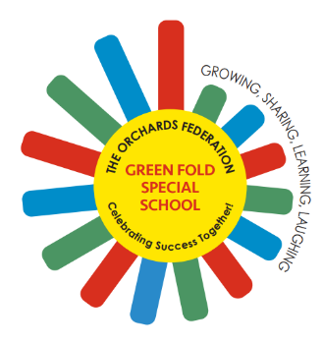

Green Fold Specialist School

An Orchards Federation Provision

Class Teacher Vacancy
Key Information
Salary range: T1 – T9 + 1 SEN Point Start date: September 2026

Telephone: 01204 335 883 Email: office@theorchards.bolton.sch.uk

www.greenfold.bolton.sch.uk

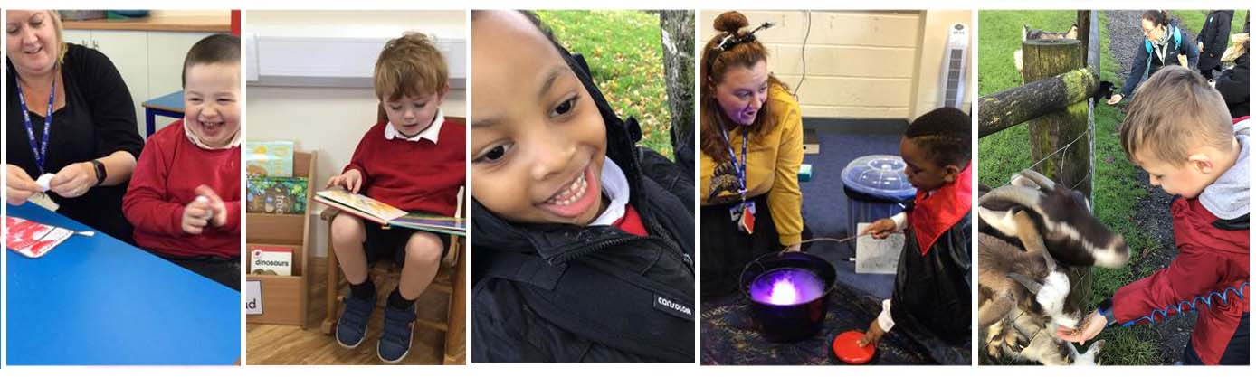


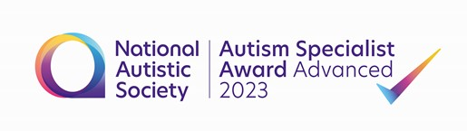

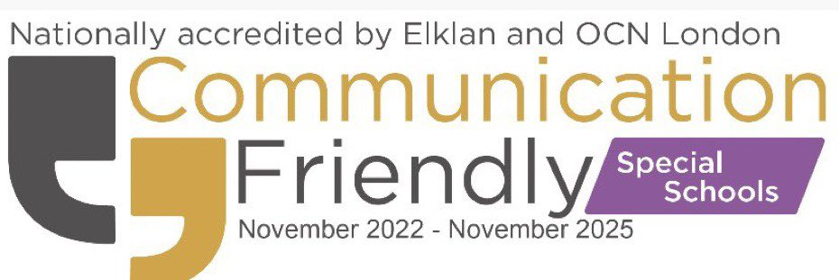

Welcome to Green Fold School!

Dear Applicants,

As Headteacher, it is my privilege to provide a key over view to Green Fold School – a super special school for super special children in the heart of Bolton. Due to expansion we are currently seeking to appoint additional permanent teachers to join our team.

Green Fold is a maintained primary special school that provides the highest quality of education for 175 children aged 4-11 with a wide variety of highly complex needs including PMLD, SLD and Autism with a range of associated communication, interaction, social, sensory and learning differences.

Our team consists of over 130 school-based practitioners in education, health and care who work tirelessly to ensure that we offer the best holistic education and care to our students and support to their families and the wider community.

Our school is part of The Orchards Federation, a group of three schools working closely together for the benefit of all our pupils, the other members of the Federation are The Orchards Nursery School and Cherry Tree Primary School.

Green Fold is located across 4 sites in Bolton each with specific enabling learning environments closely matched to our learners needs.

In 2025/26 our educational offer is organised in the following way:

- The Seedlings provision in Daubhill is the home to our Early Years team, a bespoke provision meeting the needs of our children as they enjoy a bright start on their journey with us.
- Our Saplings provision on Lever Edge Lane caters for autistic children in Key Stage 1 and Lower Key Stage 2
- The Orchards Upper Site in Farnworth provides for children with SLD and PMLD and includes resources such as our hydro pool and full tracking hoists into the classrooms for our PMLD learners who require this support.
- At the Orchards Lower Site in Farnworth our provision is focussed upon our learners with autism in Key Stage 2.

Each of our buildings have excellent facilities and all are equipped with new high specification sensory rooms and other specialist spaces.

We are proud to be recognised as outstanding practitioners in PMLD and complex needs education and are additionally the Autism Education Trust providers for Bolton - we ensure our children are always at the forefront of evidence-based learning.

Green Fold is a place where each pupil is allowed to express themselves as individuals and learn in a style that best meets their needs.

‘Pupils love coming to Green Fold School. It is a place where all pupils flourish.’ Ofsted November 2023

As a Federation we focus strongly on staff and children’s wellbeing. We can offer you an excellent opportunity to continue your professional development, where you will receive a high level of commitment and support from staff, governors and families.

This is a particularly exciting time to join the school as we continue to expand with projected numbers exceeding 185 by 2026. Green Fold and The Orchards Federation are currently undergoing significant building works at all sites to ensure the provision is fit for the future.

As part of the recruitment process, please email recruitment@theorchards.bolton.sch.uk to make an appointment to visit our school or telephone Mrs.Sue Egan on 01204 335883.

Closing Date – Tuesday 5th May at 9:00am

Interviews - Thursday 7th & Friday 8th May 2026

We hope you find this pack informative and are keen to know more. Additional information is available on our website
Green Fold Special School - Home and our facebook page (20+) Facebook @GreenFoldSchool.

Kind regards,

Lisa

Mrs. L. Walker
Headteacher

