


Admin Assistant
Salary: NJC Grade D Point 6-11 (pro-rata based on hours and term time only)
Part Time: 19 hrs/wk
Term of contract: Permanent
Required for: September 2026

The Governors of St Maxentius CE Primary School are seeking to appoint a professional, confident, flexible and well organised individual.
The person appointed will work for 19 hours/week. Working pattern to be discussed at interview.

The role is to work in the main office/reception which will involve a range of different duties to provide an effective and efficient administrative support service within the school. This will include using the schools internal system to record data, answering phone calls, greeting visitors, dealing with parents, booking meetings and providing overall administrative support for the school.

To fulfil this very rewarding and valuable role we are looking for someone who:
• Can communicate effectively with people at all levels.
• Has previous experience in an administration environment.
• Has strong IT skills with experience of using different computer software such as Microsoft Word and Excel.
• Is able to provide professional customer service always, including a professional telephone manner.
For full details of the role and responsibilities, please see the associated job description and person specification.

Application forms and job descriptions can be obtained from the “greaterjobs” website.

CLOSING DATE: Please return completed forms to HR Officer Mrs Diggle via email digglek@archbishoptempletrust.co.uk by Monday 29th June 2026 at 9am

Shortlisting will take place on Monday 29th June 2026
Interviews will take place on Friday 3rd July 2026

This school is committed to safeguarding and promoting the welfare of children and young people and expects all staff and volunteers to share this commitment. Successful candidates will be subject to an Enhanced Disclosure by the Disclosure and Barring service, satisfactory references and will be exempt from the provision of the Rehabilitation of Offenders Act 1974.

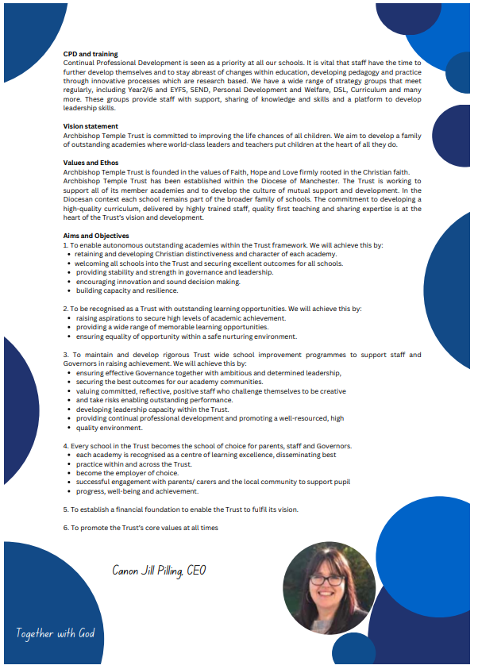

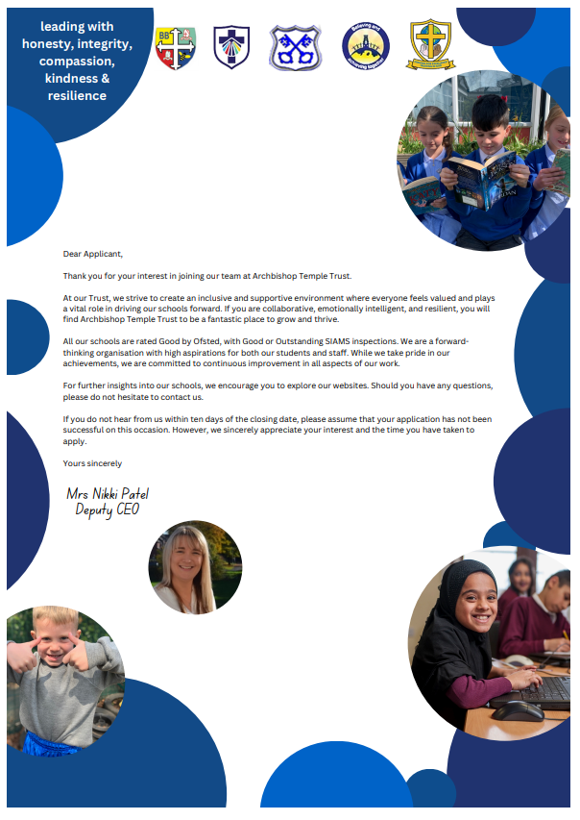


Job Description

Job Details
School Name | St Maxentius CE Primary School
Job Title | Administrative Assistant
Grade | Grade D
Primary Purpose of Job | To assist in the Office to do everything possible to ensure the School fulfils its primary purpose both effectively and efficiently
Responsible to | Head teacher
Responsible for | Not Applicable
Principal Responsibilities | The provision of an effective and efficient administrative and reception support service within school. To assist with the delivery of administrative and reception services in school and meet agreed quality and performance standards. To organise, manage and maintain the use of information systems and deliver an efficient reception service for customers.

Main Duties

Organisation
To contribute to the development and implementation of administrative services.
To manage and provide support to users of administrative services.
To organise, support and maintain the use of information technology systems and software.
To assist the Head teacher to ensure the use of systems through the Office manual are adhered to.
To contribute to the scheduling, organisation and co-ordination of activities, resources and events, e.g. school trips, meeting venues, etc.
To deliver and co-ordinate a reliable reception service and develop customer relationships.

Administration
To plan and manage your work to meet specified deadlines and requirements.
To be responsible for the research, preparation and presentation of information.
To provide advice and support for the development and implementation of quality and information.
To maintain and use databases.
To design, create, prepare and produce a range of complex documents from various sources and to specified deadlines.
To have responsibility for the receipt, recording and processing of payments in line with financial procedures.

Resources
To manage and organise the ordering, storage and distribution of specified goods and services.
To manage the attendance systems for both staff and pupils.
To photocopy, re-produce and distribute complex documents.

Responsibilities
To work effectively with other team members to contribute to improving the work of the team.
To build effective working relationships, both within the School and with partner agencies, in order to develop effective services.
To be aware of and comply with policies and procedures relating to child protection, safeguarding, health and safety and security, GDPR, confidentiality and data protection, reporting all concerns to an appropriate person.
Contribute to the overall ethos, work and aims of the school.
Appreciate and support the role of other professionals.
Attend and participate in relevant meetings as required.

The post holder may reasonably be expected to undertake other duties commensurate with the level of responsibility that may be allocated, at the discretion of the Head Teacher and to meet the needs of the school.

Version Control
Job Description prepared by: | School’s HR
Job Description updated: | 22 May 2025

Person Specification

Job Details
School Name | St Maxentius CE Primary School
Job Title | Administrative Assistant
Grade | Grade 4

Stage One
The minimum essential requirements for the above post are as follows. Please try to show in your application form, how best you meet these requirements. Disabled candidates are guaranteed an interview if they meet the essential criteria.

Skills and Knowledge |  | Method of Assessment
 | Demonstrate the ability to develop, implement and maintain quality administrative services to customers. | Application Form / Interview
 | Demonstrate the ability to work effectively as part of a team and under own supervision using initiative. | Application Form / Interview
 | Demonstrate the ability to research, locate, select and analyse information to support decision-making and audit compliance. | Application Form / Interview
 | Demonstrate the ability to plan, develop, organise and prioritise your work to meet deadlines and changes in priority. | Application Form / Interview
 | To demonstrate the ability to organise, support and maintain the use of information technology systems and software. | Application Form / Interview
 | To be able to enter and retrieve information and produce complex documents using a range of systems and software. | Application Form / Interview
 | To have the ability to provide advice and support for the development and implementation of quality and information systems. | Application Form / Interview
 | To demonstrate the ability to handle cash and be able to accurately record and monitor payments in line with financial procedures. | Application Form / Interview
 | To have the ability to schedule and co-ordinate activities and resources and have the ability to organise events, school trips etc. | Application Form / Interview
 | To be able to manage and organise the ordering, storage and distribution of specified goods and services | Application Form / Interview
 | An understanding of the services provided by the School | Application Form / Interview
 | An awareness of relevant legislation/good practice relating to schools, particularly safeguarding | Application Form / Interview
 | Competencies  Please note the school’s competencies, which are considered to be essential for all roles, are in the attached Core Competencies document. | Interview

Experience, Qualifications and Training |  | Method of Assessment
 | NVQ Business and Administration Level 3 or equivalent. | Application Form / Certificate
 | Experience of using a range of computer software packages and systems | Application Form

Work Related Circumstances |  | Method of Assessment
 | The nature and demands of the post holder’s time are not always predictable and there will be an expectation that work will be required outside normal hours from time to time. | Interview
 | This post is subject to enhanced disclosure from the Disclosure and Barring Service. | Application Form / Certificate

Stage Two
This will only be used in the event of a large number of applicants meeting the minimum essential requirements. Please try to show in your application form, how best you meet these requirements.

Skills and Knowledge |  | Method of Assessment
 | Evidence of continuous development. | Application Form
 | Evidence of managing, organising and maintaining information systems. | Application Form

Experience, Qualifications and Training |  | Method of Assessment
 | To have experience of using initiative to enhance performance. | Application Form

Version Control
Person Specification prepared by: | School’s HR
Person Specification updated: | 22 May 2025

These core competencies are considered essential for all roles within Bolton Council. Please be prepared to be assessed on any of these during the interview process and, for the successful applicant, throughout the probationary period.

Developing Self & Others
Promote a learning environment to embed a learning culture. Support others to develop their skills and knowledge to fulfil their potential. Actively pursue your own development. Support and promote the principles of Investors in People.

Civil Contingencies
Bolton Council has a statutory duty under the Civil Contingencies Act to respond in the event of an emergency. If Bolton Council’s Emergency Management Plan is activated, you may be required to assist in maintaining key Council services and supporting the community. This could require working outside of routine working hours and working from places other than your normal place of work.

Equality & Diversity
Uphold the principles of fairness and the Equality Act in all undertakings as a Bolton Council employee, including providing a fair, accessible service irrespective of customer’s race, religion, gender, sexuality, disability or age.

Customer Care
The ability to fully understand, assess and resolve the needs of all customers including those who present with complex situations, in a manner that respects dignity and expresses a caring & professional image.

Health & Safety
Take responsibility for the health and safety of yourself and others who may be affected by your acts or omissions, and comply with all health and safety legislation, policy and safe working practice, including participating in training activities necessary to your post.

Data Protection and Confidentiality
Ensure that any personal data or confidential data you hold is kept securely and is not disclosed, whether electronically, verbally or in writing, to any unauthorised third party. Follow Council policies and procedures on dealing with personal information and information assets, including The Code of Conduct, Data Protection, Acceptable Use and Information Security policies. Personal or confidential data should only be accessed or used for council purposes.

Fluency Duty
Should you be required, as a regular and intrinsic part of your role, to speak to members of the public in English, you must be able to converse at ease with customers and provide advice in accurate spoken English, as required by The Immigration Act 2016.

Working Hours
The nature and demands of the role are not always predictable and there will be an expectation that work will be required outside of normal hours from time to time.

Safeguarding
This Council is committed to safeguarding and promoting the welfare of children, young people and vulnerable adults and expects all staff and volunteers to share this commitment. Should the role involve working with the above groups, you will be subject to an Enhanced Disclosure and Barred List check by the Disclosure & Barring Service.
The values of an organisation are those key principles by which people are expected to work to day to day. They’re our culture and help define what is expected of each and every one of us.



How to apply
We hope that you have enjoyed reading about the Archbishop Temple Trust and our school and that you will feel able to apply for this post.

Please complete the downloadable application form. Please do not send CVs or open references as part of your application as these will not be considered.

It is important that you provide a complete employment history from when you left full time education. If the application form is not fully completed or has unexplained gaps in your employment history, your application will not be considered. Copies of your qualifications will be required at the interview stage; please do not send these with your application.

Please also write a letter of no more than two sides of A4 to explain why you want to work within our Trust, why you are the best candidate for the post and what you would contribute to our schools, with examples from your recent work if possible.

Please let us have both the supporting letter and the application form by 9am on Monday 29th June 2026 as we will not be able to consider applications received after that.

In accordance with the Data Protection Act, the details provided in the application form will be used for selection and interview procedures, and for employment records if your application is successful.

If you are disabled, please give details of how we can ensure that you are offered a fair selection and interview process.

Successful candidates will be asked to provide, prior to taking up the appointment, documentary evidence (including National Insurance number) showing their entitlement to work in the UK. We will also carry out an enhanced DBS and declaration of health check. References will also be required in line with Keeping Children Safe in Education 2019.


St Maxentius Church of England Primary School

At St Maxentius CE Primary School, we are a strong community, based on Christian beliefs and values, with an understanding of the awe and wonder of God, His word and His love. We work together to provide an environment where everyone is happy, confident, secure and achieving. We strive to empower all to reach their potential in a loving, respectful, creative environment.

Children at St Maxentius thrive in a broad and balanced curriculum. Pupils experience a curriculum that is knowledge rich, diverse, exciting and pupils talk with confidence and enthusiasm about their learning. Pupils are proud of their achievements and have high aspirations for their future.


The staff of St Maxentius are welcoming, dedicated and passionate advocates for the children. They truly do ‘believe and achieve together’. All members of the school community are positive and focussed on pupils achieving their own very best and they go above and beyond to support each other.


St Maxentius is proud to be within the Archbishop Temple Trust and have benefitted immensely from joining the Trust. Being part of a family of schools with the same strong aims and vision has enabled us to raise standards for pupils, develop staff expertise and support each other at times of challenge. Pupils work together across the Trust and have built relationships through working on projects together, adding to the already broad curriculum within school.

St Maxentius is truly a special place to work, with a strong and dedicated community ready to support the school on its next journey. Thank you for considering St Maxentius for your future.



Mrs Lisa Cousen
Headteacher

