

Rumworth School

Temporary Teaching Assistant Level 2
(Grade E Scale Point 11 to 17)
Required as soon as possible

Employer: Bolton Council
Location: Bolton
Salary: £28,142 (Point 11) to £31,022 (Point 17) FTE, pro-rata £21,167 - £23,333
Salary Grade: Grade E
Working Pattern: Term time plus 5 days
Working Hours: 32.5 hours weekly
Contract Type: Fixed term for one year in the first instance until 31st December 2026
Closing Date: 10:00 am on Monday 8th December 2025
Job Type: Education School based, Teaching Assistants
Interview Date: Tuesday 16th December 2025, timings TBC

We are looking to recruit a temporary TA2 Teaching Assistant in order to meet specific student needs across school, which may include providing general support for students in either KS3, KS4 or KS5. Rumworth School is a highly regarded Local Education Authority maintained special school in Bolton with an excellent reputation for providing an outstanding provision for all students. Visitors to our school always comment on the “lovely feeling and buzz” and the calm & purposeful learning environment. We have around 360 students with a range of needs. Our students are aged 11-19 and they all have an EHCP because they have a range of SEND (Special Educational Needs and Disabilities) which may include: Moderate and Severe Learning Difficulties, Complex Needs, Autistic Spectrum Conditions, Hearing and Visual Impairment, Physical Disability and Social, Emotional and Mental Health Needs. What our students most definitely do all have is a wonderful sense of fun, a love of learning, a high regard for each other and the adults who work with them, and they can’t wait to meet you!

Our ethos is “Start with the young person” therefore you will be a champion for education as the vehicle to improve the life chances and outcomes for our students. Our vision is “You can do it, we will help” - in order to meet the needs of our students, we do have small teaching group sizes and high adult to student ratios. As a teaching assistant within our team, you will embody our philosophy of supporting young people to be more “Confident, Resilient and Independent” through our rich offer of wider life experiences and activities.

Year 7 operates as a “Foundation Year” where students have a more class-based transition from their primary school with the Year 7 team delivering the majority of learning. Year 7 students also access specialist rooms including our dedicated Science laboratories, and they are taught by specialist subject teachers for lessons such as Science, Design Technology, Forest School, Art, Music, PE and ICT.
Students in Years 8 to 11 then follow a differentiated curriculum model, according to their needs:-

- Some follow a more formal curriculum with a modified mainstream approach
- Some have less transition and spend more time on the consolidation of basic skills in a based class
All students access appropriate external accreditation at the end of KS4 and during KS5, and our full accreditation offer includes GCSEs, ASDAN, BTEC, Functional Skills and Entry Level Certification, dependent upon subject and student ability. In KS5, students continue to follow the most suitable curriculum for their ability and aspirations, and they also follow courses in our new Sixth Form vocational or independence pathways. We offer a Year 14 Transition where some students continue on to the “Pathway to Employment” route, and those with SLD and complex needs would usually follow a “Pathway to Independence” route.

We are always keen to recruit staff of the highest calibre, and what matters most to us is that you are the “right fit” for our students. We do have some degree of internal flexibility when it comes to the age range you would be most keen to work with and the type of student needs that you have experience with. We welcome applications from people with mainstream experience, and those with SEND special school experience. Some of our staff join us from primary settings and some come from secondary.

Please note that we do expect applicants to be able to demonstrate that they have good personal skills in numeracy, literacy and ICT, and these may be assessed during the interview process. As this post requires GCSE grade C or above in both maths and English (or equivalent qualifications), we would also need you to provide proof of those qualification certificates at interview or prior to appointment.

Visits to our school:
Visits are strongly recommended prior to application, as this is helpful when tailoring a letter of application in order to evidence how you best meet the selection criteria. Please do not send a generic letter or a CV with your application.

Please contact our School Office on 01204 333600 in order to arrange a visit.

How to apply:
Please download and complete the application form and outline your suitability for this post at Rumworth School in your letter of application, within a maximum of two sides of A4 paper.

This post is also advertised on the “Current Vacancies” tab on our school website, and can be found at http://www.rumworth.co.uk/vacancies

All applications should please be returned electronically to Ms Marsha Andrews, the Headteacher’s PA: mandrews@rumworth.bolton.sch.uk

Closing date: 10:00 am on Monday 8th December 2025
Shortlisting: Monday 8th December 2025
Shortlisted candidates informed by 3:00 pm on Wednesday 10th December 2025
Interview Date: Tuesday 16th December 2025, timings TBC

We are committed to safeguarding and promoting the welfare of children and young people, therefore as part of our Safer Recruitment process, references will be requested for all shortlisted applicants.

Appointments are also subject to the outcome of an enhanced DBS check and being able to provide evidence of your qualifications. Please note we will ask you to confirm via email that you agree to this should you be shortlisted.

Rumworth School, Armadale Road, Bolton BL3 4TP

Telephone: 01204 333600

Rumworth School
Teaching Assistant Level 2 (Grade E)
Applicant Information Pack

Our Ethos | START WITH THE YOUNG PERSON
Our Vision | ‘YOU CAN DO IT, WE WILL HELP’  Supporting young people to be more  Confident, Resilient, Independent
Our Inclusion Principles | EQUALLY DIFFERENT, DIFFERENTLY EQUAL  At Rumworth, everyone is valued and welcomed as belonging to our school community. Difference and diversity are accepted and nurtured  as contributing to all our achievements. We foster participation and  mutual respect as part of everyday life in our school
Our Mission | We believe that everything we do should start with the young person.  For them, we aim to create a happy, safe and effective learning community, in which all stakeholders are valued. We aim to provide our students with a wealth of learning opportunities which will not only give them an enriching school experience, but will also equip our students with the skills to give every young person the chance to progress smoothly towards a life of opportunity.


Rumworth School
Teaching Assistant Level 2 (Grade E)
Job Description

Job Title Teaching Assistant level 2
Grade Grade E
Primary Purpose of To work with and supervise individual students and groups of
the Job students under the direction/instruction of teaching &/or senior staff

Responsible to Headteacher
Responsible for n/a
Principal Responsibilities Provide support for the students, teachers, curriculum and school

MAIN DUTIES

1. | Support for the Student
a | Establish excellent working relationships with students, acting as a role model
b | Be aware of and respond appropriately to individual student needs ensuring effective interaction
c | Provide specific support to students dependent upon their individual needs, ensuring their safety whilst supporting access to learning activities
d | Promote inclusion and acceptance of all students
e | Encourage students to interact with others and engage in activities led by the teacher
f | Promote self-esteem and independence
g | Provide feedback to students in relation to progress and achievement under the guidance and direction of the teacher
2 | Support for the teacher
a | Provide minimal clerical/administration support (e.g. photocopying, typing, filing, collecting money etc.)
b | Assist with the display of student work
c | Create and maintain a purposeful, orderly and supportive environment, in accordance with lesson plans
d | In liaison with the teacher, utilise strategies to support students in achieving learning goals
e | Report student achievements, progress and issues as appropriate in agreed format
f | Undertake student record keeping as requested
g | Administer routine tests and invigilate exams
h | Promote excellent student behaviour, dealing promptly with conflict and incidents and encouraging students to take responsibility for their own behaviour in line with established Rumworth School policies and practices
i | Establish and maintain constructive relationships with parents and carers
3 | Support for the curriculum
a | Undertake structured and agreed learning activities/learning programmes, taking in to account the consideration of student learning styles
b | Undertake literacy/numeracy programmes, recording achievements and progress and providing appropriate reports and feedback for the teacher
c | Support the use of ICT in learning activities and develop students’ competence and independence in its use
d | Prepare, maintain and use equipment/resources required to meet the lesson plans/relevant learning activity and assist students in their use
4 | Support for the school
a | Be aware of and comply with Rumworth School policies and procedures relating to safeguarding, child protection, health, safety and security, confidentiality and data protection. Report all concerns to the appropriate named person (as named in the policy concerned)
b | Be aware of and support difference, and ensure all students have equal access to opportunities to learn and develop
c | Contribute to the school ethos, aims and development/improvement/evolution plans
d | Appreciate and support the role of other professionals
e | Attend relevant meetings as required
f | Participate in training and other learning activities as required
g | Assist with the supervision of students out of directed lesson time, including before and after school if appropriate and within working hours
h | Accompany teaching staff and students on visits, trips and out of school activities as required
a  b  c | Developing self and others  To make every effort to access development opportunities  To actively participate in your own performance management, identifying your development needs through your personal development plan  To contribute to whole-school development by sharing your learning with others
a  b  c | Valuing Diversity  To accept that everyone has a right to their distinct identity  To treat everyone with dignity and respect, and to ensure that feedback is valued by reporting it back into the school.  To promote and participate in Rumworth School’s inclusive practices

The post holder may reasonably be expected to undertake other duties commensurate with the level of responsibility that may be allocated from time to time.

Date Job Description prepared: 25th June 2014

Job description last updated: 1st December 2023, Jenny Dunne, Headteacher


Rumworth School
Person Specification
Job Title Teaching Assistant Level 2 (Grade E)
STAGE ONE Disabled Candidates are guaranteed an interview if they meet the essential criteria

MINIMUM ESSENTIAL REQUIREMENTS |  | * Method of  Assessment
1. Skills and Knowledge
1.1 | Ability to work effectively within a team environment, understanding classroom roles and responsibilities | A / I
1.2 | Ability to build and maintain effective working relationships with all students and colleagues | A / I
1.3 | Ability to promote a positive ethos and to role model positive attributes | A / I
1.4 | Good personal numeracy and literacy skills | I
1.5 | General understanding of school curriculum and other basic learning programmes or techniques (within specified age range) | A / I
1.6 | General awareness of inclusion, especially within a school setting | A / I
1.7 | Effective use of ICT to support learning | A / I
1.8 | Customer Care - Listen and respond to the needs of individual students, their families as part of a multi-disciplinary team | A / I
1.9 | Valuing Diversity - Listen to, support and monitor the diverse contributions made to school development without prejudice.  Challenge behaviours and processes which do not positively advance the diversity agenda whilst being prepared to accept feedback about own behaviour.  Recognise people’s strengths, aspirations and abilities and help to develop their potential.  Understand how Valuing Diversity can improve our school provision and reduce disadvantage | A / I
1.10 | Developing Self and Others - Ability to question, and request right training and development that links to the post, to seek opportunities that add to skills and knowledge, to respond positively to opportunities that arise.  Ability to support others’ learning and share learning with others | A / I

2. Experience/Qualifications/Training etc.
2.1 | Minimum of 2 years’ experience of working with &/or caring for students within specified age range or NVQ Level 2 or equivalent in teaching assistance | A
2.2 | English and maths qualifications at Grade C GCSE or above, or equivalent qualifications | A
2.3 | Willingness to participate in relevant training and development opportunities | A / I

3. Work Related Circumstances – Professional Values & Practices
3.1 | High expectations of all students; respect for their social, cultural, linguistic, religious and ethnic background and a commitment to raising their educational achievements | A
3.2 | Ability to build and maintain successful relationships with students, treat them consistently, with respect and consideration and demonstrate concern for their development as learners | A / I
3.3 | Demonstrate and promote the positive values, attitudes and behaviour they expect from the students with whom they work | A / I
3.4 | Ability to work collaboratively with colleagues and carry out role effectively, knowing when to seek help and advice | A / I
3.5 | Able to liaise sensitively and effectively with parents and carers, recognising their role in student learning | A / I
3.6 | Able to improve their own practice through observations, evaluations and discussion with colleagues. | A / I

STAGE TWO | Will only be used in the event of a large number of applicants meeting the minimum essential requirements

ADDITIONAL REQUIREMENTS |  | * Method of  Assessment
1. Skills and Knowledge
1.1 | Experience of resource preparation to support learning programmes | A
1.2 | Understanding of other technologies to support learning | A

2. Experience/Qualifications/Training etc.
2.1 | Minimum of 2 years’ experience of working with &/or caring for students within specified age range or NVQ Level 2 or equivalent in teaching assistance within an educational setting | A
2.3 | Training in SEND strategies | A
2.4 | Willingness to undertake appointed person certificate in First Aid | I

For Method of Assessment * A = Application *I = Interview

Note to Applicants:

Please do try to show within your application form and your supporting letter how best you meet these requirements

General Information about Rumworth School

This positive and successful secondary special school is ambitious, high-achieving, supportive and happy; the school ensures that the impact is high on improvement for all of our students, who are at the heart of everything we do. We have around 360 students across Years 7 to 14, and next academic year this will increase as we are continuing to expand towards offering 400 places. We have just completed a building programme to accommodate this planned growth, which will further enhance the space and wide range of facilities available on our site in order to offer an appropriate secondary special school curriculum for our students who have a wide range of SEND (Special Educational Needs and Disabilities).

Staff work in close partnership with parents and other professionals to ensure we offer a broad, relevant curriculum which builds on objectives recorded in EHCPs and takes account of the full range of the interests, needs and aspirations of our students. Governors, parents and staff are very supportive of the school and responses in surveys are overwhelmingly positive. All staff embody our vision of "You can do it, we will help".

Our Shared Vision is integrated into all aspects of school development and evaluation, and it is the vehicle by which we strive to deliver those commitments we made to our children and young people and everyone in our community. The Senior Leadership Team and the Governing Body have high expectations for what all of our students can achieve, whilst seeking to ensure they become more "Confident, Resilient and Independent". We work collaboratively with our senior middle leaders and middle leaders who make up the Extended Leadership Team, and also with all staff in order to ensure high standards of provision and care for students.

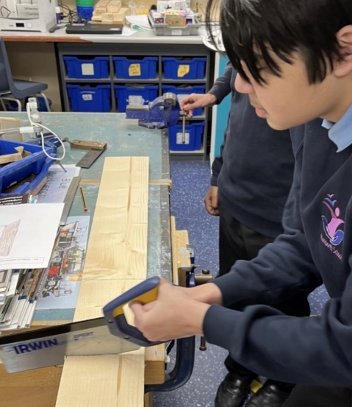
Our academic provision runs in Key Stages and then as strands according to student needs; the differing curricula provide excellent opportunities for all students to reach their potential across the full range of their needs, including SMSC. All students access appropriate external accreditation at the end of KS4 and during KS5 in our Sixth Form, and our accreditation offer includes a wide range of GCSEs, Functional Skills, ASDAN, BTEC, and Entry Level Certification, dependent upon student ability.

In Year 7, students have a more class-based curriculum with the Year 7 teaching team delivering the majority of learning within a “Foundation Year” setting. Year 7 students also access specialist rooms and may be taught by other staff for lessons such as Forest School, Art, Music, PE, Science, ICT, and Design Technology.

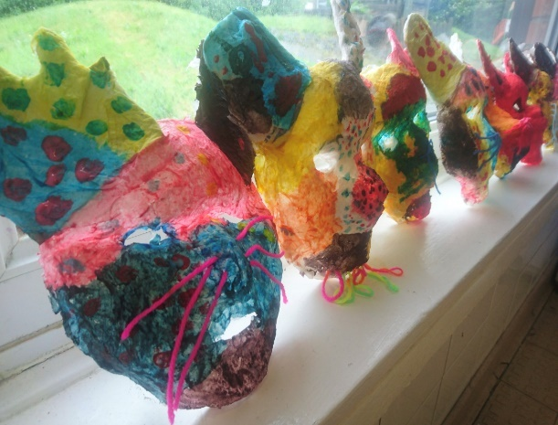
From Years 8 to 11, students then follow a differentiated curriculum model, according to their needs:-

- Some follow a more formal curriculum with a
modified mainstream approach
- Some have less transition and spend more time on the consolidation of basic skills
- Some have particular SLD / ASD / SEMH needs
and benefit from smaller groups at times

Students may have support from other professionals, who
work collaboratively with our form team staff.
During KS5 in our Sixth Form, students follow the most suitable curriculum pathway for their ability and for their vocational aspirations, and we then offer a Year 14 Transition Year which further supports our students towards an appropriate post-19 destination, which may which may be LifeBridge - the Post-19 setting that was developed a number of years ago by current and retired members of our Senior Leadership Team.


We have made significant investments in our vocational facilities and in our curriculum offer to support & promote opportunities for employability, independence and enrichment.
“Rummies” Bistro is open daily and Sixth Form students are involved in preparing and serving a wide range of drinks, snacks and meals, including barista coffees and our renowned cakes and afternoon teas.
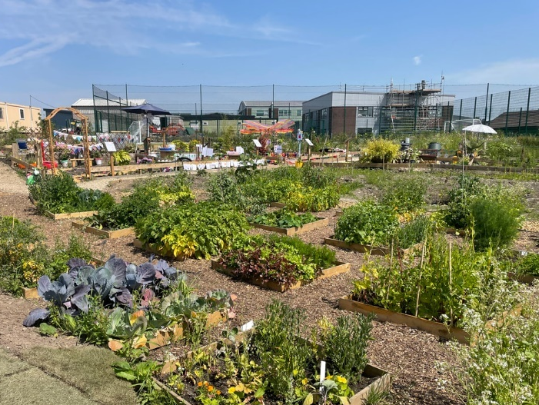

The recent extensive development of our outdoor “Growing Places” area includes a new outdoor classroom area, an industrial-scale growing polytunnel and planting areas with raised beds. Every form class has a small outdoor garden and then each year group takes part in designing an annual ‘show garden’ as part of the Rumworth School Grand Show competition.

The Forest School area, our large fishing lake, accessible outdoor trail paths, the outdoor gym and two outdoor multi-use games areas (MUGAs) all offer secure outdoor spaces to promote health and well-being. Students have the opportunity to develop new skills and access team building activities which support the holistic development of confidence and communication. Students are also taught to swim and have access to therapy sessions in our hydrotherapy pool which has a wave function, and sound & light facilities.

