

Admin Assistant
Salary: NJC Grade B Point 3-4 (pro-rata)
Part Time: 16 hrs/wk (term time only)
Term of contract: Permanent
Required for: As soon as possible
The Governors of St James CE Primary School are seeking to appoint a professional, confident, flexible and well organised individual.
The person appointed will work for 16 hours/week (Wed: 13:00-16:00 Thurs: 8:30-15:30 Fri: 8:30-15:30)

The role is to work in the main office/reception which will involve a range of different duties including answering phone calls, greeting visitors, dealing with parents, booking meetings and providing overall administrative support for the school.

To fulfil this very rewarding and valuable role we are looking for someone who:
• Can communicate effectively with people at all levels.
• Has some previous experience in an administration environment.
• Has strong IT skills with some experience of using different computer software such as Microsoft Word and Excel.
• Is able to provide professional customer service always, including a professional telephone manner.
For full details of the role and responsibilities, please see the associated job description and person specification.

Application forms and job descriptions can be obtained from the “greaterjobs” website.

CLOSING DATE: Please return completed forms to HR Officer Mrs Diggle via email digglek@boltonandfarnworthceprimarymultiacademytrust.co.uk by Monday 1st June 2026 9am

Interviews will take place on Monday 8th June 2026.
This school is committed to safeguarding and promoting the welfare of children and young people and expects all staff and volunteers to share this commitment. Successful candidates will be subject to an Enhanced Disclosure by the Disclosure and Barring service, satisfactory references and will be exempt from the provision of the Rehabilitation of Offenders Act 1974.

Visits to the school are warmly welcomed and recommended by prior appointment. Please contact Mrs Williamson at the school office on 01204 572587.


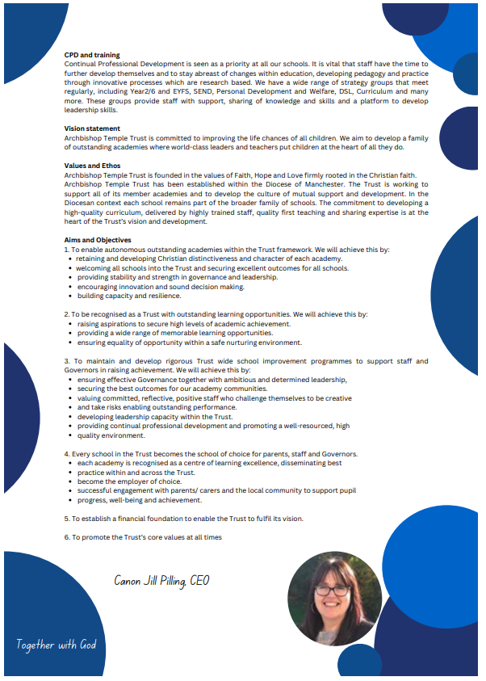

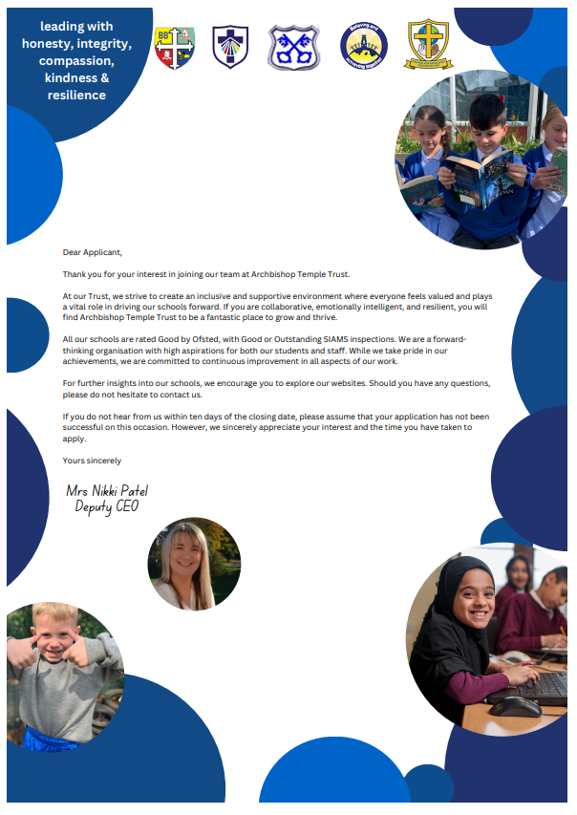


Job Description

Job Details
School Name | St James CE Primary School
Job Title | Clerical Assistant
Grade | Grade B
Primary Purpose of Job | To provide administrative and organisational support for staff and the school under the direction or instruction of teaching and senior staff.
Responsible to | Senior Administrative Assistant/Chief Finance Officer
Responsible for | Not Applicable
Principal Responsibilities | Provide general clerical, administrative financial support to the school.

Main Duties

Organisation
Undertake reception duties, including answering the telephone and face to face enquiries and signing in visitors.
Assist with pupil first aid/welfare duties, looking after sick pupils, liaising with parents and staff etc.
Assisting with arrangements for visits by school nurse, photographer etc.

Administration
Provide routine clerical support e.g. photocopying, filing, faxing, email and the completion of routine forms.
Maintain manual and computerised records/management information systems as appropriate.
Undertake typing, word-processing and other IT based tasks.
Undertake routine administration e.g. distribution and collection of registers and the administration surrounding school meals etc.

Resources
Operate office equipment e.g. photocopier, computer, fax machine.
Arrange orderly and secure storage of supplies.
Undertake routine financial administration, e.g. collect and record money.

Responsibilities
Be aware of and comply with policies and procedures relating to child protection, safeguarding, health and safety and security, GDPR, confidentiality and data protection, reporting all concerns to an appropriate person.
Contribute to the overall ethos, work and aims of the school.

Job Description

Job Details
School Name | St James CE Primary School
Job Title | Clerical Assistant
Grade | Grade B
Primary Purpose of Job | To provide administrative and organisational support for staff and the school under the direction or instruction of teaching and senior staff.
Responsible to | Senior Administrative Assistant/Chief Finance Officer
Responsible for | Not Applicable
Principal Responsibilities | Provide general clerical, administrative financial support to the school.

Main Duties

Organisation
Undertake reception duties, including answering the telephone and face to face enquiries and signing in visitors.
Assist with pupil first aid/welfare duties, looking after sick pupils, liaising with parents and staff etc.
Assisting with arrangements for visits by school nurse, photographer etc.

Administration
Provide routine clerical support e.g. photocopying, filing, faxing, email and the completion of routine forms.
Maintain manual and computerised records/management information systems as appropriate.
Undertake typing, word-processing and other IT based tasks.
Undertake routine administration e.g. distribution and collection of registers and the administration surrounding school meals etc.

Resources
Operate office equipment e.g. photocopier, computer, fax machine.
Arrange orderly and secure storage of supplies.
Undertake routine financial administration, e.g. collect and record money.

Responsibilities
Be aware of and comply with policies and procedures relating to child protection, safeguarding, health and safety and security, GDPR, confidentiality and data protection, reporting all concerns to an appropriate person.
Contribute to the overall ethos, work and aims of the school.
Appreciate and support the role of other professionals.
Attend and participate in relevant meetings as required.

The post holder may reasonably be expected to undertake other duties commensurate with the level of responsibility that may be allocated, at the discretion of the Head Teacher and to meet the needs of the school.

Version Control
Job Description prepared by: | School’s HR
Job Description updated:

Person Specification

Job Details
School Name | St James CE Primary School
Job Title | Clerical Assistant
Grade | Grade 2

Stage One
The minimum essential requirements for the above post are as follows. Please try to show in your application form, how best you meet these requirements. Disabled candidates are guaranteed an interview if they meet the essential criteria.

Skills and Knowledge |  | Method of Assessment
 | Basic awareness of first aid. | Application Form / Interview
 | Good understanding and ability to use relevant technology e.g. photocopier. | Application Form / Interview
 | Basic computer and keyboard skills. | Application Form / Interview
 | Participate in development and training opportunities. | Application Form / Interview
 | Ability to relate well to children and adults. | Application Form / Interview
 | Work constructively as part of a team, understanding school roles and responsibilities and your own position within these. | Application Form / Interview
 | To be able to respond to management instruction to ensure tasks are completed within specified timeframes | Application Form / Interview
 | Ability to build and maintain successful relationships with pupils, treat them consistently, with respect and consideration and demonstrate concern for their development as learners. | Application Form / Interview
 | Demonstrate and promote the positive values, attitudes and behaviour they expect from the pupils with whom they work. | Application Form / Interview
 | Ability to work collaboratively with colleagues and carry out role effectively, knowing when to seek help and advice. | Application Form / Interview
 | Able to liaise sensitively and effectively with parents and carers recognising their role in pupil learning. | Application Form / Interview
 | Able to improve their own practice through observations, evaluations and discussion with colleagues. | Application Form / Interview
 | Good numeracy and literacy skills. | Application Form / Interview
 | Competencies  Please note the school’s competencies, which are considered to be essential for all roles, are in the attached Core Competencies document. | Interview

Experience, Qualifications and Training |  | Method of Assessment
 | Willingness to participate in relevant training and development opportunities. | Application Form / Interview

Work Related Circumstances |  | Method of Assessment
 | High expectations of all pupils; respect for their social, cultural, linguistic, religious and ethnic background and a commitment to raising their educational achievements. | Application Form / Interview
 | This post is subject to an enhanced disclosure and a barred list check from the Disclosure and Barring Service. | Application Form / Certificate

Stage Two
This will only be used in the event of a large number of applicants meeting the minimum essential requirements. Please try to show in your application form, how best you meet these requirements.

Skills and Knowledge |  | Method of Assessment
 | Understanding of other basic technology, video, photocopier, computer | Application Form / Interview

Experience, Qualifications and Training |  | Method of Assessment
 | NVQ Level 1 or Level 2 or equivalent qualification or experience in relevant discipline. | Certificate / Application Form / Interview

Version Control
Person Specification prepared by: | School’s HR
Person Specification updated:

These core competencies are considered essential for all roles within Bolton Council. Please be prepared to be assessed on any of these during the interview process and, for the successful applicant, throughout the probationary period.

Developing Self & Others
Promote a learning environment to embed a learning culture. Support others to develop their skills and knowledge to fulfil their potential. Actively pursue your own development. Support and promote the principles of Investors in People.

Civil Contingencies
Bolton Council has a statutory duty under the Civil Contingencies Act to respond in the event of an emergency. If Bolton Council’s Emergency Management Plan is activated, you may be required to assist in maintaining key Council services and supporting the community. This could require working outside of routine working hours and working from places other than your normal place of work.

Equality & Diversity
Uphold the principles of fairness and the Equality Act in all undertakings as a Bolton Council employee, including providing a fair, accessible service irrespective of customer’s race, religion, gender, sexuality, disability or age.

Customer Care
The ability to fully understand, assess and resolve the needs of all customers including those who present with complex situations, in a manner that respects dignity and expresses a caring & professional image.

Health & Safety
Take responsibility for the health and safety of yourself and others who may be affected by your acts or omissions, and comply with all health and safety legislation, policy and safe working practice, including participating in training activities necessary to your post.

Data Protection and Confidentiality
Ensure that any personal data or confidential data you hold is kept securely and is not disclosed, whether electronically, verbally or in writing, to any unauthorised third party. Follow Council policies and procedures on dealing with personal information and information assets, including The Code of Conduct, Data Protection, Acceptable Use and Information Security policies. Personal or confidential data should only be accessed or used for council purposes.

Fluency Duty
Should you be required, as a regular and intrinsic part of your role, to speak to members of the public in English, you must be able to converse at ease with customers and provide advice in accurate spoken English, as required by The Immigration Act 2016.

Working Hours
The nature and demands of the role are not always predictable and there will be an expectation that work will be required outside of normal hours from time to time.

Safeguarding
This Council is committed to safeguarding and promoting the welfare of children, young people and vulnerable adults and expects all staff and volunteers to share this commitment. Should the role involve working with the above groups, you will be subject to an Enhanced Disclosure and Barred List check by the Disclosure & Barring Service.
The values of an organisation are those key principles by which people are expected to work to day to day. They’re our culture and help define what is expected of each and every one of us.



How to apply
We hope that you have enjoyed reading about the Archbishop Temple Trust and our school and that you will feel able to apply for this post.

Please complete the downloadable application form. Please do not send CVs or open references as part of your application as these will not be considered.

It is important that you provide a complete employment history from when you left full time education. If the application form is not fully completed or has unexplained gaps in your employment history, your application will not be considered. Copies of your qualifications will be required at the interview stage; please do not send these with your application.

Please also write a letter of no more than two sides of A4 to explain why you want to work within our Trust, why you are the best candidate for the post and what you would contribute to our schools, with examples from your recent work if possible.

Please let us have both the supporting letter and the application form by 9am on Monday 1st June 2026 as we will not be able to consider applications received after that.

In accordance with the Data Protection Act, the details provided in the application form will be used for selection and interview procedures, and for employment records if your application is successful.

If you are disabled, please give details of how we can ensure that you are offered a fair selection and interview process.

Successful candidates will be asked to provide, prior to taking up the appointment, documentary evidence (including National Insurance number) showing their entitlement to work in the UK. We will also carry out an enhanced DBS and declaration of health check. References will also be required in line with Keeping Children Safe in Education 2019.



Dream | Believe | Learn | Achieve

My name is Chris Booth and I am the very proud Principal of our special ‘St James Family’. Each day is an absolute pleasure, working with the staff and parents who are committed to make a difference to the lives of the pupils with whom we work. Our children are nurtured through the Christian values of respect, peace, love, forgiveness, honesty and hope. As a result, our pupils are kind, caring and polite; visitors always feel a warm welcome when they walk through our front door. The children of St James are utterly delightful, with exemplary behaviour and a real credit to the school and their families.


St James is situated in a very vulnerable catchment area, with above-average pupil premium and SEND figures. However, this does not stop our pupils from achieving what we set out for them, nor does it stop us as practitioners believing that our children CAN DO. I am very lucky to serve a staff who work incredibly hard to ensure the children in our care receive the very best that we can offer them. We are big advocates that ‘team work makes the dream work’ and we ensure that we are there to support, challenge and motivate each other. Staff new to school, or on supply, always comment on how helpful and friendly the staff team of St James are. We are always eager to grow our workforce with like-minded individuals, who have a passion to make a difference. Our children deserve a great education, with great professionals to ensure we achieve this.


Working within the Archbishop Temple Trust has opened many doors for school improvement and networking. Staff at St James have benefited from many CPD opportunities for training and sharing best practice. Strong and supportive relationships across staff flourish within our MAT. The impact for the children is also positive, with the opportunity to visit other schools in contrasting environments and to work on joined-up projects.

Thank you for considering our school and MAT to either start or further your career in education. I look forward to hearing from you.

Mr Chris Booth
Headteacher

