


Deputy Club Manager
Salary
: NJC Grade A Point 3 (pro-rata based on hours and term time only) Part Time: 23.75 hrs/wk (Monday – Friday 7.15-9.00 & 15.15-18.15)
Term of contract: Permanent
Required for: ASAP

The governors of St. Maxentius CE Primary School are seeking to appoint an enthusiastic and dedicated Playworker to join our Out of School Club. This is a fantastic opportunity for anyone looking for a rewarding role working with children.

To fulfil this very rewarding and valuable role we are looking for someone who:
- has experience of working with children aged 4-11years old
- understands the varied needs of children and their families
- can plan and deliver creative high quality play care and opportunities
- can encourage positive behaviour and provide emotional support for children
- provides equal opportunities for all children creating an inclusive environment
- creates a safe and welcoming environment
- has good communication skills with parents, children and school staff
- is able to work effectively as part of a team
- has sound judgement, common sense and lots of initiative
- has sufficient understanding and use of English to ensure the well-being of the children
Desirable: has first aid, food hygiene or safeguarding certificates
For full details of the role and responsibilities, please see the associated job description and person specification.

Application forms and job descriptions can be obtained from the “greaterjobs” website.

CLOSING DATE: Please return completed forms to HR Officer Mrs Diggle via email digglek@archbishoptempletrust.co.uk by Monday 28th September at 9am

Interviews will take place on Monday 5th October 2026

This school is committed to safeguarding and promoting the welfare of children and young people and expects all staff and volunteers to share this commitment. Successful candidates will be subject to an Enhanced Disclosure by the Disclosure and Barring service, satisfactory references and will be exempt from the provision of the Rehabilitation of Offenders Act 1974.

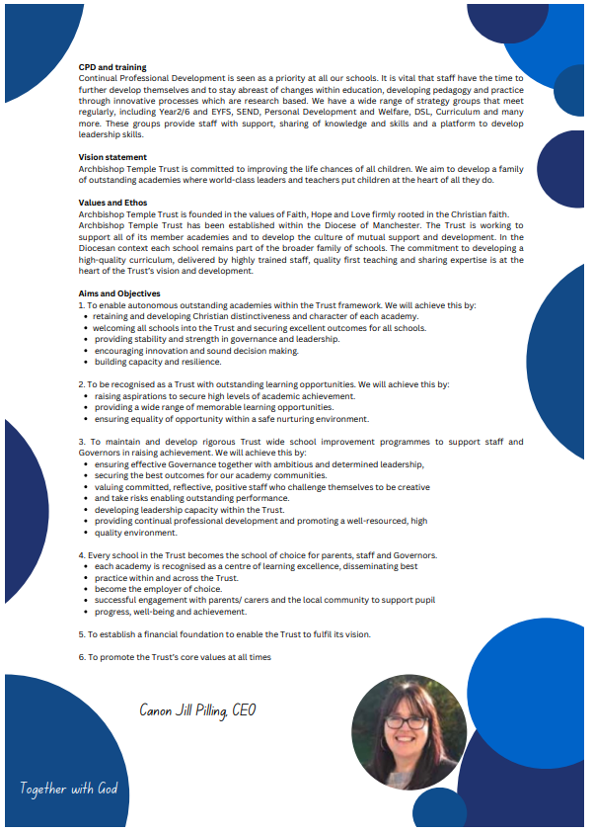

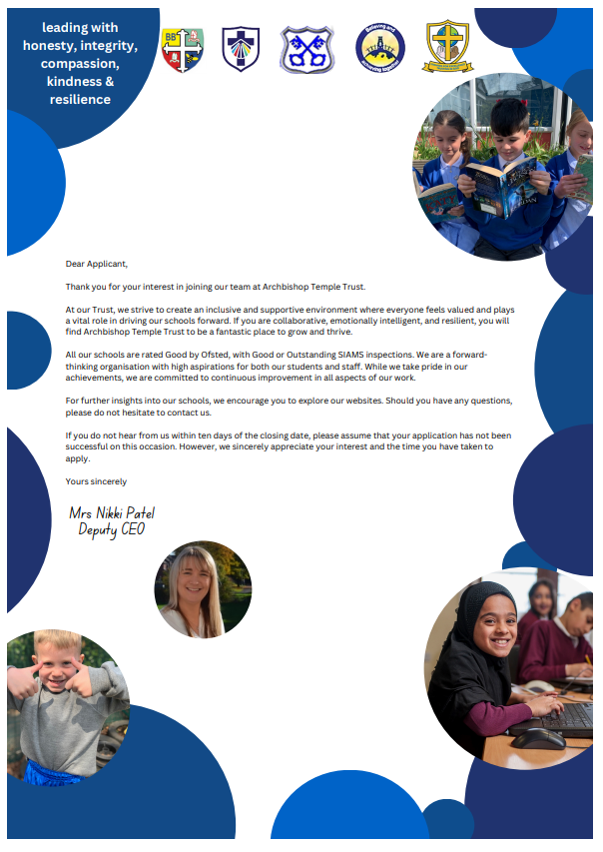



Job Description

Job Details
School Name
Job Title | Playworker Level 1
Grade | Grade A
Primary Purpose of Job | To assist with the operation of an out of school club for nursery and school age children.
Responsible to | The children who attend the Out of School Club or Holiday Club.
Responsible for | Not applicable.
Principal Responsibilities | Assisting with the operation of a before-school (where before school care is offered), after school and holiday club in accordance with agreed policies. Ensuring the provision of high quality childcare and appropriate play opportunities for all children attending the club. Liaison with parents and other appropriate agencies.

Main Duties
To provide full good quality and safe care for children including meeting individual needs, supervision of activities and outings, provision of refreshments.
To prepare and serve breakfast and healthy snacks for the children.
To be responsible for monies including fees, trip money and lunch money where appropriate.
To provide good quality, creative, appropriate play opportunities in a safe and child centred environment and via a Children's Rights-Based approach.
To provide support and a safe and secure environment for children with additional needs, i.e. autism, ADHD or a physical disability, after appropriate training.
To prepare activities and assist in programme planning.
To encourage parental and community involvement and support for the club.
To support the development of the club, including striving to achieve any necessary standards or awards.
To liaise with parents, schools and other agencies in order to promote the club and ensure the children’s well-being.
To administer first aid when appropriately qualified as requested.
To ensure that premises and equipment are kept in a clean and safe condition and to be responsible for security when necessary, in line with Health and Safety Legislation.
To work within agreed policies and maintain good practice and to carry out all responsibilities within an equal opportunities framework.
To wear a uniform (if provided) and identification when working in the relevant Club.
To work flexibly including early mornings, afternoons and evenings.

The post holder may reasonably be expected to undertake other duties commensurate with the level of responsibility that may be allocated, at the discretion of the Head Teacher and to meet the needs of the school.

Version Control
Job Description prepared by: | School’s HR
Job Description updated:

Person Specification

Job Details
School Name
Job Title | Playworker
Grade | Grade A

Stage One
The minimum essential requirements for the above post are as follows. Please try to show in your application form, how best you meet these requirements. Disabled candidates are guaranteed an interview if they meet the essential criteria.

Skills and Knowledge |  | Method of Assessment
 | Understanding of child development and the importance of play. | Application Form / Interview
 | Ability to provide and facilitate appropriate and creative play activities in a child centred environment. | Application Form / Interview
 | Understanding of good quality childcare and how to care for children in a sensitive and responsible way. | Application Form / Interview
 | Deal with difficult situations in a confident and responsible manner, in line with School policies. | Application Form / Interview
 | Ability to respond to and meet children’s individual needs and rights and build appropriate relationships with them and their carers. | Application Form / Interview
 | Accurately record and process information. | Application Form / Interview
 | Organisational skills. | Application Form / Interview
 | Financial skills, in order to handle small amounts of money. | Application Form / Interview
 | Understanding of methods of communicating and be able to communicate both verbally and in writing in a clear and concise way with children and adults. | Application Form / Interview
 | Ability to work on own initiative. | Application Form / Interview
 | Awareness of Health and Safety at Work. | Application Form / Interview
 | Understanding and commitment to equal opportunities and be able to demonstrate this within the work environment. | Application Form / Interview
 | Understanding of and ability to meet the needs of a multi-cultural community. | Application Form / Interview
 | Understanding of and ability to work with children with SEN or disabilities. | Application Form / Interview
 | Awareness of safeguarding principles and safe working practices. | Application Form / Interview
 | Displays commitment to the protection and safeguarding of children and young people. | Application Form / Interview
 | Ability to recognise when pupils are in danger of risk or harm and know what actions to take to protect them, in accordance with school procedures. | Application Form / Interview
 | Competencies  Please note the school’s competencies, which are considered to be essential for all roles, are in the attached Core Competencies document. | Interview

Experience, Qualifications and Training |  | Method of Assessment
 | Experience of working with children in a play environment. | Application Form / Interview

Work Related Circumstances |  | Method of Assessment
 | Willingness to undertake appropriate training. | Interview
 | Willingness to work flexible hours and attend related meetings. | Application Form / Interview
 | This post is subject to an enhanced disclosure and a barred list check from the Disclosure and Barring Service. | Application Form / Certificate

Stage Two
This will only be used in the event of a large number of applicants meeting the minimum essential requirements. Please try to show in your application form, how best you meet these requirements.

Skills and Knowledge |  | Method of Assessment
 |  | Application Form / Interview

Experience, Qualifications and Training |  | Method of Assessment
 | Appropriate qualification in Childcare or Playwork at NVQ Level 2. | Certificate
 | Paediatric First Aid. | Application Form / Interview
 | Basic Food Hygiene Certificate. | Application Form / Interview

Version Control
Person Specification prepared by: | School’s HR
Person Specification updated:

These core competencies are considered essential for all roles within Bolton Council. Please be prepared to be assessed on any of these during the interview process and, for the successful applicant, throughout the probationary period.

Developing Self & Others
Promote a learning environment to embed a learning culture. Support others to develop their skills and knowledge to fulfil their potential. Actively pursue your own development. Support and promote the principles of Investors in People.

Civil Contingencies
Bolton Council has a statutory duty under the Civil Contingencies Act to respond in the event of an emergency. If Bolton Council’s Emergency Management Plan is activated, you may be required to assist in maintaining key Council services and supporting the community. This could require working outside of routine working hours and working from places other than your normal place of work.

Equality & Diversity
Uphold the principles of fairness and the Equality Act in all undertakings as a Bolton Council employee, including providing a fair, accessible service irrespective of customer’s race, religion, gender, sexuality, disability or age.

Customer Care
The ability to fully understand, assess and resolve the needs of all customers including those who present with complex situations, in a manner that respects dignity and expresses a caring & professional image.

Health & Safety
Take responsibility for the health and safety of yourself and others who may be affected by your acts or omissions, and comply with all health and safety legislation, policy and safe working practice, including participating in training activities necessary to your post.

Data Protection and Confidentiality
Ensure that any personal data or confidential data you hold is kept securely and is not disclosed, whether electronically, verbally or in writing, to any unauthorised third party. Follow Council policies and procedures on dealing with personal information and information assets, including The Code of Conduct, Data Protection, Acceptable Use and Information Security policies. Personal or confidential data should only be accessed or used for council purposes.

Fluency Duty
Should you be required, as a regular and intrinsic part of your role, to speak to members of the public in English, you must be able to converse at ease with customers and provide advice in accurate spoken English, as required by The Immigration Act 2016.

Working Hours
The nature and demands of the role are not always predictable and there will be an expectation that work will be required outside of normal hours from time to time.

Safeguarding
This Council is committed to safeguarding and promoting the welfare of children, young people and vulnerable adults and expects all staff and volunteers to share this commitment. Should the role involve working with the above groups, you will be subject to an Enhanced Disclosure and Barred List check by the Disclosure & Barring Service.
The values of an organisation are those key principles by which people are expected to work to day to day. They’re our culture and help define what is expected of each and every one of us.



How to apply
We hope that you have enjoyed reading about the Archbishop Temple Trust and our school and that you will feel able to apply for this post.

Please complete the downloadable application form. Please do not send CVs or open references as part of your application as these will not be considered.

It is important that you provide a complete employment history from when you left full time education. If the application form is not fully completed or has unexplained gaps in your employment history, your application will not be considered. Copies of your qualifications will be required at the interview stage; please do not send these with your application.

Please also write a letter of no more than two sides of A4 to explain why you want to work within our Trust, why you are the best candidate for the post and what you would contribute to our schools, with examples from your recent work if possible.

Please let us have both the supporting letter and the application form by 9am on Monday 28th September 2026 as we will not be able to consider applications received after that.

In accordance with the Data Protection Act, the details provided in the application form will be used for selection and interview procedures, and for employment records if your application is successful.

If you are disabled, please give details of how we can ensure that you are offered a fair selection and interview process.

Successful candidates will be asked to provide, prior to taking up the appointment, documentary evidence (including National Insurance number) showing their entitlement to work in the UK. We will also carry out an enhanced DBS and declaration of health check. References will also be required in line with Keeping Children Safe in Education 2019.


St Maxentius Church of England Primary School

At St Maxentius CE Primary School, we are a strong community, based on Christian beliefs and values, with an understanding of the awe and wonder of God, His word and His love. We work together to provide an environment where everyone is happy, confident, secure and achieving. We strive to empower all to reach their potential in a loving, respectful, creative environment.

Children at St Maxentius thrive in a broad and balanced curriculum. Pupils experience a curriculum that is knowledge rich, diverse, exciting and pupils talk with confidence and enthusiasm about their learning. Pupils are proud of their achievements and have high aspirations for their future.


The staff of St Maxentius are welcoming, dedicated and passionate advocates for the children. They truly do ‘believe and achieve together’. All members of the school community are positive and focussed on pupils achieving their own very best and they go above and beyond to support each other.


St Maxentius is proud to be within the Archbishop Temple Trust and have benefitted immensely from joining the Trust. Being part of a family of schools with the same strong aims and vision has enabled us to raise standards for pupils, develop staff expertise and support each other at times of challenge. Pupils work together across the Trust and have built relationships through working on projects together, adding to the already broad curriculum within school.

St Maxentius is truly a special place to work, with a strong and dedicated community ready to support the school on its next journey. Thank you for considering St Maxentius for your future.



Mrs Lisa Cousen
Headteacher

