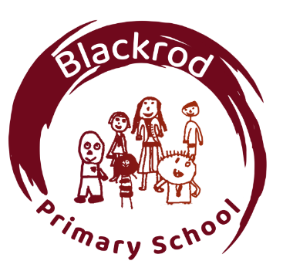
Class Teacher

Blackrod Primary School

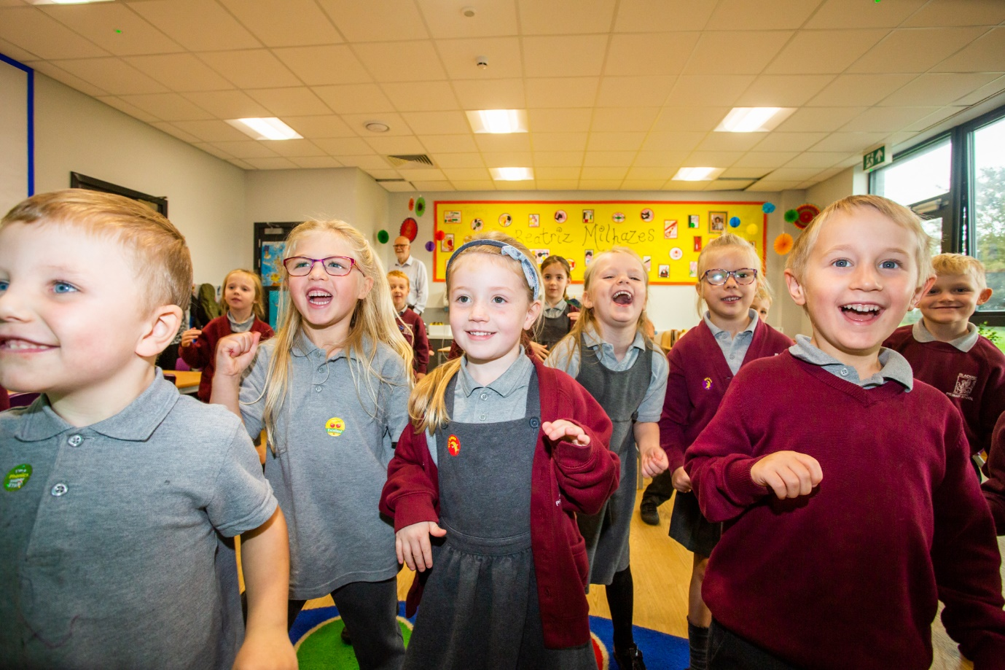

Welcome from the Head Teacher

I would like to offer you a very warm welcome to Blackrod Primary School, a highly successful, popular school situated in the North West of Bolton. Ofsted judged us 'outstanding' in every area during their most recent inspection.

We are passionate about our school. It is a special place where children feel cared for, supported respected and safe. We always strive for academic excellence and provide an exciting and enriching curriculum for all our children. We help every child fulfil their potential and we celebrate everyone’s uniqueness and the gifts and talents they have. Every child is precious to us, and it is a privilege to play a part in their development. The key to our success, we believe is a love of life and learning within a school where children feel cared for, supported, respected and safe.

We seek a candidate who will share our philosophy and embrace the ethos and the values which are at the schools’ core. Our staff are all high performing professionals who go above and beyond expectations to make a difference to pupils’ lives. They provide children with the skills, knowledge, resilience, enthusiasm, and life skills which will equip them to lead a rewarding and happy life. We respect the skills, knowledge, and experience of each of our staff members and strive to support them on their quest for continual professional development. In turn this encourages a love of learning which embeds across the school from children to staff alike.

We have a very strong relationship with parents and our community, and this is at the heart of our school.

Should you wish to visit or find out more please contact us from the details below.

I look forward to meeting you.

Kind regards

Katherine Mead

Head Teacher
Mission Statement

At Blackrod Primary School we provide a happy, secure, caring, and purposeful environment, where individuals fulfil their full potential and develop a joy in learning and life.

We are Proud of Our School

Blackrod Primary School is an exciting place where children achieve highly, supported by motivated, talented, and inspiring professionals.

Judged as ‘Outstanding’ by Ofsted in 2024, Blackrod Primary School focus on their core goal: to develop children who are prepared for, and excited by, the world of tomorrow. The school is situated in the heart of a local village community on the North West outskirts of Bolton and has outstanding grounds with spectacular views over the countryside and beyond. Our pupil intake comes from the local surrounding area. Our children are well motivated, keen to learn and are proud of their school.

We are committed to the development of children both within and outside of school. We have an active extra-curricular offer including before and after school child-care, holiday care and BYB@Blackrod a provision through which we work with partners externally to drive new opportunities for children outside of school time. We are committed to local community partnerships. We engage with active networks of professional practice and work with the local cluster of schools to share expertise.

Number of pupils on roll: 315

Closing date for applications: Friday 2nd October at 12pm

Interview date: W/C: 5th October 2026

For all further details are all available on the advert document

Primary Teacher Job Description

Employment details
Job title: Classroom teacher
Job purpose:
The classroom teacher will be responsible for delivering learning in accordance with the curriculum, national guidelines, and the school’s strategy. The successful candidate must also carry out other duties that support pupils’ learning while operating in accordance with the school’s policies and procedures. The classroom teacher is responsible for teaching a class of approximately 30 children.

Main duties and responsibilities
To undertake all duties, as required by the Teachers’ Standards.
To be committed to the ethos and success of the school.
To keep up-to-date with, and remain knowledgeable of, the requirements of the national curriculum.
To have regard for continuing professional development (CPD) and contribute to the school’s process of self-evaluation and development.
To be familiar with the school’s systems, structures, policies and procedures.
To effectively plan and deliver a varied, balanced and appropriate curriculum which emphasises raising standards and achieving excellence.
To adapt teaching styles to suit all learners and provide a supportive learning environment.
To differentiate resources and equipment so lessons may be accessed appropriately by all pupils.
To work as part of a team to evaluate and develop pupils’ learning needs.
To promote excellent behaviours for learning through effective classroom management in line with school policy
To encourage pupils to develop and use their creativity, initiative, independence and responsibilities.
To systematically assess and record pupils’ academic and social progress, and use the results to inform lesson planning decisions and drive progression in learning
To monitor both class work and homework, provide constructive feedback, and set informed targets for pupil progress.
To report on each individual pupil’s progress to the head teacher and parents as required.
To actively support school activities, on occasion, such as educational trips, extra-curricular activities and clubs, and parents’ evenings, which may require some out-of-hours availability.

