

Brownlow Fold
Primary School

Recruitment and Selection of

Class Teacher

DATE: September 2026

Brownlow Fold School
Darley Street
Bolton
BL1 3DX

Contents

Covering letter from Headteacher

Details of Application & Selection Process

Full time, Fixed Term Teaching position

Job Description and Person Specifications

Application Form



Dear Applicant,
Post of: Class Teacher
Full Time, Fixed Term for 12 months

We are seeking to appoint an inspirational and committed teacher to work in partnership with our experienced and dedicated staff, to build on our successes and drive the school forward in future development and growth. This position is a great opportunity for a teacher who wants to start their career within a good school with a strong and innovative Senior Leadership Team.

The children, staff and Governors are looking for someone who:
- Is an experienced and outstanding Foundation Stage classroom practitioner;
- Is able to provide help and support for pupils, and have a positive impact on classroom practice through coaching, evaluation, feedback and staff development;
- Has high expectations of themselves, pupils and staff and has a passion for enabling all children and staff to reach their potential;
- Is a team player with the ability to motivate, lead and support colleagues;
- Is extremely driven and committed to working with the Brownlow Fold team to secure our long-term goals.
Brownlow Fold offers you:
- A popular school in the heart of a multicultural community;
- Happy, caring children who are eager to learn and enthusiastic about school and their learning;
- An enthusiastic and dedicated team, determined to enable every child to succeed;
- Supportive parents and a committed Governing body;
- Excellent opportunities for professional development;
- Simplifying work processes and managing workloads for an improved work-life balance, in a school where staff wellbeing is one of our central aims.
We are a school that makes a difference to the lives of our children and families. We offer our children a lot more than just the National Curriculum and focus on more than ‘just doing well in tests.’ Skills such as honesty, integrity, resilience and empathy are life skills that are necessary for society and every work place. Learning at Brownlow Fold is about helping our children to develop their interests and abilities, providing valuable learning experiences both inside and outside the classroom. Our ethos is characterised by high expectations and aspirations for all pupils. We are committed to achieving high standards for all pupils in order that they can attain the highest levels of achievement and personal development.

An informal visit to the school is encouraged and warmly welcomed. We recommend that visits take place during the school day then you are able to meet the children and staff and get a real flavour of what life at Brownlow Fold is like. Please contact Louise Vickers, School Business Manager on 01204 333511, to arrange.

We look forward to hearing from you.

Mrs J. Cheung,

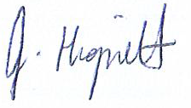
Headteacher

Details of Application and Selection Process:

Class Teacher
Full Time, Fixed Term for 12 months

The position is open to applications from ECTs

Timelines:

Salary, Grade: Main Scale

Closing date: Noon on Monday 2nd November 2026
Shortlisting date: Monday 2nd November 2026
Lesson observation and Monday 9th November
Interview date: Monday 9th November

Required from: As soon as possible

Following the shortlisting process, successful candidates will be invited for an interview.

The interview process will involve a panel interview.

The successful candidate will be informed soon after the decision has been made.

Unsuccessful candidates will get the opportunity to obtain verbal feedback from the Head Teacher.

If after reading this documentation, you feel that you meet the specification for the post, and can meet the challenges facing the school, we would like to hear from you.

Please send your completed application form, together with a supporting statement to:

Mrs J Cheung
Brownlow Fold School
Darley Street
Bolton
BL1 3DX
Tel: 01204 333511
E-mail: office @brownlow-fold.bolton.sch.uk

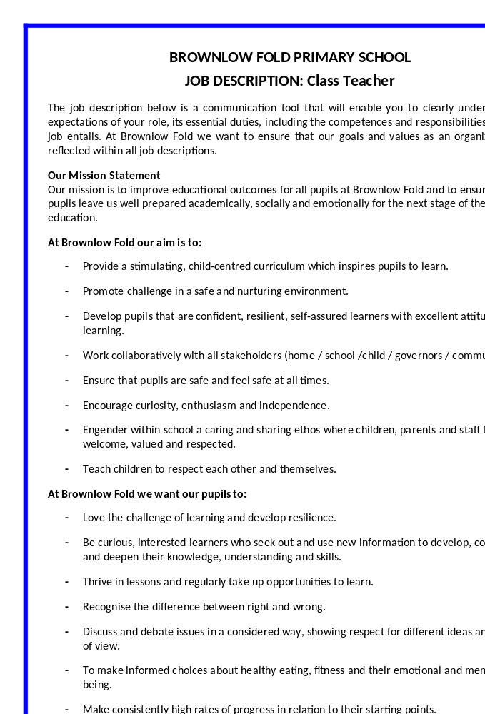

BROWNLOW FOLD PRIMARY SCHOOL

CLASS TEACHER JOB DESCRIPTION

Title
- Class Teacher – Full Time

Salary Grade
- Main Scale

Purpose of the Job
- To be a primary school teacher

Directly responsible to:
- The Head Teacher, the Deputy Head Teacher and the Governing Body.

Principal Responsibilities
- The professional duties of a teacher are those set out in the current Teachers' Pay and Conditions document.

Main Duties
- Those duties listed in the current Teachers' Pay and Conditions document.
- Meeting Performance Management objectives

Pastoral Duties
- To take a role with regard to discipline and pastoral care within the framework of the agreed and adopted policies
- To offer support and guidance to staff, parents and pupils

Academic Duties
- To act as lead subject co-ordinator for a designated area throughout school
- To work collaboratively with a subject based team if appropriate

Customer Care
- To provide quality services that are what our parents/carers and pupils want and need
- To give parents/carers and pupils the opportunity to comment or complain if they need to
- To work with parents/carers and pupils and do what needs to be done to meet their needs
- To inform the Head Teacher about what parents/carers and pupils say in relation to the services delivered

Continuing Professional Development
- To make every effort to access development opportunities and ensure you spend time with the school CPD co-ordinator or your staff development team leader in order to identify your development needs.
- To be ready to share learning with others
- To participate in five staff training days each academic year

Valuing Diversity
- To accept everyone has a right to their distinct identity.
- To treat everyone with dignity and respect and to ensure that what all members of our school tell us is valued by reporting back to the school
- To be responsible for promoting and participating in the achievement of the school valuing diversity ethos

This is not an exhaustive list of responsibilities and related duties and may be amended at the discretion of the Head Teacher to meet the needs of the school. The post holder may reasonably be expected to undertake other duties commensurate with the level of responsibility that may be allocated from time to time.

Job Description prepared/updated: | July 2017
Job Description prepared by: | The Head Teacher with guidance from Bolton Council Schools Human Resource Office

Post Holder Signed: | Date:
Head Teacher Signed: | Date:

ORGANISATIONAL COMPETENCIES

Customer Care
- To provide quality services that are what our parents/carers and pupils want and need
- To give parents/carers and pupils the opportunity to comment or complain if they need to
- To work with parents/carers and pupils and do what needs to be done to meet their needs
- To inform the Head Teacher about what parents/carers and pupils say in relation to the services delivered

Valuing Diversity
- To accept everyone has a right to their distinct identity.
- To treat everyone with dignity and respect and to ensure that what all members of our school tell us is valued by reporting back to the school
- To be responsible for promoting and participating in the achievement of the school valuing diversity ethos

Continuing Professional Development
- To make every effort to access development opportunities and ensure you spend time with the school CPD co-ordinator or your staff development team leader in order to identify your development needs.
- To be ready to share learning with others
- To participate in relevant staff training days each academic year

Developing Yourself and Supporting Others
- To make every effort to access development opportunities and ensure you spend time with your line manager identifying your development needs through your professional development plan.

Health and Safety
- To operate safely within the workplace with regard to Health and Safety legislation.

Confidentiality
- An acknowledgement of the need to maintain confidentiality at all times and to become aware of the National, Council and school/setting policies on Confidentiality, and the management and sharing of information.


BROWNLOW FOLD PRIMARY SCHOOL

TEACHER PERSON SPECIFICATION
Disabled candidates are guaranteed an interview if they meet the essential criteria

MINIMUM ESSENTIAL REQUIREMENTS

Professional Values and Practice
- Effective communication skills to develop the partnership with pupils, parents/carers and colleagues;
- Awareness of the school environment, including links with the local community;
- Awareness of the professional values and behaviour expected of teachers;
- Commitment to professional development using targets agreed during induction.

Knowledge and Understanding
- Secure knowledge of the National Primary Strategy and the National Curriculum;

Or for Foundation Stage Teachers
- Secure knowledge of the six areas described in the Curriculum Guidance for the Foundation Stage;
- Experience of using ICT effectively both in curriculum planning and teaching;
- Understanding of your responsibilities under the SEN Code of Practice;
- Knowledge and experience of developing a purposeful learning environment;
- Respect for pupils’ social, cultural, linguistic, religious and ethnic backgrounds with an understanding of how these may affect their learning.

Planning, Expectations and Targets
- Knowledge and experience of applying a framework of curriculum planning which:
- Includes long and short-term plans,
- Requires learning objectives to be identified for classes, groups and individuals,
- Enables monitoring, assessment and recording of pupils’ progress.
- Understanding the role of other professionals in maximizing pupils’ learning.

Teaching and Class Management
- Organisational and time management skills to enable effective teaching of whole class, groups and individual pupils;
- Knowledge and experience of interactive teaching methods and collaborative group work, which enable pupils to take responsibility for their own learning;
- Experience of enabling pupils with different learning needs and of varying abilities (including EAL) to maximise their learning through provision of differentiated activities;
- Awareness of equality issues, including maximizing opportunities to explore and promote equality and raise awareness of diversity through teaching and learning;
- Using a range of strategies to promote good behaviour and to inappropriate behaviour within school policies.

Qualifications
- To have completed DFES recognized initial teacher training course leading to Qualified Teacher Status;
- To have trained, or being trained for the appropriate age group.



