

Rumworth School

Teaching Assistant TA4

Level 4 (Grade G Scale Point 23 to 27)

Full-time and Fixed Term

Employer: Bolton Council
Location: Bolton
Salary: £34,434 (Point 23) to £38,220 FTE (full-time equivalent), pro-rata £25,899- £28,747
Salary Grade: Grade G
Working Pattern: Term time plus 5 days
Working Hours: 32.5 hours per week
Contract Type: Fixed Term for 12 months
Closing Date: 9am on Monday 29th June 2026
Job Type: Education School based, Teaching Assistants
Interview Date: 1st July 2026, 2nd July and/or 3rd July 2026- exact date and timings TBC

We are looking to recruit a Fixed Term Teaching Assistant TA4 who will also provide student support, which will include working across a range of subjects for students in our Interactive Base, KS3, KS4 or KS5. You will have experience of both working across a range of curriculum areas and of providing effective pastoral support for students, and you will also act as a point of support for staff for this. You will be able to support our students effectively in and out of the classroom and you will also plan and provide individual and group learning experiences, including delivering intervention and covering lessons as required.

Rumworth School is a highly regarded Local Education Authority maintained special school in Bolton with an excellent reputation for providing an outstanding provision for all students. Visitors to our school always comment on the “lovely feeling and buzz” and the calm & purposeful learning environment. We currently cater for a range of learning difficulties and additional needs for around 360 students. Our students are aged 11-19 and they all have an EHCP because they have a range of SEND which may include: Moderate and Severe Learning Difficulties, Complex Needs, Autistic Spectrum Conditions, Hearing and Visual Impairment, Physical Disability and Social, Emotional and Mental Health Needs. What our students most definitely do all have is a wonderful sense of fun, a love of learning, a high regard for each other and the adults who work with them, and they can’t wait to meet you!

Our ethos is “Start with the young person” therefore you will be a champion for education as the vehicle to improve the life chances and outcomes for our students. Our vision is “You can do it, we will help” - in order to meet the needs of our students, we do have small teaching group sizes and high adult to student ratios. As a form teacher, you will embody our philosophy of supporting young people to be more “Confident, Resilient and Independent” through our rich offer of wider life experiences and activities.
Year 7 operates as a “Foundation Year” where students have a more class-based transition from their primary school with the Year 7 team delivering the majority of learning. Year 7 students also access specialist rooms including our dedicated Science laboratories, and they are taught by specialist subject teachers for lessons such as Science, Design Technology, Forest School, Art, Music, PE and ICT.
Students in Years 8 to 11 then follow a differentiated curriculum model, according to their needs:-
- Some follow a more formal curriculum with a modified mainstream approach
- Some have less transition and spend more time on the consolidation of basic skills in a based class

All students access appropriate external accreditation at the end of KS4 and during KS5, and our full accreditation offer includes GCSEs, ASDAN, BTEC, Functional Skills and Entry Level Certification, dependent upon subject and student ability. In KS5, students continue to follow the most suitable curriculum for their ability. We offer a Year 14 Transition where some students continue on to the “Pathway to Employment” route, and those with SLD and complex needs would usually follow a “Pathway to Independence” route.

We are always keen to recruit staff of the highest calibre, and what matters most to us is that you are the “right fit” for our students. We do have a degree of internal flexibility when it comes to the age range you would be most keen to work with and the type of student needs that you have experience with. We welcome applications from people with mainstream experience, and those with SEND special school experience.

Please note that we do expect applicants to be able to demonstrate that they have good personal skills in numeracy, literacy and ICT, and these may be assessed during the interview process. As this post requires GCSE grade C or above in both maths and English (or equivalent qualifications), we would also need you to provide proof of those qualifications at interview or prior to appointment.

Visits to our school:
Visits are strongly recommended prior to application, as this is helpful when tailoring a letter of application in order to evidence how you best meet the selection criteria. Please do not send a generic letter or a CV with your application.

Please contact our School Office on 01204 333600 in order to arrange a visit.

How to apply:
Please download and complete the application form and outline your suitability for this post at Rumworth School in your letter of application, within a maximum of two sides of A4 paper.

This post is also advertised on the “Current Vacancies” tab on our school website.

All applications should please be returned electronically to Mrs Marsha Andrews, the Headteacher’s PA: mandrews@rumworth.bolton.sch.uk

Closing date: 9am Monday 29th June 2026
Shortlisting: Tuesday 30th June 2026
Shortlisted candidates to be informed by 5:00 pm on Tuesday 30th June 2026
Interview Date: 1st July 2026, 2nd July and/or 3rd July 2026- exact date and timings TBC
We are committed to safeguarding and promoting the welfare of children and young people, therefore as part of our Safer Recruitment process, references will be requested for all shortlisted applicants prior to interview. Please note we will ask you to confirm via email that you agree to this should you be shortlisted.

Appointments are also subject to the outcome of an enhanced DBS check and being able to provide evidence of your qualifications.

Rumworth School, Armadale Road, Bolton BL3 4TP

Telephone: 01204 333600

Rumworth School
Fixed Term Teaching Assistant TA4
Level 4 (Grade G)
Applicant Information Pack

Our Ethos | START WITH THE YOUNG PERSON
Our Vision | ‘YOU CAN DO IT, WE WILL HELP’  Supporting young people to be more  Confident, Resilient, Independent
Our Inclusion Principles | EQUALLY DIFFERENT, DIFFERENTLY EQUAL  At Rumworth, everyone is valued and welcomed as belonging to our school community. Difference and diversity are accepted and nurtured  as contributing to all our achievements. We foster participation and  mutual respect as part of everyday life in our school
Our Mission | We believe that everything we do should start with the young person.  For them, we aim to create a happy, safe and effective learning community, in which all stakeholders are valued. We aim to provide our students with a wealth of learning opportunities which will not only give them an enriching school experience, but will also equip our students with the skills to give every young person the chance to progress smoothly towards a life of opportunity.


Rumworth School
Teaching Assistant Level 4 (Grade G)
Job Description
Job Title | TA4 HIGHER LEVEL TEACHING ASSISTANT
Grade | G SCALE POINT 23 TO 27
Primary Purpose of the Job | To provide students with specialist support and contextualised teaching in order to assist them with meeting their learning targets within lessons, small groups and 1:1 sessions  To carry out diagnostic assessments of identified students and support the development of individual learning programmes  To carry out targeted interventions to promote progress, and carry out assessment, then record and monitor the progress of identified students  To liaise with support staff across the school to increase understanding and awareness of individual learners’ needs  To develop relevant learning resources in a range of formats to support student progress  To support in classroom management and behaviour techniques  To manage and develop specialist resources within the school
Responsible to | Headteacher
Responsible for | n/a
Principal Responsibilities | Provide support for the learners, teachers, other teaching assistants and for curriculum development and resourcing

MAIN DUTIES
1. | Support for the Student
a | Promote inclusion and acceptance of all students
b | Provide consistent supportive learning experiences for students, responding appropriately to individual needs
c | Encourage students to interact with others and engage in adult-led activities
d | Promote self-esteem and independence, employing strategies to recognise and reward achievement within established Rumworth School procedures
 | And then, in conjunction with the teacher:
e | Assess the needs of students and use detailed knowledge and specialist skills to support student learning
f | Establish excellent working relationships with all students, acting as a role model and setting high expectations
g | Develop and implement individual learning programmes
h | Provide feedback to students in relation to their progress and achievement
2 | Support for the teacher
a | Production of lesson planning and resources within the agreed system of supervision, including assisting with the display of student work
b | Effectively contribute to the selection and preparation of teaching resources that meet the diversity of students’ needs and interests
c | Use teaching and learning objectives to plan challenging and appropriate activities, and evaluate & adjust lesson/work plans as appropriate within agreed systems of supervision
d | Monitor and evaluate student responses to learning activities through observation and planned recording of achievement against pre-determined learning objectives
e | Provide objective and accurate feedback and data as required on student achievement, progress and other matters, ensuring the availability of appropriate evidence
f | Be responsible for keeping and updating records in an agreed format with the teacher, contributing to reviews of systems/records as requested
g | Administer and assess/mark tests and accurately record achievement/progress, including the invigilation of exams/tests
h | Establish a clear framework for student discipline, anticipate and manage student behaviour constructively, promoting self-control and independence in line with established Rumworth School policies and practices
i | Support the role of parents & carers in student learning and contribute to/lead meetings with parents & carers to give constructive feedback on student progress/achievement etc.
3 | Support for the curriculum
a | Deliver learning activities/programmes, adjusting activities according to individual needs within agreed system of supervision
b | Support the delivery of literacy and numeracy programmes, effectively utilising all alternative learning opportunities to support extended development
c | Use ICT effectively in learning activities and develop student competence and independence in its use
d | Assist students to access learning activities through specialist support
e | Select and prepare required resources to lead learning activities, taking account of the interest, language and cultural backgrounds of students
f | Advise on appropriate deployment and use of specialist aids, resources and equipment
4 | Support for the school
a | Comply with Rumworth School policies and procedures relating to safeguarding, child protection, health, safety and security, confidentiality and data protection. Report all concerns to the appropriate named person (as named in the policy concerned)
b | Be aware of, and support difference and ensure all students have equal access to opportunities to learn and develop
c | Contribute to the college ethos, aims and development/improvement plans
d | Establish constructive relationships and communicate with other agencies/professionals, in liaison with the teacher, to support achievement and progress of students taking the initiative to develop appropriate multi-agency approaches
e | Attend and participate in regular meetings as required
f | Participate in training and other learning activities as required
g | Establish own best practice, take a lead in targeted intervention and support others
h | Assist with the planning of opportunities for students to learn in out-of-school contexts, according to Rumworth School policies and procedures and within working hours
i | Contribute to the identification and execution of appropriate “learning outside the classroom” (LOTC) activities, which consolidate and extend in-school activities
5 | Line Management responsibilities
a | Deployment of learning support within own lessons or groups, inclusive of deployment of resources to support Literacy and Numeracy across the wider school
b | Ensure effective team communication and actively support the development of others
c | Actively participate in Rumworth School’s distributed leadership processes and practices

Customer Care
a. To provide quality services that are what our students, families and staff want and need
b. To give customers the opportunity to comment or complain if they need to
c. To work with customers and do what needs to be done to meet their needs
d. To inform your line manager about what customers say in relation to the services delivered

Developing self and others
a. To make every effort to access development opportunities
b. To actively participate in your own performance management, identifying your development needs through your personal development plan
c. To contribute to whole-college development by sharing your learning with others

Valuing Diversity
a. To accept that everyone has a right to their distinct identity
b. To treat everyone with dignity and respect, and to ensure that feedback is valued by reporting it back into the college.
c. To promote and participate in LifeBridge ASEND & Rumworth School’s inclusive practices

The post holder may reasonably be expected to undertake other duties commensurate with the level of responsibility that may be allocated from time to time.

Date Job Description updated | 2nd December 2024
Job Description updated by | Jenny Dunne, Headteacher


Rumworth School Person Specification

Job Title Teaching Assistant TA4
Level 4 (Grade G)

STAGE ONE Disabled Candidates are guaranteed an interview if they meet the essential criteria

 | Essential | Desirable | Method
QUALIFICATIONS & EDUCATIONAL EXPERIENCE
A Higher Level Teaching Assistant qualification or equivalent, OR the willingness to undertake HLTA qualification training | ✓ |  | A
English and maths qualifications at Grade C GCSE or above, or equivalent | ✓ |  | A I
An NVQ Level 3 or equivalent qualification in teaching assistance, or a relevant Level 3 qualification e.g. A Level maths or English |  | ✓ | A
Willingness to participate in relevant training and continuing professional development opportunities | ✓ |  | A
Minimum of 4 years of experience of working in an educational setting, within a suitable age range/subject area | ✓ |  | A
PROFESSIONAL SKILLS & ABILITIES TO BEST SUPPORT EFFECTIVE TEACHING & LEARNING
Ability to plan & lead learning for individuals, small groups and whole classes, with a focus on Assistive Communication Technology | ✓ |  | A I R
Skilled and competent in a range of ICT to best support effective learning | ✓ |  | A I R
Excellent interpersonal & communication skills, both verbal and written | ✓ |  | A I R
A good understanding of the national curriculum and associated learning programmes e.g. external accreditation in core subjects | ✓ |  | A I
Ability to organise, plan and prioritise own time effectively | ✓ |  | A R
Ability to work with students at all ability levels, regardless of specific individual need | ✓ |  | A I R
Ability to adapt own approach and work flexibly in accordance with student needs | ✓ |  | A R
Ability to prepare appropriate high-quality resources to support learning activities, lessons and intervention programmes | ✓ |  | A I R
PROVIDING SUPPORT FOR OUR ETHOS & VISION
Promote a positive ethos and be a role model for positive attributes | ✓ |  | A I R
A passion for ensuring all aspects of school life demonstrate integrity and respect, including appropriate use of social media | ✓ |  | A I R
A clear understanding of educational issues & challenges relating to SEND | ✓ |  | A I R
Understanding of inclusion, especially within a school setting | ✓ |  | A I R
A passion for enhancing the life chances and outcomes of our students, particularly in terms of their independence and employability | ✓ |  | A I R
Understand how Valuing Diversity can improve our school provision and reduce disadvantage | ✓ |  | A I R
PROVIDING SUPPORT FOR EFFECTIVE LEADERSHIP
Ability to lead and motivate a team of staff within your classroom, ensuring effective communication and deployment | ✓ |  | A I R
Ability to contribute to distributed leadership within the school | ✓ |  | A I R
Ability to build & maintain effective working relationships with students & colleagues, whilst understanding classroom roles and responsibilities | ✓ |  | A I R
Experience of excellent teamwork to foster & support positive outcomes | ✓ |  | A I R
Ability to think creatively, critically, flexibly and positively to anticipate and solve problems that may arise | ✓ |  | A I R
Ability to foster, and work within, an open culture where all are valued and treated fairly | ✓ |  | A I R
PERSONAL QUALITIES
Enthusiasm, drive and a love for the job | ✓ |  | A I R
Flexibility, adaptability and creativity | ✓ |  | A I R
Resilience | ✓ |  | A I R
Ability to de-personalise a challenging situation | ✓ |  | A I R
A good sense of humour | ✓ |  | A I R
Sensitivity towards others | ✓ |  | A I R

General Information about Rumworth School

This positive and successful secondary special school is ambitious, high-achieving, supportive and happy; the school ensures that the impact is high on improvement for all of our students, who are at the heart of everything we do. We have around 360 students in 35 classes across Years 7 to 14, and next academic year this will increase as we are continuing to expand towards offering 400 places. We are currently having another building programme to accommodate this planned growth, which will further enhance the space and wide range of facilities available on our site in order to offer an appropriate secondary special school curriculum for our students who have a wide range of SEND.

Staff work in close partnership with parents and other professionals to ensure we offer a broad, relevant curriculum which builds on objectives recorded in EHCPs and takes account of the full range of the interests, needs and aspirations of our students. Governors, parents and staff are very supportive of the school and responses in surveys are overwhelmingly positive. All staff embody our vision of "You can do it, we will help".

Our Shared Vision is integrated into all aspects of school development and evaluation, and it is the vehicle by which we strive to deliver those commitments we made to our children and young people and everyone in our community. The Senior Leadership Team and the Governing Body have high expectations for what all of our students can achieve, whilst seeking to ensure they become more "Confident, Resilient and Independent". We work collaboratively with our senior middle leaders and middle leaders who make up the Extended Leadership Team, and also with all staff in order to ensure high standards of provision and care for students.

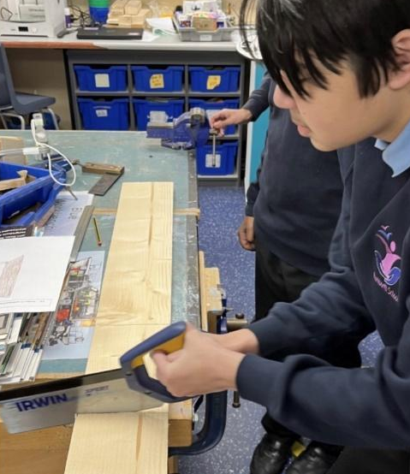
Our academic provision runs in Key Stages and then as strands according to student needs; the differing curricula provide excellent opportunities for all students to reach their potential across the full range of their needs, including SMSC. All students access appropriate external accreditation at the end of KS4 and during KS5 in our Sixth Form, and our accreditation offer includes a wide range of GCSEs, Functional Skills, ASDAN, BTEC, and Entry Level Certification, dependent upon student ability.
In Year 7, students have a more class-based curriculum with their class teacher delivering the majority of their learning within a “Foundation Year” setting. Year 7 students also access specialist rooms and may be taught by other staff for lessons such as Forest School, Art, Music, PE, Science, ICT, and Design Technology.

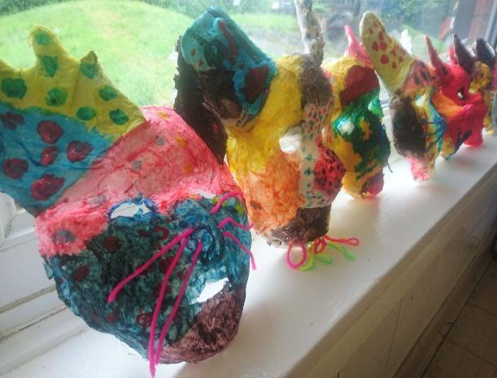
From Years 8 to 11, students then follow a differentiated curriculum model, according to their needs:-
- Some follow a more formal curriculum with a
modified mainstream approach
- Some have less transition and spend more time on the consolidation of basic skills
- Some have particular SLD / ASD / SEMH needs
and benefit from smaller groups at times

Students may have support from other professionals, who
work collaboratively with our form team staff.
During KS5 in our Sixth Form, students follow the most suitable curriculum pathway for their ability, and we then offer a Year 14 Transition Year which further supports our students towards an appropriate post-19 destination, which may which may be LifeBridge - the Post-19 setting that was developed a number of years ago by current and retired members of our Senior Leadership Team.


We have made significant investments in our vocational facilities and in our curriculum offer to support & promote opportunities for employability, independence and enrichment. “Rummies” Bistro is open daily and Sixth Form students are involved in preparing and serving a wide range of drinks, snacks and meals, including barista coffees and our renowned cakes and afternoon teas.

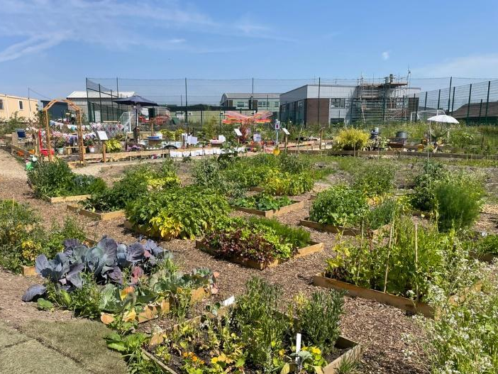

The recent extensive development of our outdoor “Growing Places” area includes a new outdoor classroom area, an industrial-scale growing polytunnel and planting areas with raised beds. Every form class has a small outdoor garden and then each year group takes part in designing an annual ‘show garden’ as part of the Rumworth School Grand Show competition.

The Forest School area, our large fishing lake, accessible outdoor trail paths, the outdoor gym and two outdoor multi-use games areas (MUGAs) all offer secure outdoor spaces to promote health and well-being. Students have the opportunity to develop new skills and access team building activities which support the holistic development of confidence and communication. Students are also taught to swim and have access to therapy sessions in our hydrotherapy pool which has a wave function, and sound & light facilities.

