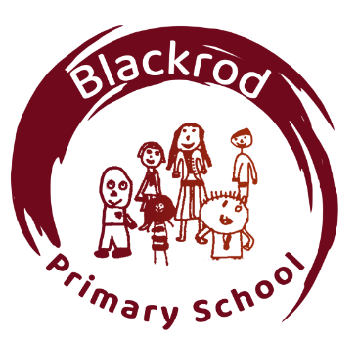
Teaching Assistant

Blackrod Primary School

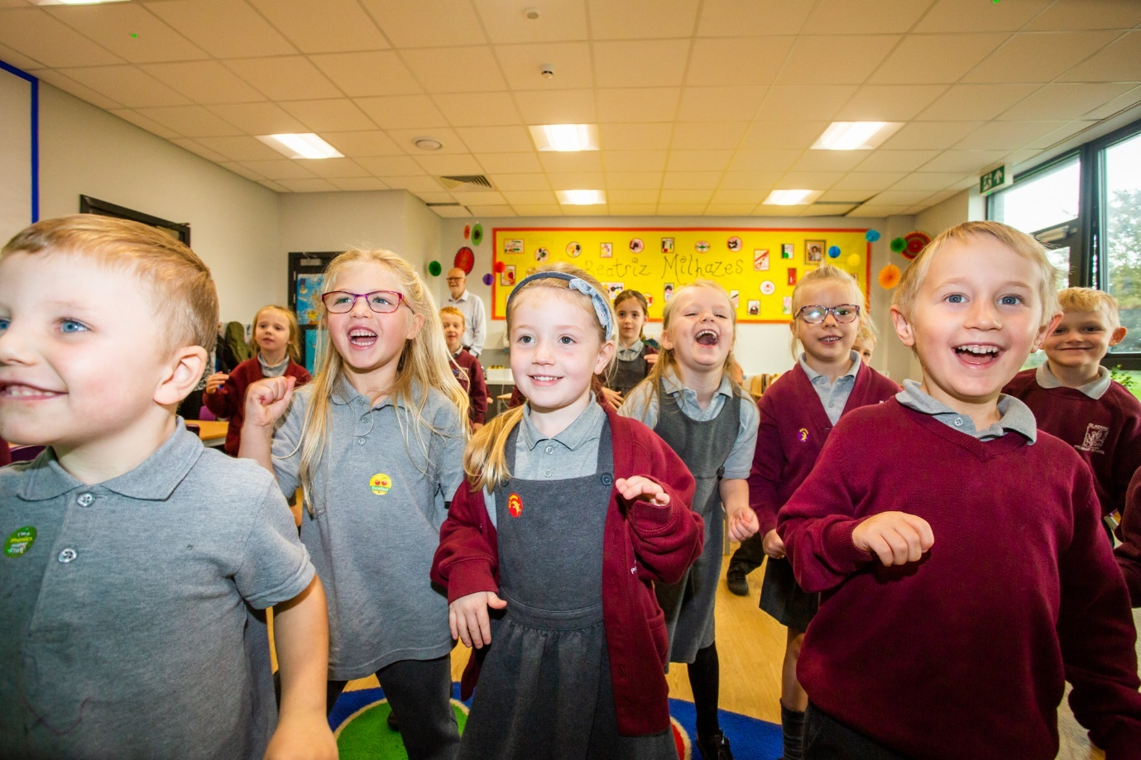

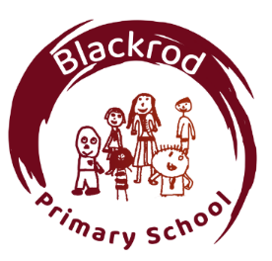
Welcome from the Head Teacher

I would like to offer you a very warm welcome to Blackrod Primary School, a highly successful, popular school situated in the North West of Bolton. Ofsted judged us 'outstanding' in every area during their most recent inspection.

We are passionate about our school. It is a special place where children feel cared for, supported respected and safe. We always strive for academic excellence and provide an exciting and enriching curriculum for all our children. We help every child fulfil their potential and we celebrate everyone’s uniqueness and the gifts and talents they have. Every child is precious to us, and it is a privilege to play a part in their development. The key to our success, we believe is a love of life and learning within a school where children feel cared for, supported, respected and safe.

We seek a candidate who will share our philosophy and embrace the ethos and the values which are at the schools’ core. Our staff are all high performing professionals who go above and beyond expectations to make a difference to pupils’ lives. They provide children with the skills, knowledge, resilience, enthusiasm, and life skills which will equip them to lead a rewarding and happy life. We respect the skills, knowledge, and experience of each of our staff members and strive to support them on their quest for continual professional development. In turn this encourages a love of learning which embeds across the school from children to staff alike.

We have a very strong relationship with parents and our community, and this is at the heart of our school.

Should you wish to visit or find out more please contact us from the details below.

I look forward to meeting you.

Kind regards

Katherine Mead

Head Teacher
Mission Statement

At Blackrod Primary School we provide a happy, secure, caring, and purposeful environment, where individuals fulfil their full potential and develop a joy in learning and life.

We are Proud of Our School

Blackrod Primary School is an exciting place where children achieve highly, supported by motivated, talented, and inspiring professionals.

Judged as ‘Outstanding’ by Ofsted in 2024, Blackrod Primary School focus on their core goal: to develop children who are prepared for, and excited by, the world of tomorrow. The school is situated in the heart of a local village community on the North West outskirts of Bolton and has outstanding grounds with spectacular views over the countryside and beyond. Our pupil intake comes from the local surrounding area. Our children are well motivated, keen to learn and are proud of their school.

We are committed to the development of children both within and outside of school. We have an active extra-curricular offer including before and after school child-care, holiday care and BYB@Blackrod a provision through which we work with partners externally to drive new opportunities for children outside of school time. We are committed to local community partnerships. We engage with active networks of professional practice and work with the local cluster of schools to share expertise.

Number of pupils on roll: 313

Closing date for applications: Wednesday 22nd April at 12.30pm
Interview date: W/C Monday 27th April 2026. This will be confirmed at shortlisting.

For all further details are all available on the advert document

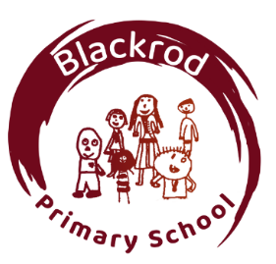
Teaching Assistant Job Description

Employment details
Job Title: Teaching Assistant
Job purpose:
To provide support for teaching and learning activities.
To contribute to children’s development and safeguarding.
To provide support to develop the learning environment

Main duties and responsibilities
Provide support for learning activities across a range of key stages and in a range of environments
Support children’s development (e.g. physical, emotional, social, communication and intellectual development needs)
Help to keep children safe, including maintaining a safe environment, dealing with accidents, supporting safeguarding.

Engage in professional development training relevant to the role including some after school sessions.

Encourage children’s positive behaviour and uphold the school behaviour and relationships policy
Contribute to positive relationships with children and adults through communication and interaction
Provide effective support for colleagues
Support all curriculum activities
Support the use of information and communication technology for teaching and learning
Use information and communication technology to support pupils’ learning
Observe and report on pupil’s learning, behaviour, SEND and safeguarding
Support children with SEND implementing adaptations and interventions.
Support development of learning environments.
Accompany and supervise pupils on educational visits and out-of-school activities
Contribute to maintaining pupil records for learning, behaviour, SEND and safeguarding
Contribute to monitoring and maintaining curriculum resources
Invigilate tests and examinations
Implement outdoor play and learning during lunchtime as an OPAL playworker

Support the planning and delivery of fun, engaging and safe holiday club activities. Supervise children across a variety of age groups, ensuring a positive, active and enriching experience during school holidays.

