

Brownlow Fold Primary School
Wellbeing Pledge
Together we Fly
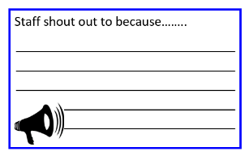 | Staff Shout Outs |  | Annual Flu Jab for staff the request it
 | Communication | 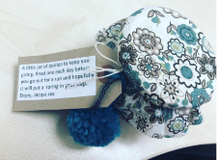 | Random Acts of Kindness
 | Employee Assistance Programme |  | Dedicated leadership time for leadership roles
 | Growth Mindset | 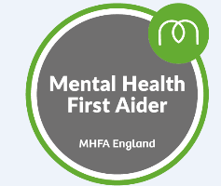 | Certified Mental Health First Aiders in school
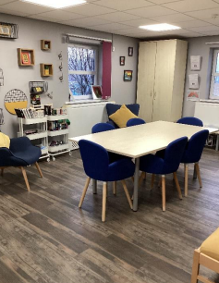 | Access to a staff room/wellbeing room and a dedicated PPA space |  | In house Coaching/Mentoring available for every member of staff if requested/required
 | Termly staff appreciation breakfast or lunch |  | Flexible working for staff (where possible)
 | Staff access to fitness sessions weekly: general fitness and yoga |  | Occupational Health
 | Career development opportunities | Reframing | Finding new ways of perceiving a tricky situation.
 | 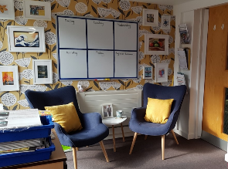  Annual CPD focusing on well being |  | School environments which support wellbeing and calm
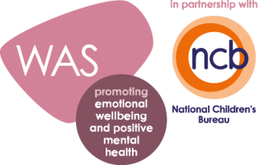 | Accredited Wellbeing Award |  | Headteacher Psychological first aid trained from Public Health England (PHE)
Mission Statement | Mission Statement that focuses on mental health and emotional wellbeing |  | Reflective teaching practices focused on research
 | Access to Headspace App for all staff that want it |  | Wellbeing Library
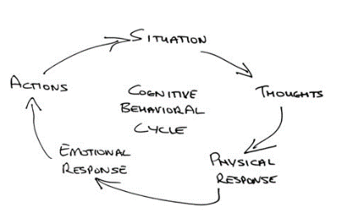   | Wellbeing Support  Headteacher certified CBT Therapist. |  | Headteacher NLP Practitioner
Open door policy for HT/DHT/AHT including urgent out of hours



